

Management & Science University

University Drive, Off Persiaran Olahraga

Section 13, 40100 Shah Alam

Selangor Darul Ehsan

**THESIS MANAGEMENT & EVALUATION SYSTEM**

(THEMES)

USER MANUAL for STUDENT

Version 1.0

Document Reference: MSU/THEMES/UM/001

**DOCUMENT DETAILS**

|  |  |
| --- | --- |
| **Effective Date:** | 1Jun 2015 |
| **Document Owner:** | Information Technology and Innovation Centre (ITIC) |

**REVISION HISTORY**

|  |  |  |  |
| --- | --- | --- | --- |
| **Date** | **Version** | **Description** | **Author** |
| 18 Feb 2015 | 0.1 | Document creation | Zuraimi, Nizam |
| 02 Mar 2015 | 0.2 | Document review and update | Zuraimi |
| 19 May 2015 | 0.3 | Document review and update | Zuraimi, Nizam |
| 06 Nov 2015 | 1.0 | Document review and update | Zuraimi |

**TABLE OF CONTENTS**

1 INTRODUCTION 1

1.1 Scope 1

1.2 System Requirement 1

1.2.1 URL 1

1.2.2 Internet Browser 1

1.2.3 User Access 1

1.3 Screen Design 1

2 MODULE and FEATURE 1

2.1 Available Module and Feature for Student 1

3 LOGIN and LOGOUT 4

3.1 Login 4

3.2 Logout 5

4 MAIN 6

4.1 Announcement 6

5 PUBLICATION 7

5.1 List of Publication 7

5.2 Manage Publication 9

5.2.1 Add Publication 9

5.2.2 Edit Publication – Saved Mode 11

5.2.3 Edit Publication – Added Mode 13

5.2.4 Delete Publication 14

6 THESIS 15

6.1 Student Programme 15

6.1.1 Student Profile 15

6.1.2 Thesis 17

6.1.2.1 Submit New Proposal 18

6.1.2.2 Disapproved 27

6.1.2.3 Cancel Proposal 29

6.1.2.4 Approval by Faculty 33

6.1.2.5 Edit Proposal 34

6.1.2.6 View Proposal 36

6.1.3 Supervisor/Co-Supervisor List 38

6.1.4 Subject Taken 39

6.1.5 Thesis History 40

7 Monthly Progress Report 41

7.1 Thesis Chapter 41

7.1.1 Add Thesis Chapter 42

7.1.2 Update Thesis Chapter 43

7.1.3 Delete Thesis Chapter 44

7.1.4 Add Thesis Sub-chapter 45

7.1.5 Update Sub-Chapter 47

7.2 Monthly Progress Report 48

7.2.1 New Monthly Progress Report 49

7.2.1.1 Add Discussion Detail 52

7.2.1.2 Add Attachment 55

7.2.1.3 Update Attachment 57

7.2.1.4 Delete Attachment 58

7.2.1.5 Delete Discussion Detail 59

7.2.2 Edit Monthly Progress Report – Draft in Progress 60

7.2.3 Edit Monthly Progress Report – Request Changes 62

7.3 Progress Report History 63

8 PROPOSAL DEFENCe 65

8.1 Defence Proposal 65

8.1.1 New Defence Proposal 66

8.1.1.1 Add Publication 69

8.1.1.2 Delete Publication 71

8.1.1.3 Add Conference 72

8.1.1.4 Edit Conference 74

8.1.1.5 Delete Conference 75

8.1.2 Delete Defence Proposal 76

8.1.3 Edit Defence Proposal 78

8.2 Defence Proposal History 79

9 WORK COMPLETION 81

9.1 Work Completion 81

9.1.1 New Work Completion 82

9.1.1.1 Add Publication 85

9.1.1.2 Delete Publication 87

9.1.1.3 Add Conference 88

9.1.1.4 Edit Conference 90

9.1.1.5 Delete Conference 91

9.1.2 Delete Defence Proposal 93

9.1.3 Edit Work Completion 94

9.2 Manage Amendment 96

9.2.1 Feedback Status 97

9.2.1.1 Add Feedback Status 97

9.2.1.2 Delete Feedback Status 101

9.2.1.3 Submit Feedback Status 103

9.2.2 Update Amendment Status 106

9.2.2.1 Submit Amendment Status 106

10 Thesis EVALUATION / VIVA 110

10.1 Thesis Submission 110

10.1.1 New Thesis Submission 111

10.1.1.1 Upload Attachment 112

10.1.2 Request Changes / Edit Thesis / Re-Submit Thesis 115

10.1.2.1 Upload Attachment 117

10.2 Amendment on Thesis 121

10.2.1 New Amendment Submission 121

10.2.1.1 Upload Attachment 124

10.2.2 Request Changes / Save as Draft 127

10.2.2.1 Upload Attachment 129

10.2.3 Amendment on Thesis 133

10.2.3.1 Upload Attachment 134

10.2.4 Request Changes on Amendment 138

10.2.4.1 Upload Attachment 139

10.3 Appeal Session 143

10.3.1 Request for Appeal 143

11 Message 145

11.1 Inbox 145

11.1.1 New and Read Message 145

11.1.2 Delete Message 146

11.2 New Message 147

11.2.1 Send Message 147

11.2.2 Select Recipient 149

11.2.3 Upload Attachment - Add 151

11.2.4 Upload Attachment - Update 153

11.2.5 Upload Attachment - Delete 154

11.3 Sent Message 155

11.3.1 View Sent Message 155

11.3.2 Delete Sent Message 157

12 Control Panel 158

12.1 Change Password 158

12.1.1 Before Login 158

12.1.2 After Login 160

13 Help 162

13.1 Online Help - Student 162

13.2 User Manual 165

13.3 Frequently Asked Question 166

13.4 About Us 167

**LIST OF FIGURES**

Figure 1: Manual Structure 1

Figure 2: THEMES Screen Structure Design 2

Figure 3: Modules and Features 3

Figure 4: Login Page 4

Figure 5: Logout 5

Figure 6: Announcement 6

Figure 7: List of Publication 8

Figure 8: Add Publication 9

Figure 9: Edit Publication – Saved Mode 11

Figure 10:Edit Publication – Added Mode 13

Figure 11: Delete Publication 15

Figure 12: Student Programme Tab 16

Figure 13: Thesis ID Naming Convention 17

Figure 14: First Time Proposal Preparation 25

Figure 15: Proposal Disapproved by Faculty 28

Figure 16: Proposal Cancellation 31

Figure 17: Request for Cancellation 33

Figure 18: Request Changes – Edit Proposal 35

Figure 19: View Proposal – Approved by Senate 36

Figure 20: View Proposal – Approved with Changes by Senate 37

Figure 21: List of Supervisor / Co-Supervisor 38

Figure 22: Subject Taken 39

Figure 23: Student Programme – Thesis History 40

Figure 24: Thesis Chapter 42

Figure 25: Add Chapter 42

Figure 26: Update Chapter 43

Figure 27: Delete Chapter 44

Figure 28: Add Sub-Chapter 45

Figure 29: Update Chapter 47

Figure 30: Monthly Progress Report 48

Figure 31: New Monthly Progress Report 51

Figure 32: Add Discussion Date 54

Figure 33: Edit Report 62

Figure 34: Progress Report History 63

Figure 35: Thesis Submission 110

Figure 36: New Thesis Submission 111

Figure 37: Upload Attachment 114

Figure 38: Re-Submit Thesis 116

Figure 39: Upload Attachment 119

Figure 40: New Amendment 122

Figure 41: Upload Attachment 126

Figure 42: Request Changes 128

Figure 43: Upload Attachment 131

Figure 44: Amendment on thesis 133

Figure 45: Upload Attachment 136

Figure 46: Request Changes 138

Figure 47: Upload Attachment 141

Figure 48: Appeal Session 143

Figure 49: New Message 147

Figure 50: Select Recipient 149

Figure 51: Upload Attachment 152

Figure 52: Upload Attachment 153

Figure 53: Upload Attachment 154

Figure 54: Sent 156

Figure 55: Sent 157

Figure 56: Change Password Page Before Login 159

Figure 57: Change Password Page After Login 160

Figure 58: Online Help 163

Figure 59: User Manual 165

Figure 60: FAQ 166

# INTRODUCTION

Thesis Management and Evaluation System (THEMES) version 1.0.0 is a system for the Student, Supervisor, Faculty and Senate to monitor the status of thesis proposal from its initial stage toward to the end. It is not only use by the respective personnel to control and manage the quality of the thesis to meet the university standard but it also can be used to keep track all the communication between the student and university. If required the history can be retrieved to view the completed work or its progress.

The system contains the main modules which are Thesis Proposal Submission and Approval, Monthly Progress Report Review, Thesis Proposal Defense, Thesis Work Completion, Thesis Evaluation/Viva and Senate Endorsement.

## Scope

The manual will guide the student on how to use the system in every stages starting from the thesis proposal submission, monthly report submission, defence proposal submission, work completion submission, viva evaluation and senate endorsement.

The manual is structured into the following sections:

| **Manual Section** | **Description** |
| --- | --- |
| Prerequisite | This section describes the actions or steps shall be done and in place first before the required steps can be done. |
| Steps | This section describes the steps to follow in order to yield the result for the desired function. |
| Next Action | This section describes the expected next steps to be followed once the above steps have been successfully performed. |
| Warning | This section describes the expected warning triggered by the system if the steps performed violate the business rule validation. |
| Note | This section describes the additional information which may be useful to the user while using the system. |

Figure 1: Manual Structure

## System Requirement

### URL

The system is available over the internet via the URL <http://themes.msu.edu.my> and accessible only by the registered and authorized postgraduate student and respective MSU’s staff.

### Internet Browser

It is recommended to run the system on the following internet browser

* Mozilla Firefox version 35 and above (recommended)
* Microsoft Internet Explorer version 8 and above

### User Access

The postgraduate students who have been successfully registered in Campus Management System (CMS) aka KLAS2 will be automatically become THEMES user or otherwise the student needs to check with the CMS admin on his/her credential status. By default the Student Matrix Number will be the user id to access the THEMES system.

The MSU’s staff that has been identified as reviewer, supervisor or co-supervisor can access the THEMES system once the THEMES admin registered him/her into the system. By default Employee ID will be the user id to access the THEMES system.

## Screen Design

The THEMES system screen has been design into the 5 sections namely section A, B, C, D and E.

Section A to contain the THEMES **Header** in which it contains the name of the system, the user name and Logout button

Section B to contain the THEMES **Top Panel** in which it contains the list of functions for the system.

Section C to contain the THEMES **Left Panel** in which it contains the list of sub-functions resulting from the selection in Section B.

Section D to contain the THEMES **Working Area** in which it shows the page for user respond resulting from the selection in Section C.

Section E to contain the THEMES **Footer** in which it contains the university name and its copyright.

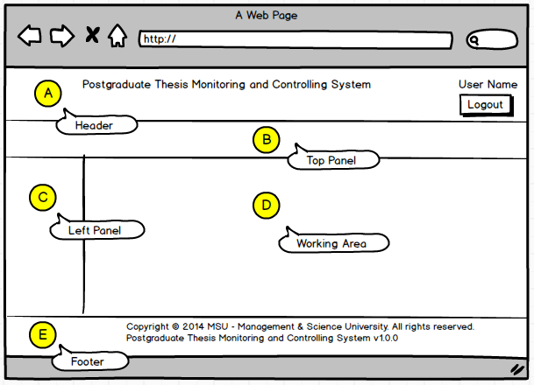

Figure 2: THEMES Screen Structure Design

# MODULE and FEATURE

## Available Module and Feature

The user will have the access to all the modules as listed below:

| **Module** | **Feature** | **Description** |
| --- | --- | --- |
| Main | Announcement | This feature will list all the announcement published by the Faculty |
| Publication | List of Publication | This feature will list all the publication published by the student and other student too |
|  | Manage Publication | This feature will allow the student to add and manage the publication which has been published before |
| Thesis | Student Programme | This feature contain another five (5) features which is *Student Profile, Thesis, Supervisor/Co-Supervisor, Subject Taken* and *Thesis History*  *Student Profile*  This is the page where the summary of student profile information is displayed like student matric number, programme, thesis information and thesis progress flow  *Thesis*  This is the page where the student will start to initiate the submission of thesis proposal  *Supervisor/Co-Supervisor*  This is the page where the Supervisor / Co-Supervisor has accepted the invitation to supervise the postgrad student  *Subject Taken*  This is the page where all the subjects taken by the student is listed. The information is retrieved from KLAS2 system  *Thesis History*  This is the page where the activity of thesis proposal starting from its submission till approval is tracked and recorded for future reference. |
| Monthly Progress Report | Thesis Chapter | This feature is the page where the student needs to define the thesis’s chapter and its subchapter (if any). |
|  | Monthly Progress report | This feature is the page where the student can submit the monthly progress report to the Supervisor |
|  | Progress Report History | This feature is the page where the student can view back the history of the progress report starting from its submission until approved by the Supervisor. |
| Proposal Defense | Defense Proposal History | This feature is the page where the student can view back the history of the defence proposal starting from its submission until approved by the Supervisor. |
|  | Defense Proposal | This feature is the page where the student can submit the defense proposal report as advised by the Supervisor for approval by the Evaluation Committee. |
| Work Completion | Manage Amendment | This feature is the page where the student to amend the thesis based on the feedback given by the Evaluation Committee. |
|  | Work Completion | This feature is the page where the student can submit the work completion seminar report as advised by the Supervisor for approval by the Evaluation Committee. |
| Thesis Evaluation / VIVA | Appeal Session | This feature is the page where the student request to have re-evaluation from the Faculty due to the thesis is disapproved by the Evaluation Committee. |
|  | Amendment On Thesis | This feature is the page where the student can amend the thesis based on the feedback given by the Evaluation Committee before re-evaluation. |
|  | Thesis Submission | This feature is the page where the student submits the thesis proposal to the Faculty and Examination Committee for evaluation. |
| Message | Inbox | This feature is the page where the messages are displayed to the student either it is sent by the sender or automatically triggered by the system due to some activity. |
|  | New Message | This feature is the page where the student will create and submit a message to the recipient. |
|  | Sent | This feature is the page where the student can find all the messages which have been sent to the recipient. |
| Control Panel | Change Password | This feature is provided to the student (as a user) to change the password as and when required to comply with the application security requirement |
| HELP | FAQ | This feature is the page where the frequent asked questions are displayed and listed to the student. |
|  | User Manual | This feature is the page where the relevant user manuals in PDF format are made available to the student for reference. |
|  | Online Help – Student | This feature is an alternative help to the user manual. |
|  | About Us | Information page about the system and the team. |

Figure 3: Modules and Features

# LOGIN and LOGOUT

## Login

This is the first page sight by the student to get into the THEMES system.

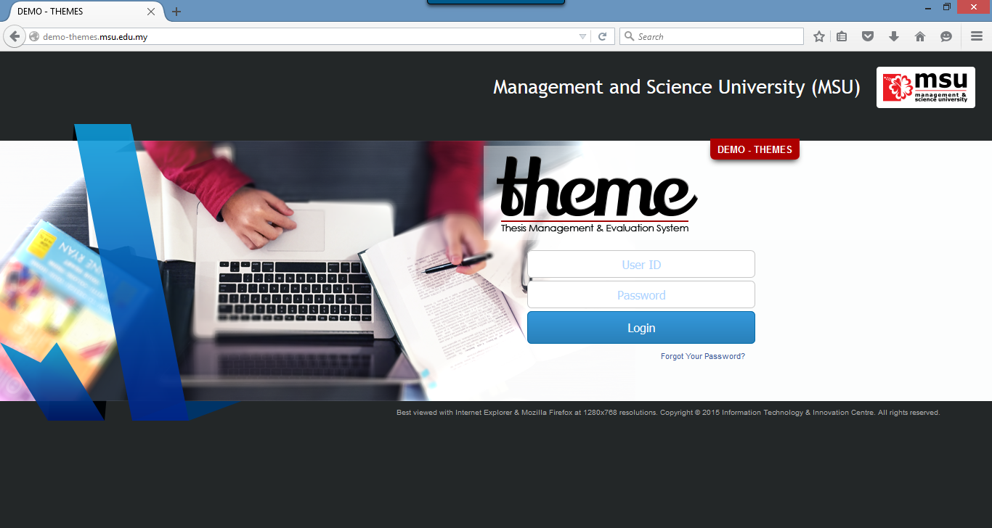

**2**

**1**

Figure 4: Login Page

**Prerequisite**

The user must have the User ID and Password registered with the THEMES system

**Steps**

1. Open the Internet Browser i.e. Mozilla Firefox or Microsoft Internet Explorer

Enter this URL <http://themes.msu.edu.my/> to access the system

1. Login page will be displayed in which the user needs to provide the **User ID** and **Password**.

**Warning**

1. If the provided **User ID** and **Password** are incorrect, the system will prompt an error message and the user needs to provide the right **User ID** and **Password** again.
2. Just in case the user forgot the password, it can be reset via the Forgot Your Password.

**Note**

None

## Logout

Once the necessary or required activities has been done or completed, the student can quit from the system by clicking on the **Logout** button.

If the system is inactivity for about 1 minute, the system will logged out the user automatically.

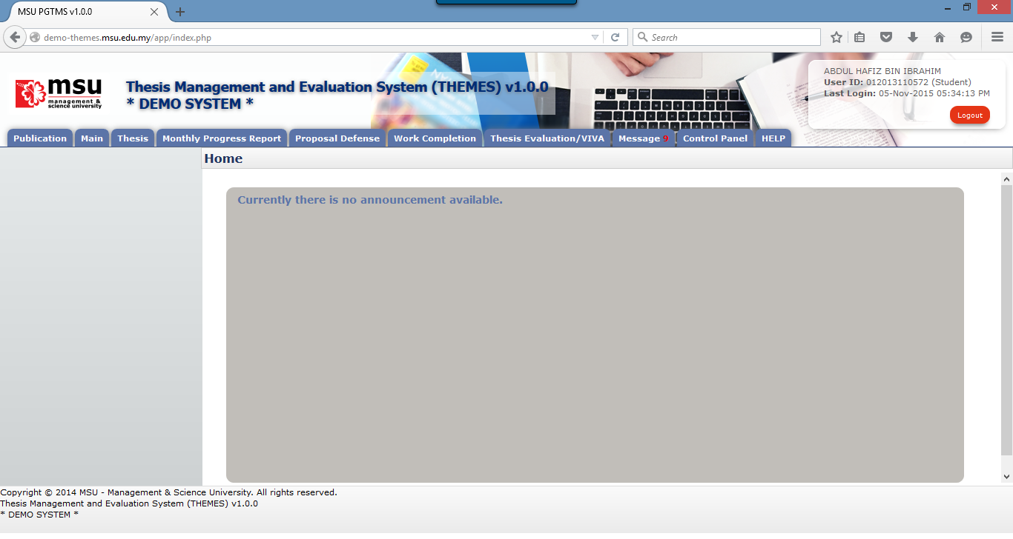

**1**

Figure 5: Logout

**Prerequisite**

The user has to successfully login to the system first.

**Step**

Find the **Logout** button located on the right top corner of the system **Header** section. Click on it and you will be logout from the system successfully.

**Warning**

None

**Note**

It is advisable to the user to properly logout from the system instead of force quit by closing the windows.

# MAIN

## Announcement

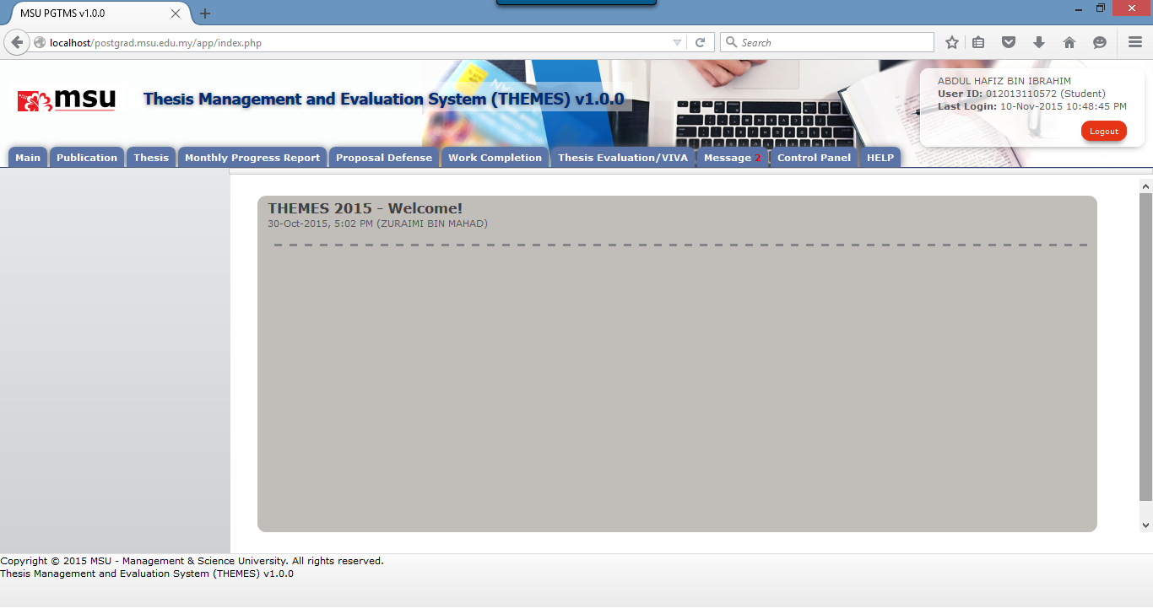

**1**

Figure 6: Announcement

**Prerequisite**

The user has to successfully login to the system first.

**Steps**

Observe the list of announcement is listed on the **Working Area** section

**Warning**

None

**Note**

Note

# PUBLICATION

## List of Publication

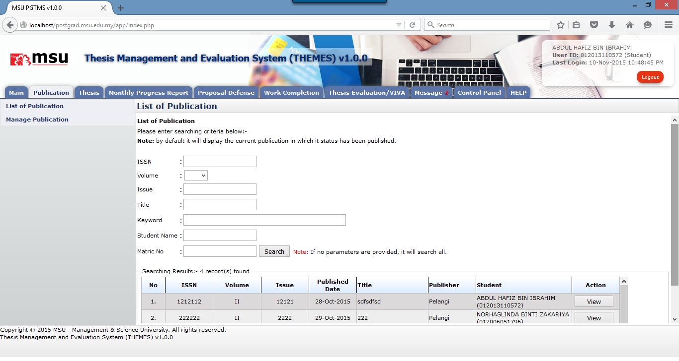

**2**

**1**

Figure 7: List of Publication

**Prerequisite**

None

**Steps**

1. Enter the searching criteria and click the **Search** button to get the specific search or just click on the **Search** button to get the general search result.
2. Click the **View** button to view the publication detail.

**Warning**

None

**Note**

None

## Manage Publication

### Add Publication

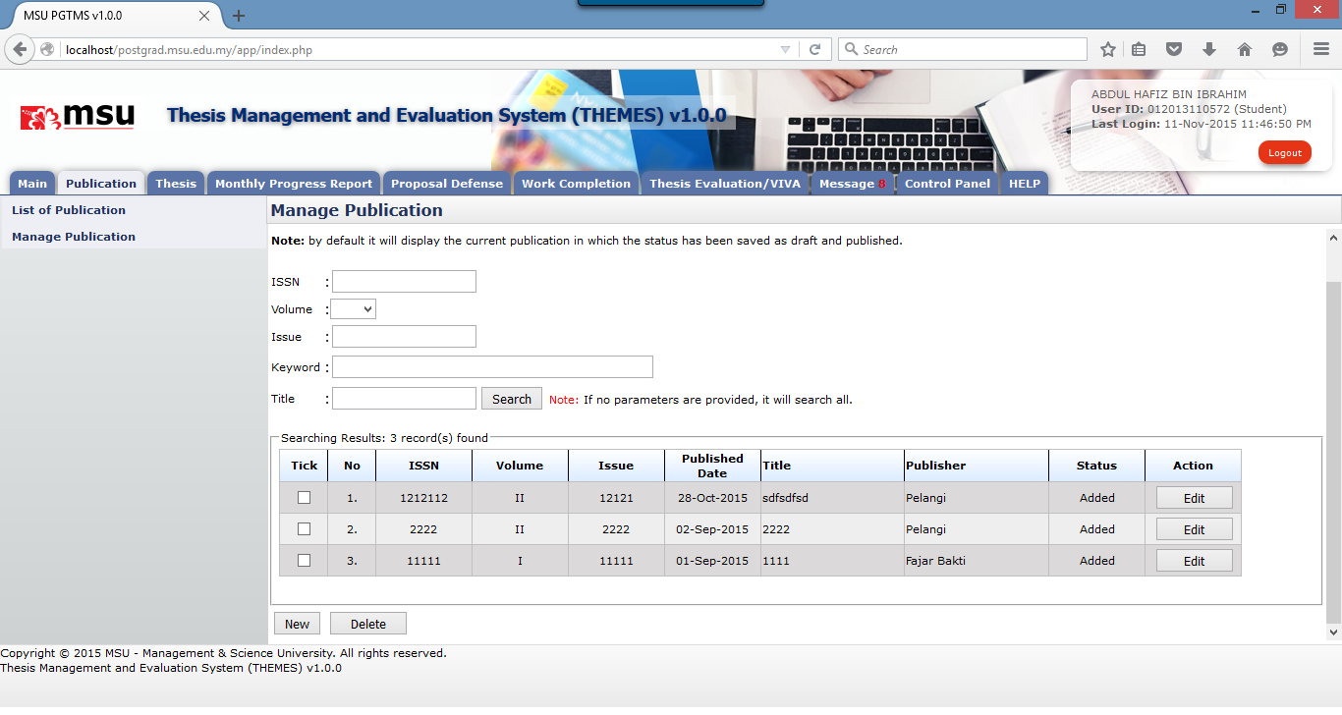

**2**

**1**

**3**

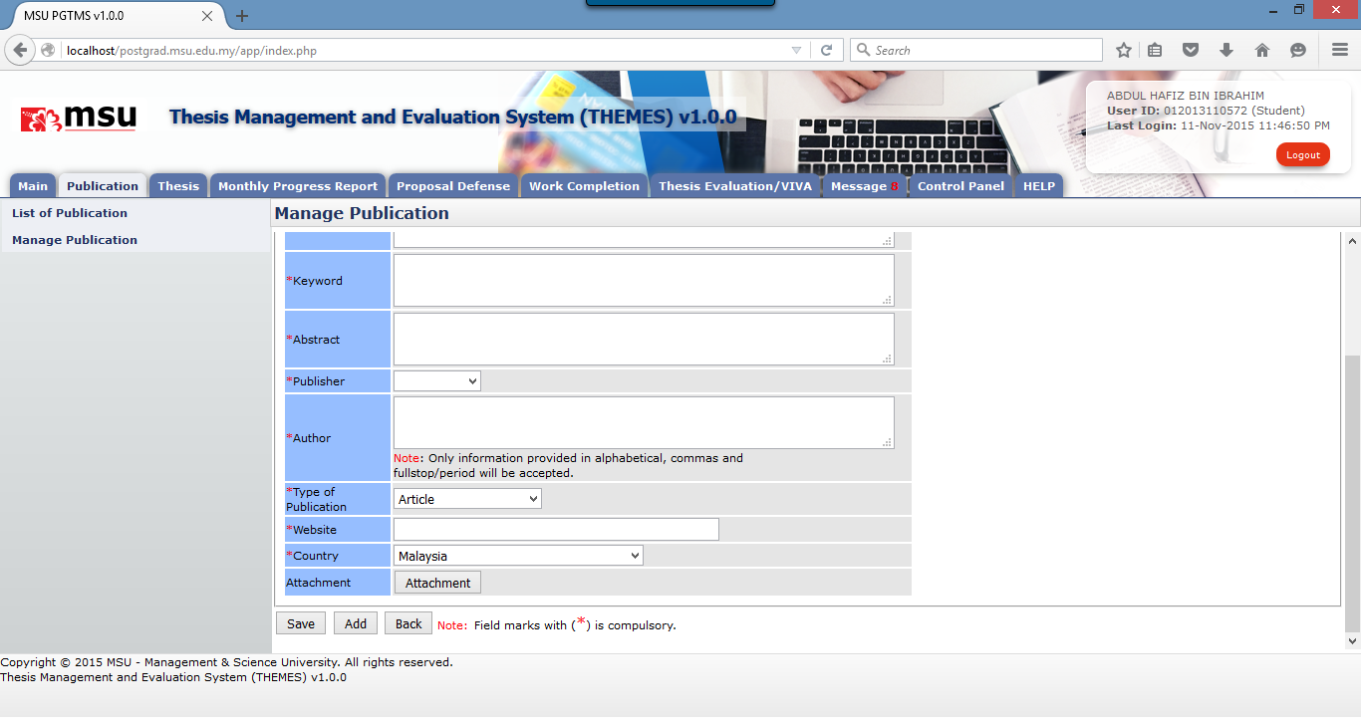

**5**

**4**

Figure 8: Add Publication

**Prerequisite**

List of Publisher has been added.

**Steps**

1. Click on the **Publication** tab on the Top Panel.
2. Click on the **Manage Publication** on the Left Panel.
3. Click on the **New** button to open the Publication page.
4. Enter the publication details
5. Click the **Save** button to save the changes temporary and unavailable yet to the other student or click on **Add** button to confirm the changes and available to the other student.

**Warning**

System will prompt a notification message if the mandatory field indicated by the asterisk (*) is left blank or unselected.

**Note**

None

### Edit Publication – Saved Mode

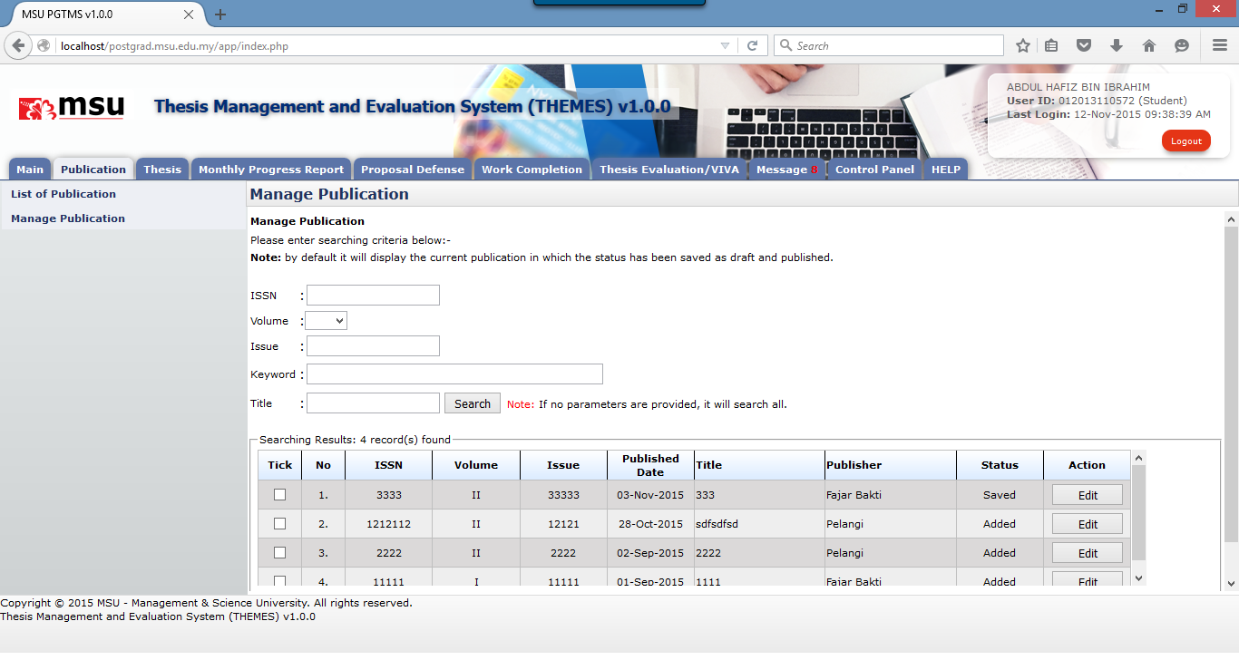

**2**

**1**

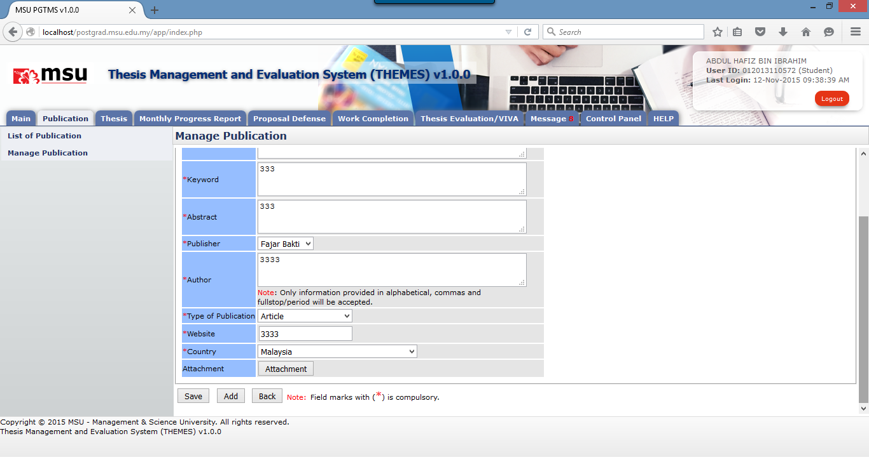

**4**

**3**

Figure 9: Edit Publication – Saved Mode

**Prerequisite**

The Publication has been added already.

**Steps**

1. Enter the searching criteria and click the **Search** button to get the specific search or just click on the **Search** button to get the general search result.
2. Click the **Edit** button to open the Publication Page.
3. Update the publication detail.
4. Click **Save** button to save the changes temporary and unavailable to the other student or click **Add** button to confirm the changes and available to the other student.

**Warning**

System will prompt a notification message if the mandatory field indicated by the asterisk (*) is left blank or unselected.

**Note**

None

### Edit Publication – Added Mode

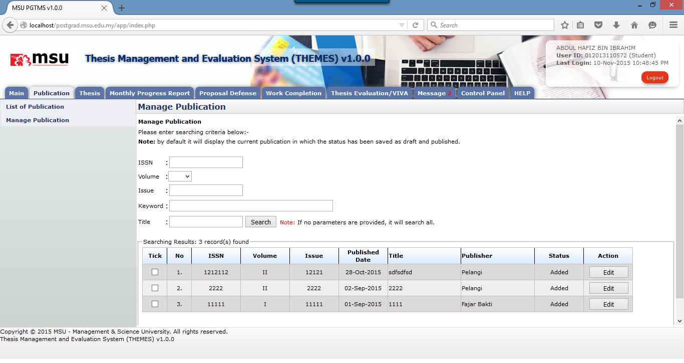

**2**

**1**

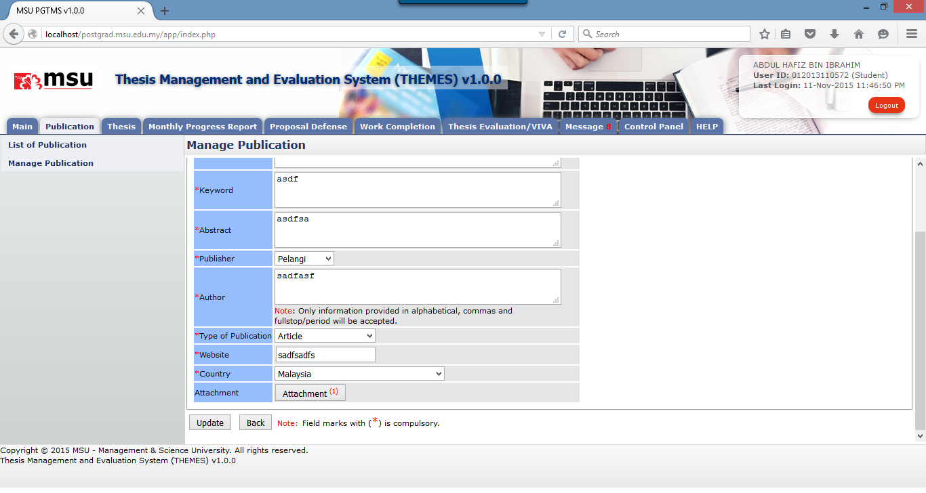

**4**

**3**

Figure 10:Edit Publication – Added Mode

**Prerequisite**

The Publication has been added already.

**Steps**

1. Enter the searching criteria and click the **Search** button to get the specific search or just click on the **Search** button to get the general search result.
2. Click the **Edit** button to open the Publication Page.
3. Update the publication detail.
4. Click **Update** button to save the changes.

**Warning**

System will prompt a notification message if the mandatory field indicated by the asterisk (*) is left blank or unselected.

**Note**

None

### Delete Publication



**3**

**1**

**2**

Figure 11: Delete Publication

**Prerequisite**

The Publication has been added already.

**Steps**

1. Enter the searching criteria and click the **Search** button to get the specific search or just click on the **Search** button to get the general search result.
2. Tick the checkbox in which the publication is going to be deleted. It can be done in multiple rows.
3. Click **Delete** button to delete the publication from the list.

**Warning**

System will prompt a notification message if the checkbox is unselected before the deletion.

**Note**

None

# THESIS

## Student Programme

Student Programme will contain all information that related to students, which are Student Profile, Thesis, Supervisor/Co-supervisor lists, Subject Taken and Thesis History.

### Student Profile

Student Profile tab contains the basic student and thesis information including its thesis progress status.

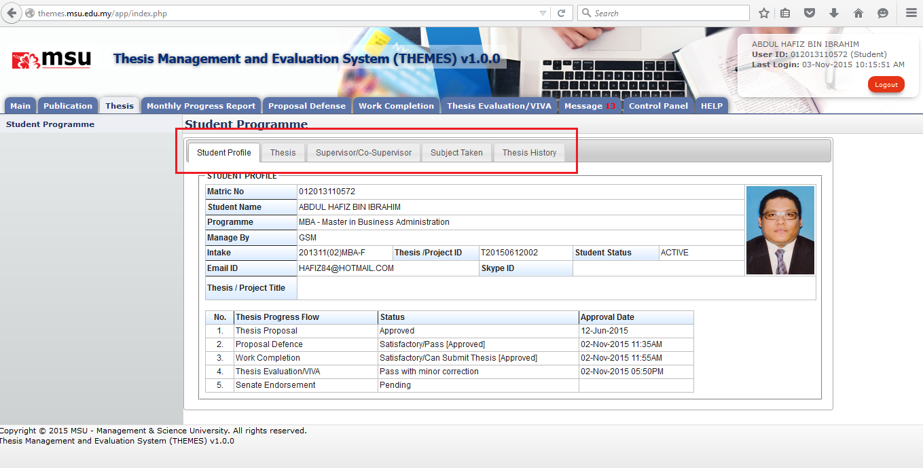

**3**

**1**

**2**

Figure 12: Student Programme Tab

**Prerequisite**

None

**Steps**

1. Click on the **Thesis** tab on the system **Top** panel section.
2. The **Student Programme** menu will be displayed on the system **Left** panel and click on it.
3. The other 5 tabs will be displayed on the **Working Area** section in which each tab will contain the information as mentioned previously.

**Warning**

None

**Note**

If the user is yet to submit the thesis proposal, the section of Thesis Progress Flow will be empty. It will be updated based on the current status progress for each thesis stage.

### Thesis

**Thesis** tab is the page where the student can submit, amend and view the proposal. Please refer next sections for details steps.

Each thesis proposal will be assigned with the unique Thesis ID which follows the naming convention below:

| **Character Position** | **Description** | **Example** |
| --- | --- | --- |
| 1..1 | Character ‘T’ which represent the word ‘**Thesis’** | T |
| 2..9 | The date of which the thesis proposal is submitted successfully. The date format is based on YYYYMMDD  **Note**  YYYY – The Year  MM – The Month  DD – The Day | 20150304 |
| 10..12 | Running Number | 001 |

Figure 13: Thesis ID Naming Convention

Example of generated Thesis ID

*Proposal Date*

T20150304001

*Prefix for Thesis*

*Running number*

#### Submit New Proposal

##### First Time

If the user is yet to submit the thesis proposal, the message as shown in the figure below will be displayed to the user.

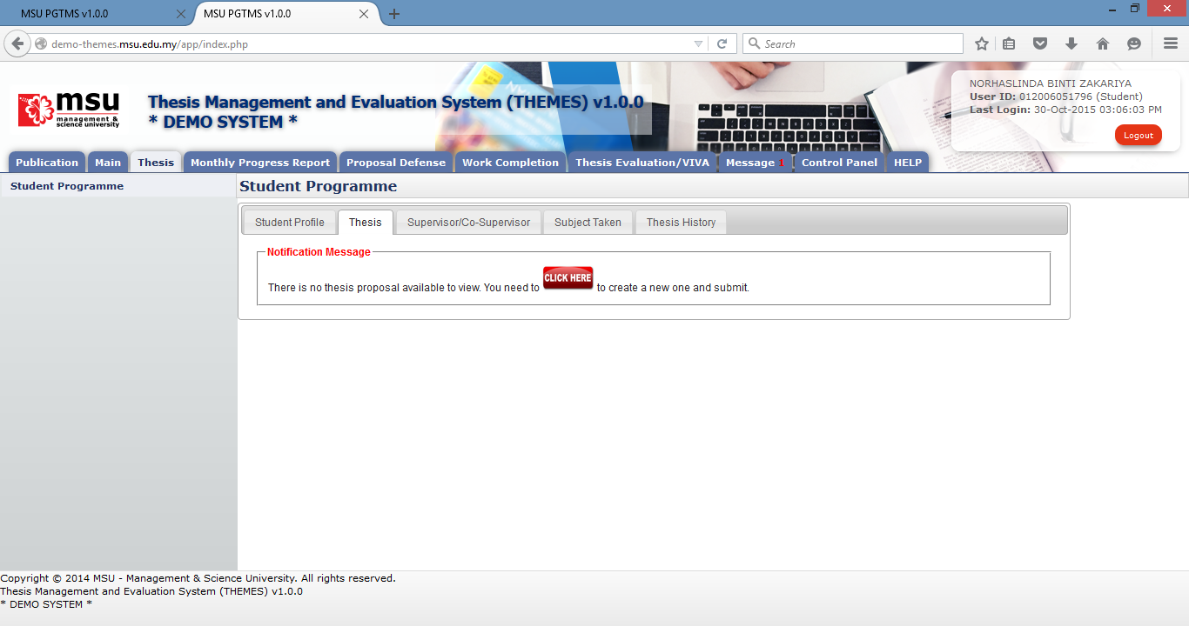

**1**

**2**

**4**

**3**

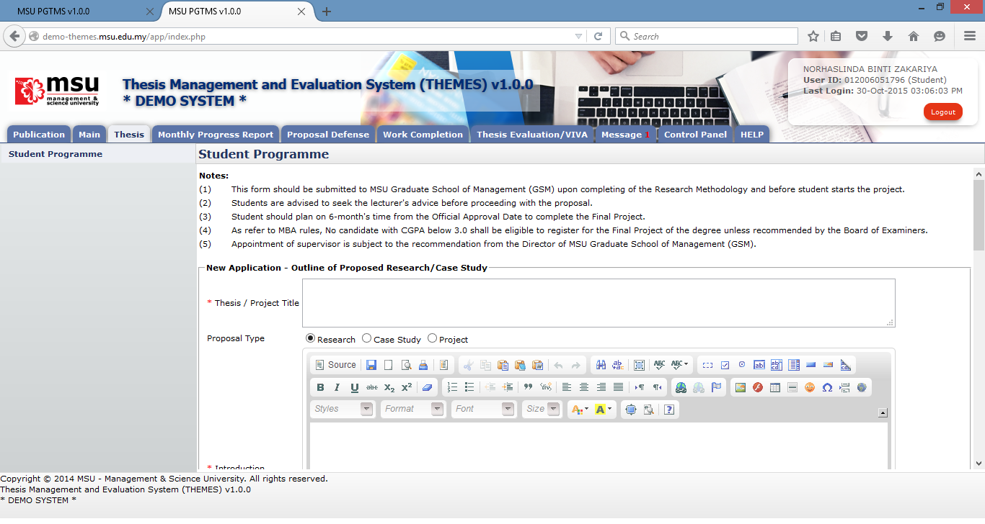

**6**

**5**

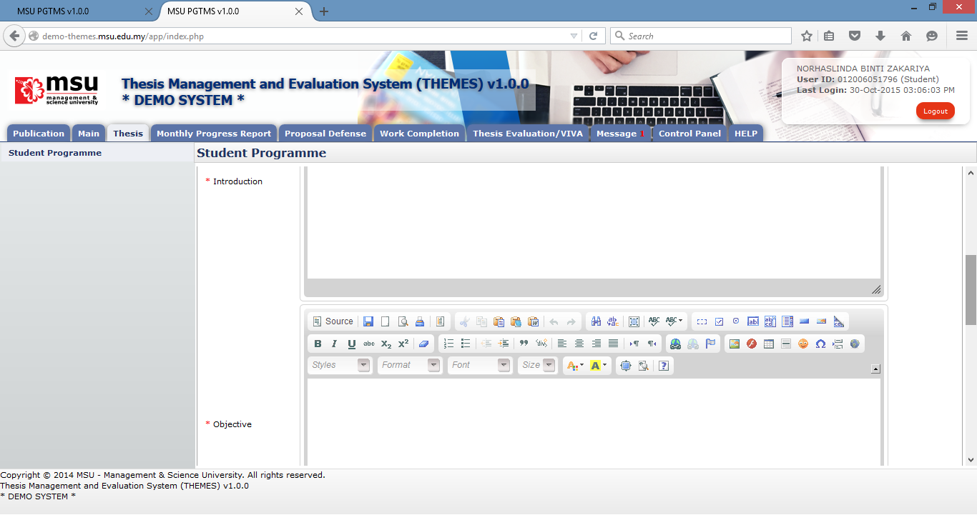

**8**

**7**

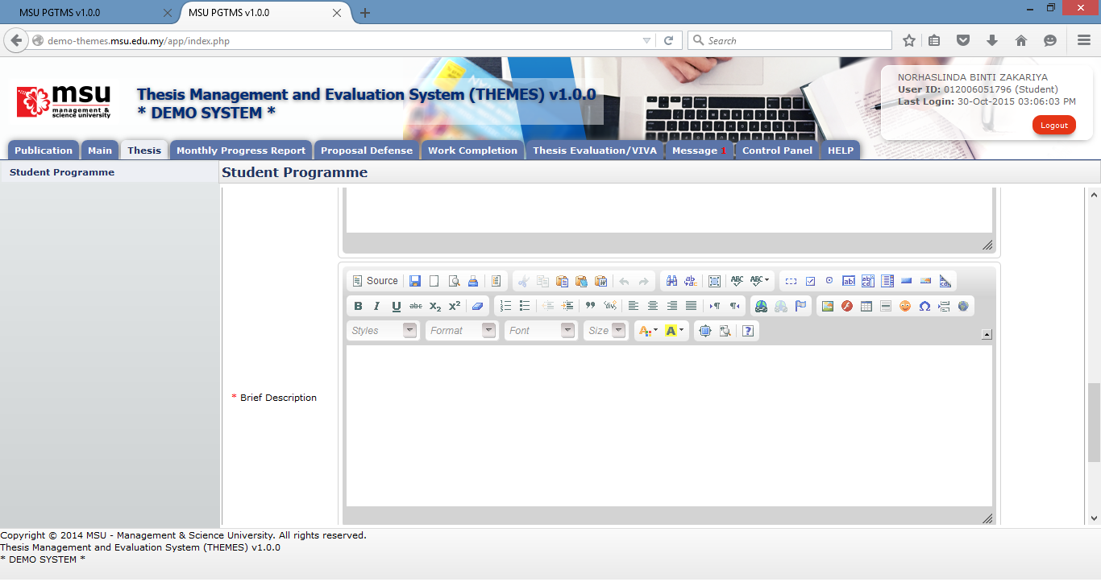

**9**

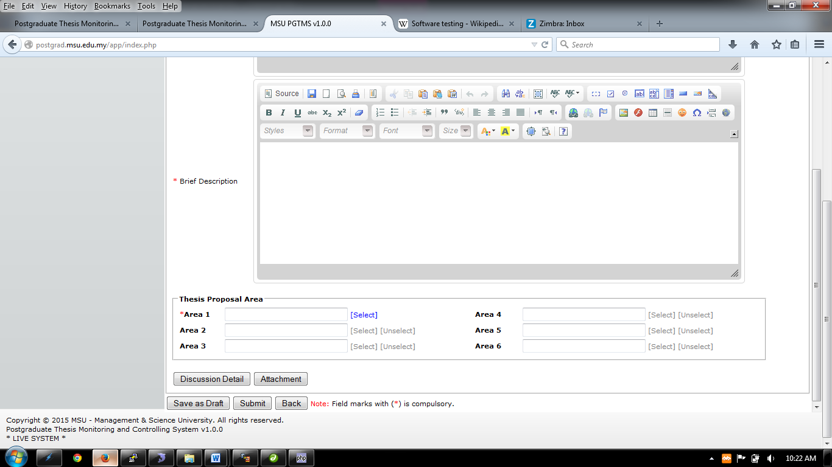

**10**

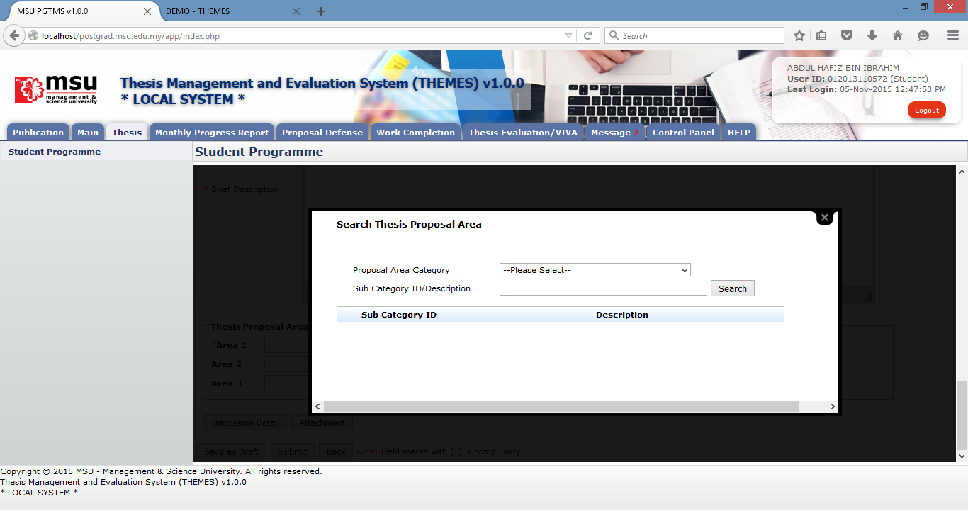

**11**

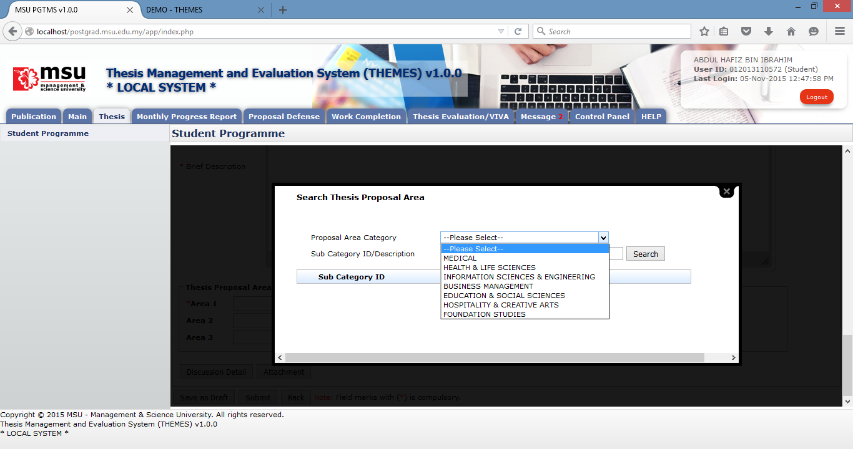

**12**

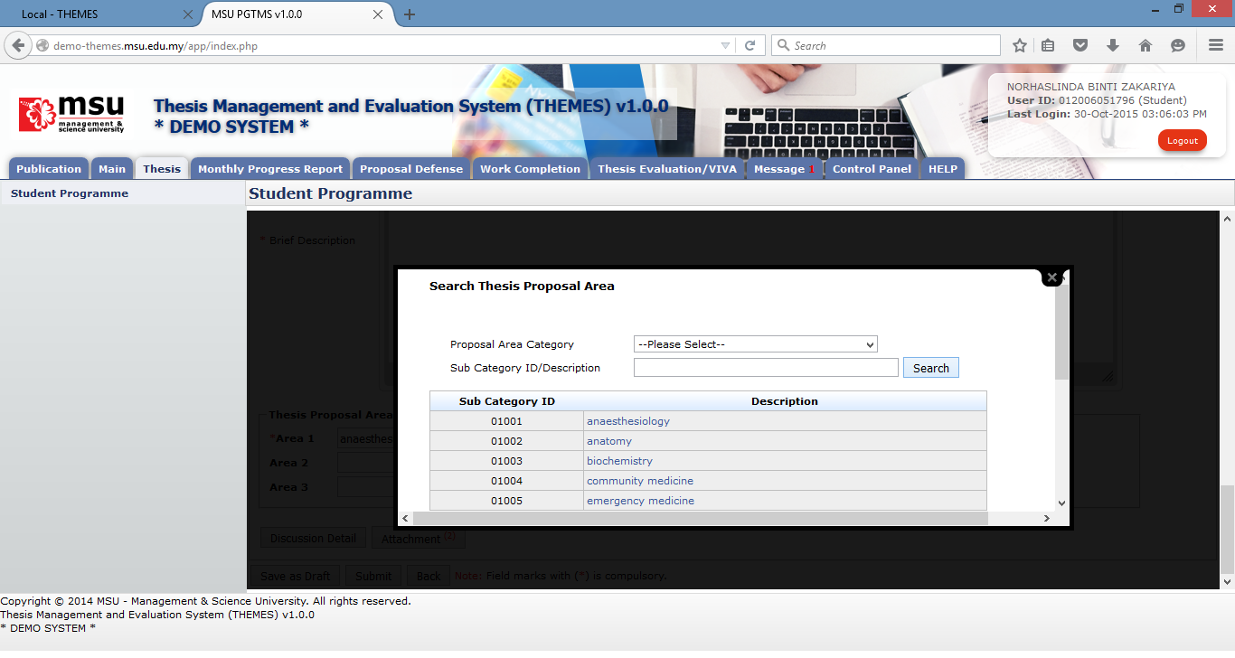

**13**

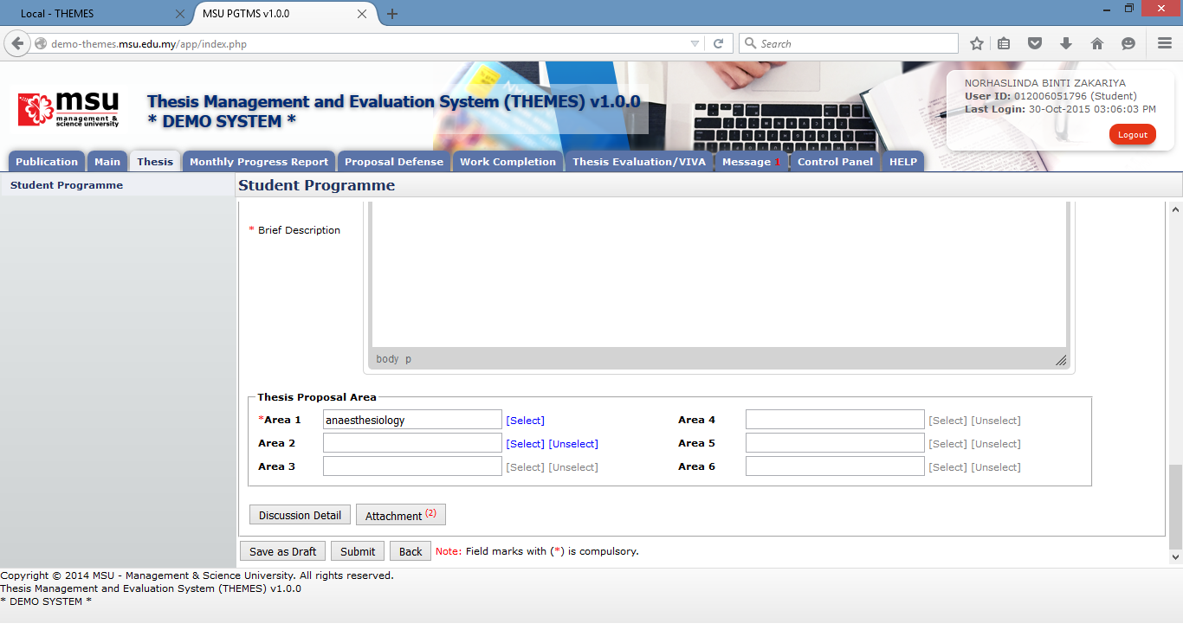

**14**

**15**

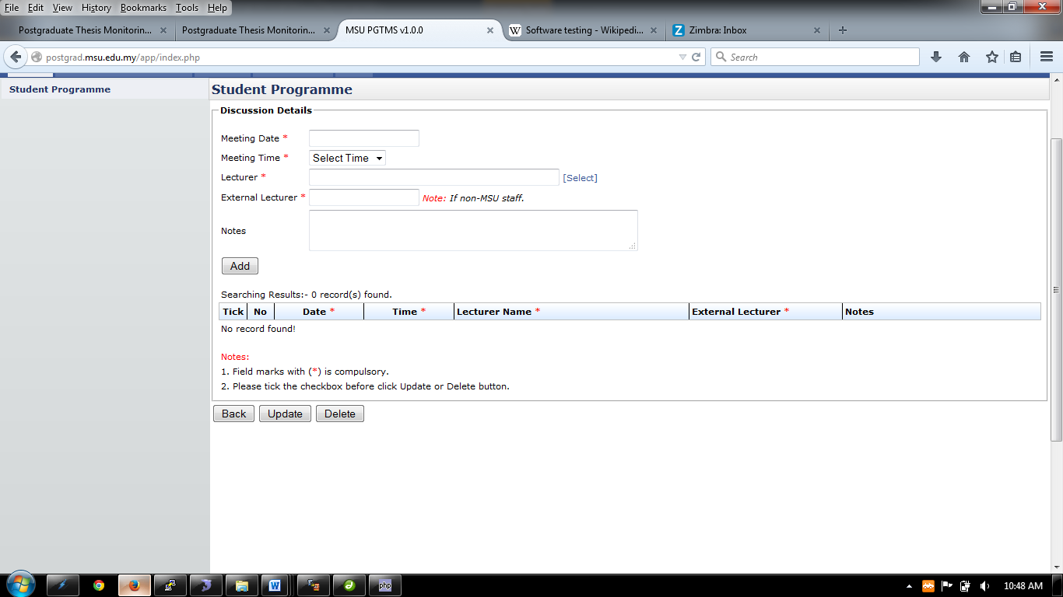

**17**

**16**

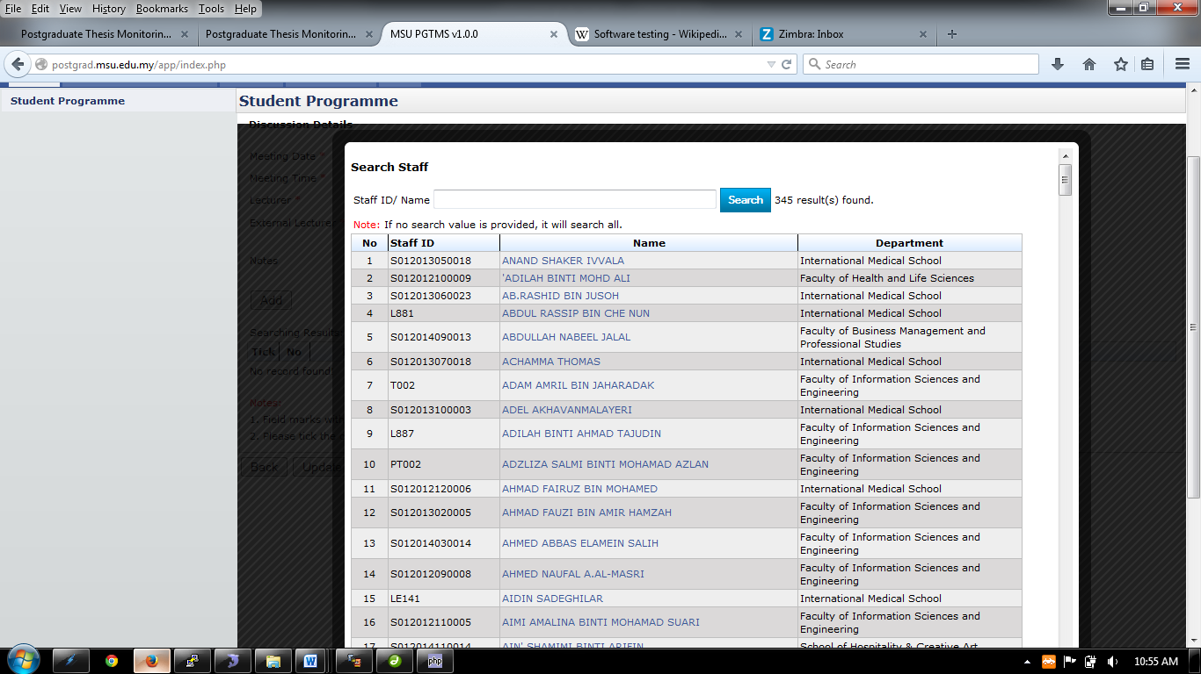

**19**

**18**

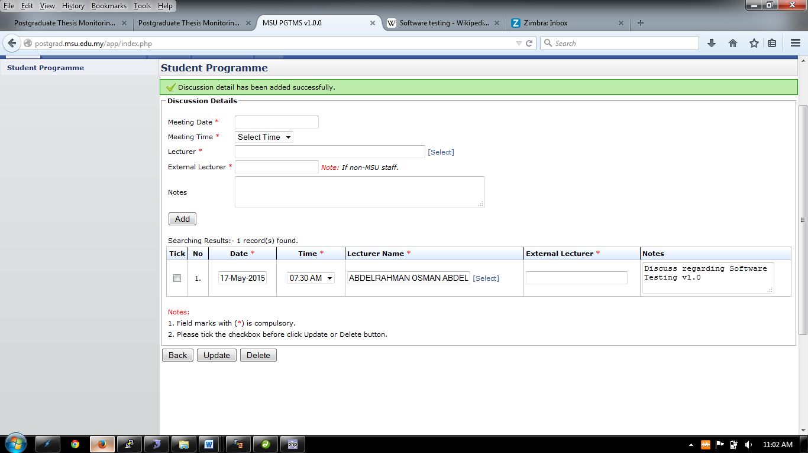

**23**

**21**

**22**

**20**



**24**

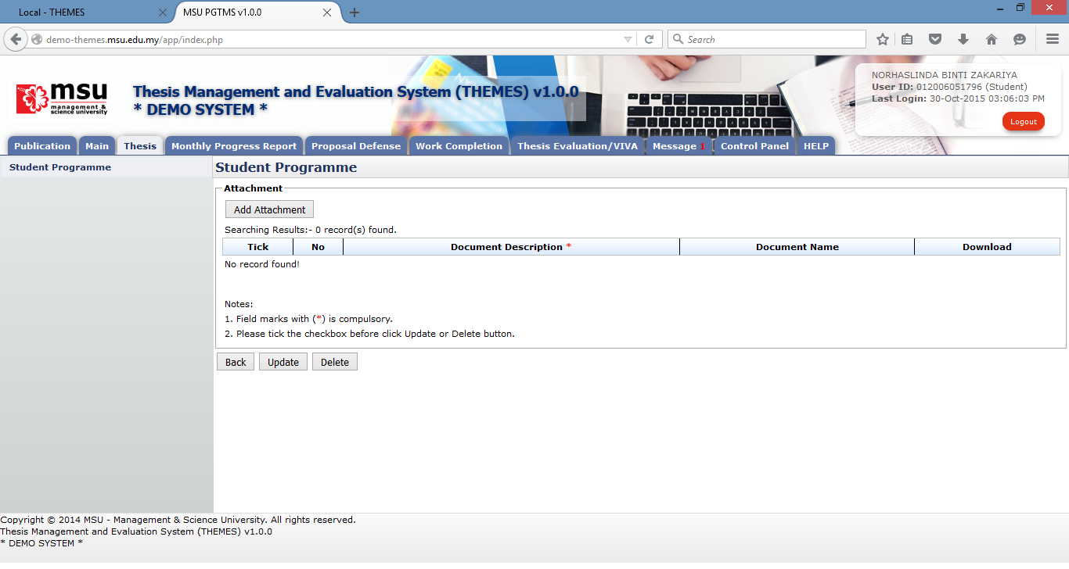

**25**

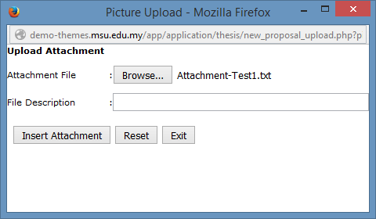

**28**

**27**

**26**

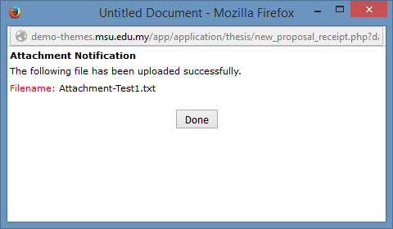

**29**

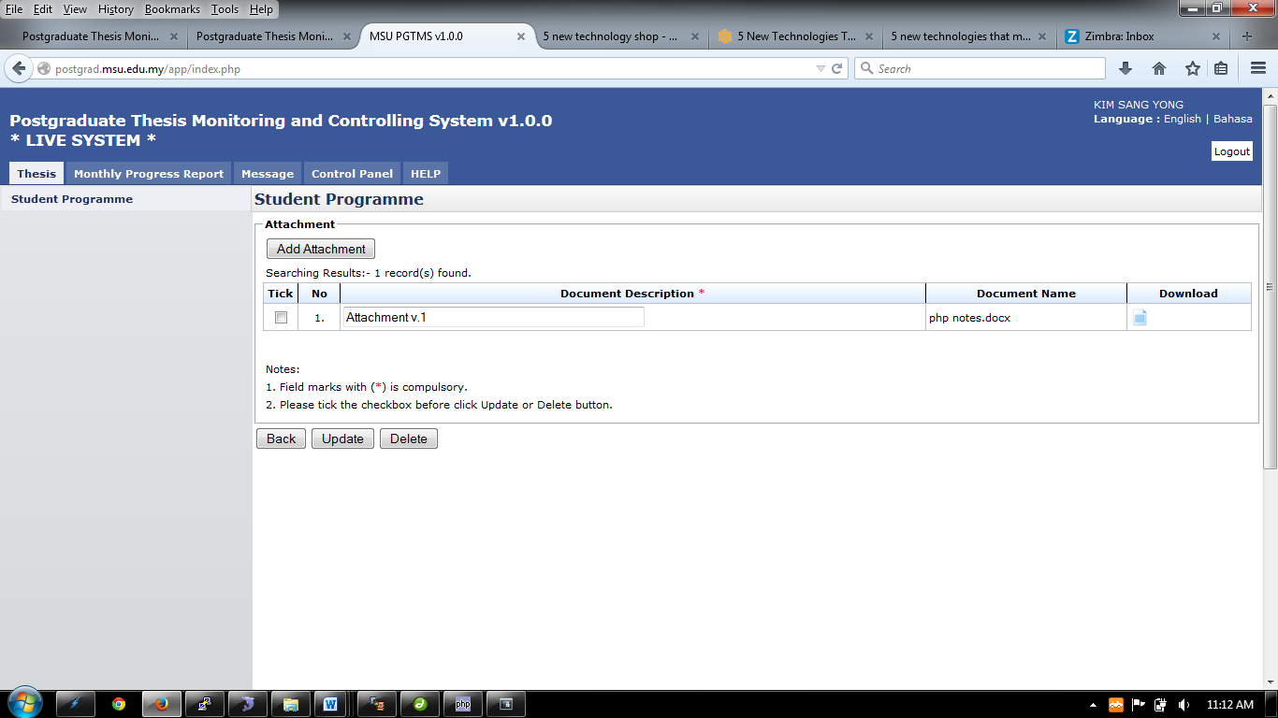

**31**

**32**

**30**

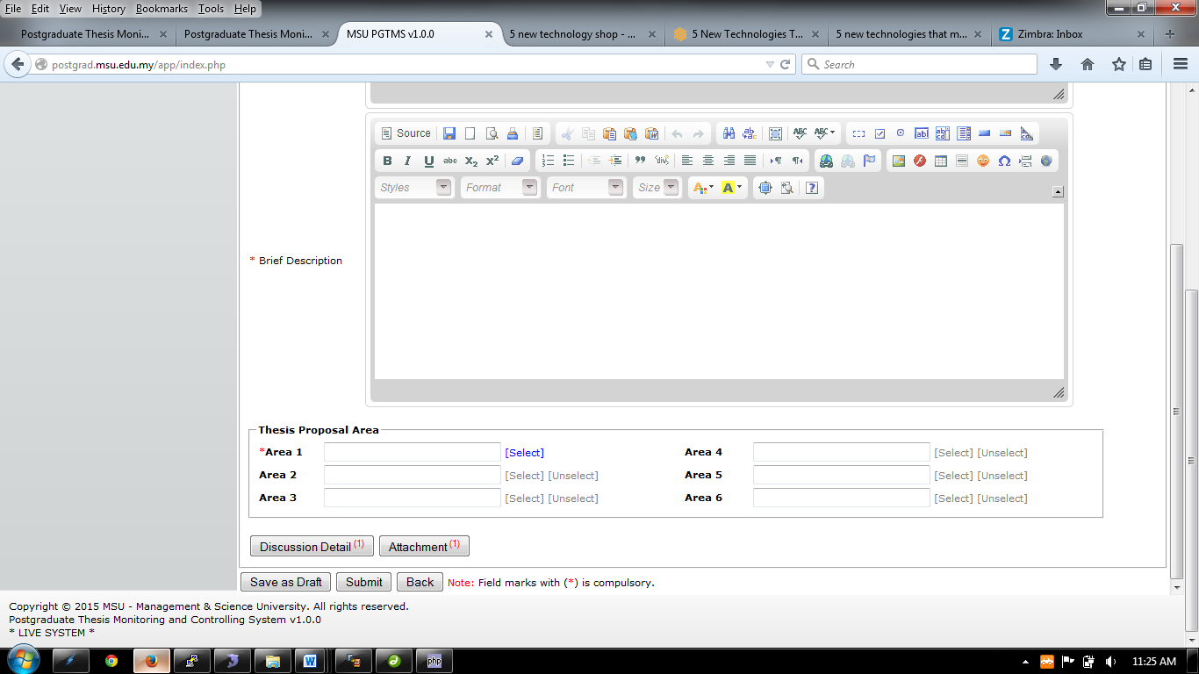

**33**



**35**

**36**

**34**

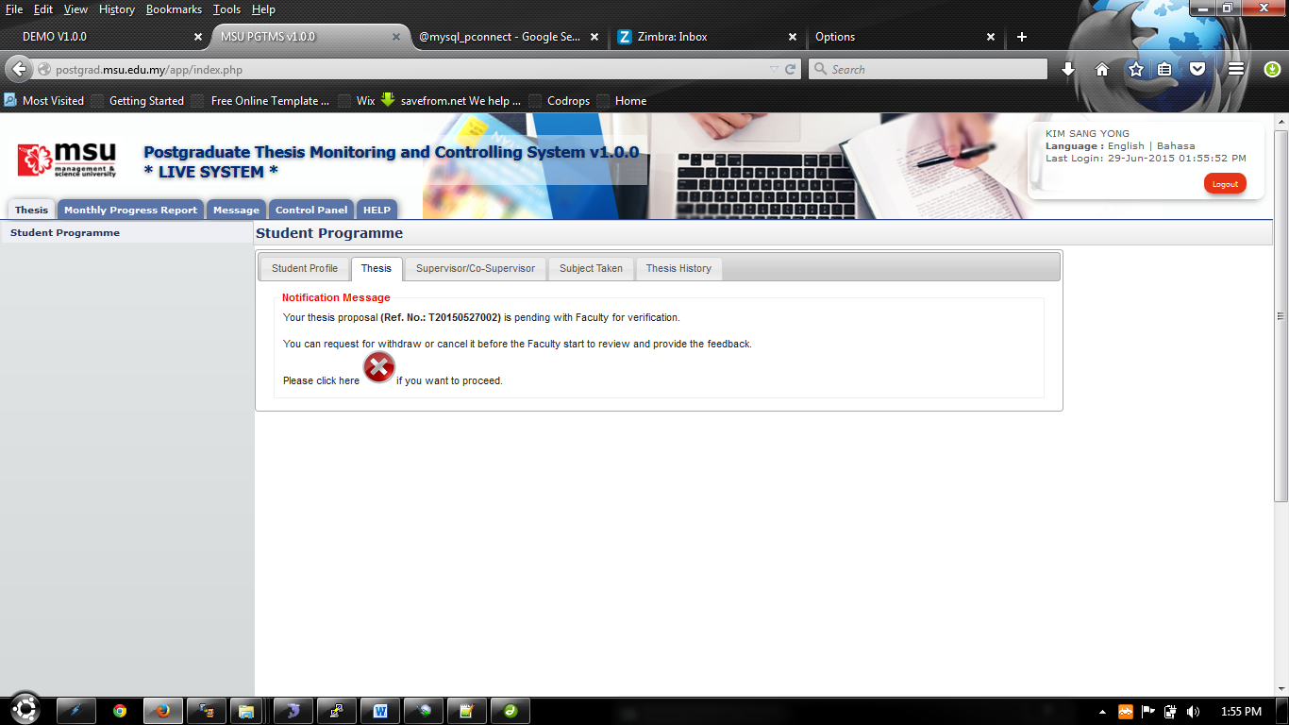

**37**

Figure 14: First Time Proposal Preparation

**Prerequisite**

The student has yet to submit the thesis proposal.

**Steps**

1. Click on the **Thesis Tab** on the Top Panel.
2. Click on the **Student Programme** menu on the **Left** panel.
3. Click on the **Thesis Tab** on the Student Programme page to create the thesis proposal.
4. Click on the **Click Here** button to open the proposal page.
5. Enter the Thesis / Project Title
6. Select Proposal Type
7. Enter the necessary description into the **Introduction**
8. Enter the necessary description into the **Objective**
9. Enter the necessary description into the **Brief Description**
10. Minimum 1 **Thesis Area** need to be selected to associate with the proposal. That will also enable the Faculty to assign the right and suitable Supervisor / Co-supervisor to consult with the student. Click Select link above to choose thesis proposal area.
11. On Proposal Area page, the user can list all the available area by clicking the Search button without specifying the searching criteria.
12. The user also can list the specific area by specifying the searching criteria like **Proposal Area Category** or **Sub Category ID / Description**.
13. The user also can select the specific proposal area from the list populate above.
14. The selected Thesis Proposal Area will be populated into the Thesis Proposal Area table as shown above.
15. The user can add the discussion detail which has been done with the lecturer. Click the **Discussion Detail** button.
16. Enter the discussion detail such as Meeting Date, Meeting Time, Lecturer or External Lecturer and Notes. All the field mark with asterisk (*) is compulsory.
17. To select the lecturer participated in the discussion, click **Select** link to open the **Search Staff** page.
18. On the **Search Staff** page, the user can list all the lecturer available without specifying the searching criteria like **Staff ID/Name**. Or the user can search the lecturer by specifying the search criteria.
19. Based on the search result list, click on the selected lecturer to pick his/her name so that it will be populated into the Discussion Detail list.
20. Once all the required information has been provided, then click **Add** button to add it into the discussion list.
21. To change or update the added record, user can change it on the particular record, tickthe checkbox and click **Update** Button.
22. To delete the added record, tick the checkbox, and click **Delete** button to delete it.
23. Click **Back** Button to go back to the previous page.
24. The user can add attachment to the proposal via the **Attachment** button. Click the button to open the Insert Attachment page.
25. Click **Add** Attachment button and popup window will be appeared as shown below.
26. Click **Browse** button to browse the file and select it. The selected filename will be displayed beside the **Browse** button. File Description is optional.
27. Click **Insert Attachment** button once done.
28. **Reset** button is to reset the entries of Attachment File and its File Description.
29. Click **Done** button to acknowledge the insertion of the attachment.
30. To Update Document Description, click on the field and change the description. Then tick the checkbox on the left side and click **Update** button to update it.
31. To delete attachment, tick the checkbox and click the **Delete** button to delete it.
32. Click **Back** Button to go back to the previous page
33. After the **Discussion Detail** and **Attachment** have been added, the number of added record will be shown on its button respectively.
34. The user can save the proposal temporarily via **Save as Draft** button in case there is a need to review and update it later.
35. If it is final, the user can submit it to the Faculty and Senate for thesis approval via **Submit** button. The email notification will be sent to the faculty
36. Click **Back** button if to return back to **Student Programme** page.
37. If the student needs to withdraw or cancel the newly submitted proposal, it can be done via cancel button as shown above. Please refer next section on how to cancel the proposal.

#### Disapproved

##### Process Flow

There are 2 scenarios in which the student’s thesis proposal gets disapproved.

1. **First Scenario**

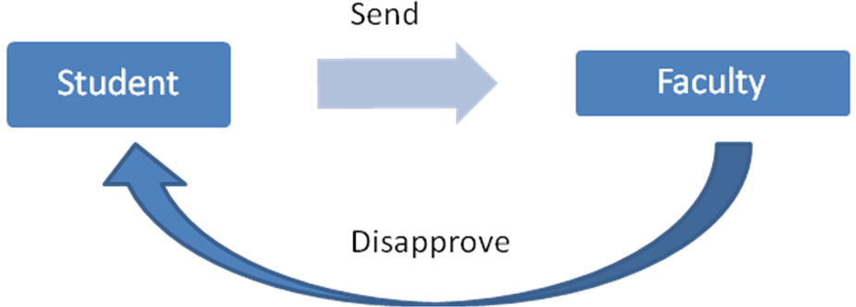

In first scenario, the student’s thesis proposal disapproved by the Faculty due to some reason.

1. **Second Scenario**

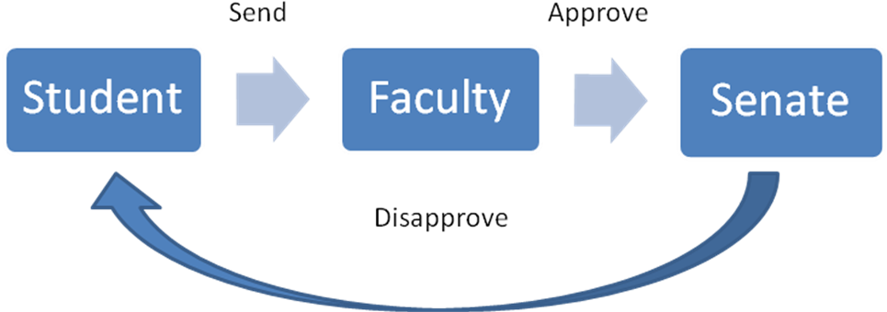

In second scenario, the student’s thesis proposal disapproved by the Senate due to some reason.

##### Disapproved

If there is a case where the thesis proposal does not meet the expectation of the Faculty or the content does not fit the title, the proposal may be rejected or disapproved by the Faculty.

For this scenario, the system will notify the student on the proposal status.

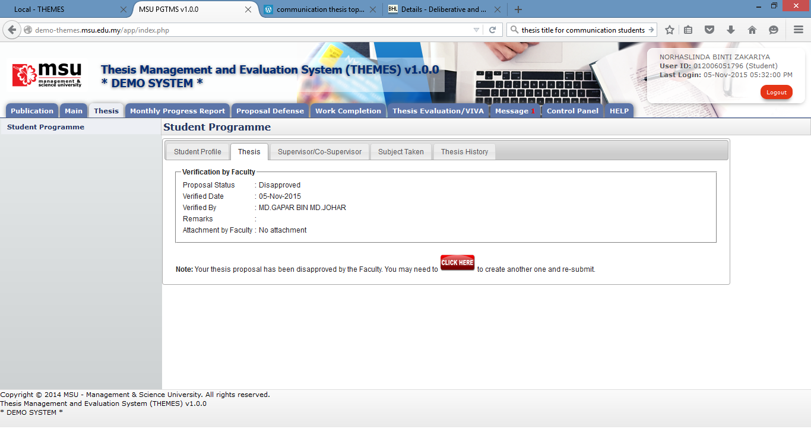

**5**

**4**

**3**

**1**

**2**

Figure 15: Proposal Disapproved by Faculty

**Prerequisite**

The student is yet to submit the thesis proposal to the Faculty.

**Steps**

1. After the proposal has been submitted to the Faculty, the Faculty will review it and determine its status. In case the proposal gets rejected due to some reason, the student can check it via **Thesis** tab. Click **Thesis** tab on **Top** panel
2. Click on the **Student Programme** on the **Left** panel
3. Click on the **Thesis** Tab on the **Working Area** section.
4. The system will show the proposal status and the student can read the **Remarks** and download the **Attachment** from Faculty (if any).
5. For this case, the student can amend the proposal according to the advice given by the Faculty. Click on the **Click Here** button to proceed and resubmit.

**Warning**

None.

**Note**

None.

#### Cancel Proposal

##### Process Flow

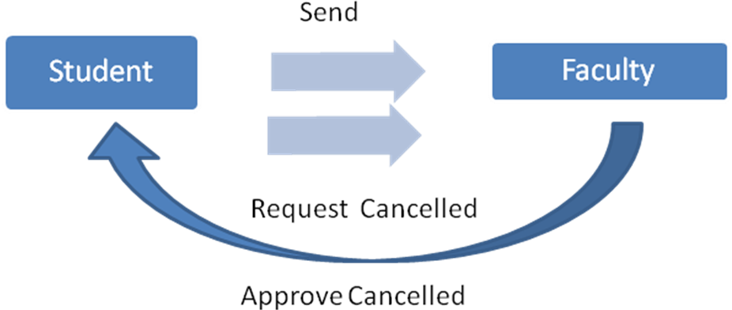

In this scenario, the student request for the cancellation from the Faculty after the thesis proposal has been submitted. Faculty will response through the system and notify student the cancellation.

##### Request for Proposal Cancellation

Student is allowed to cancel his/her newly submitted proposal in case he/she realizes some amendment need to be done.

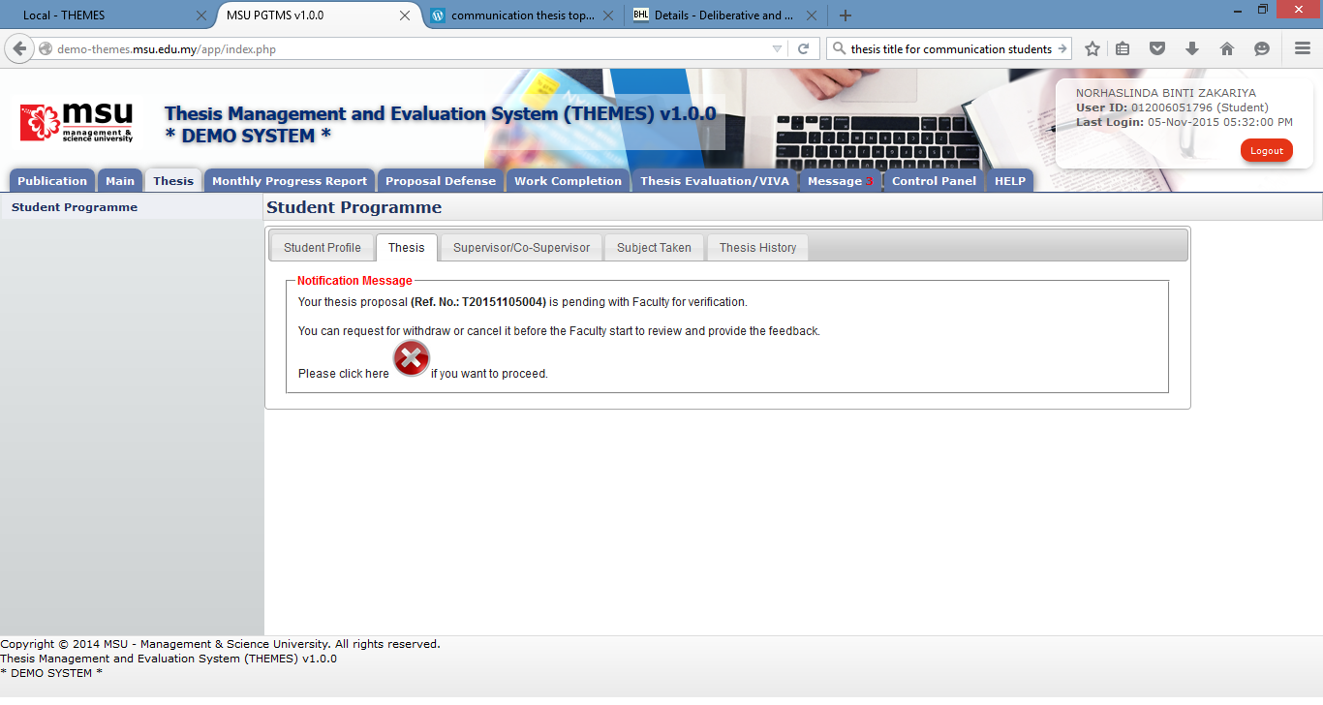

**4**

**3**

**2**

**1**

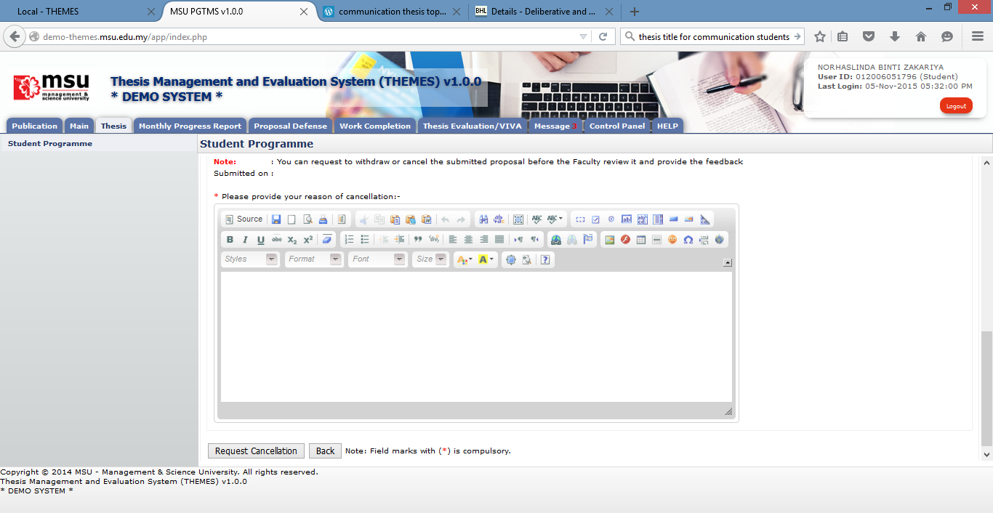

**7**

**6**

**5**

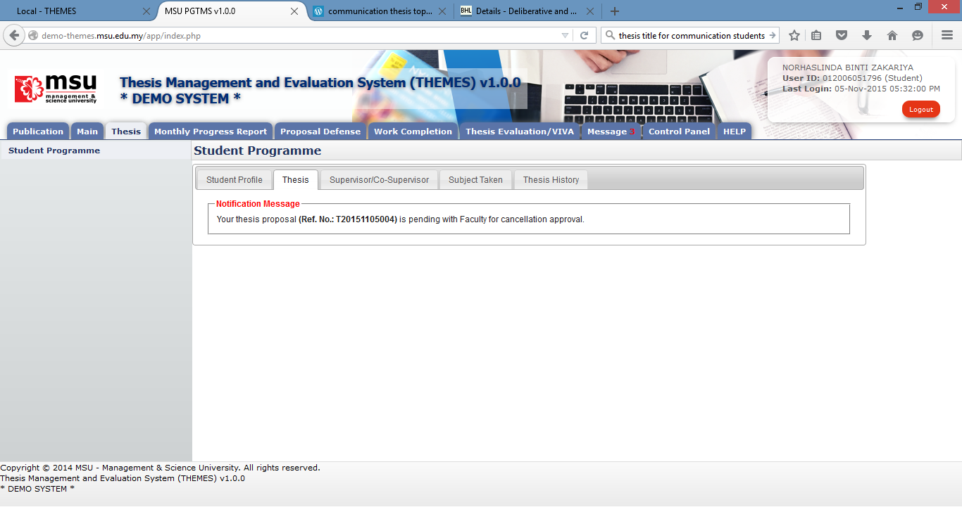

**8**

Figure 16: Proposal Cancellation

**Prerequisite**

1. The thesis proposal has been submitted
2. The Faculty is yet to review and provide feedback status to the thesis proposal

**Steps**

1. Click on the **Thesis** tab on the **Top** panel
2. Click on the **Student Programme** menu on the **Left** panel
3. Click on the **Thesis** tab on the **Working Area**
4. System will display the notification message to the student indicate that the proposal has been successfully submitted to the Faculty. If the student decided to cancel the proposal, he/she can click on the Cancel button. Please note the cancellation only can be done if the Faculty is not yet provide the feedback.
5. The student needs to provide the justification of the cancellation.
6. Once confirm click the **Request for Cancellation** button.
7. Otherwise the student can click **Back** button and wait feedback from the Faculty and Senate.
8. The above message will be displayed after the student submits the cancellation request to the Faculty.

**Next Action**

The student is to resubmit another new thesis proposal. The new Thesis ID will be assigned as to keep track a new thesis process flow.

**Warning**

None

**Note**

None

#### Approval by Faculty

##### Approval by Faculty

Once the Faculty approved the proposal cancellation request, the student can see the notification message from the system as shown below.

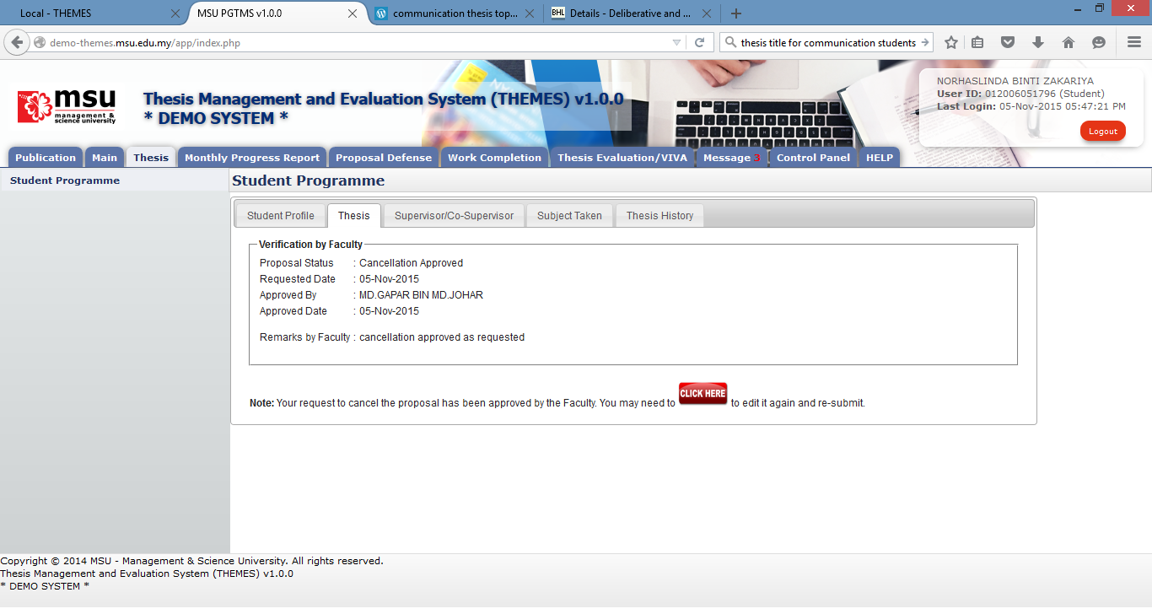

**5**

**4**

**3**

**1**

**2**

Figure 17: Request for Cancellation

**Prerequisite**

1. The Thesis Proposal request for cancellation has been sent to the Faculty
2. The Faculty has approved the cancellation request

**Steps**

1. Click on the **Thesis** tab on the **Top** panel
2. Click on the **Student Programme** menu on the **Left** panel
3. Click on the Thesis tab on the **Working Area**
4. System will display the notification message to the student indicate that the proposal cancellation request has been approved by the Faculty.
5. As such the student can open back the proposal via **Click Here** button and amend it accordingly. The student can resubmit the proposal once the changes has been incorporated and finalized.

**Next Action**

The student to resubmit another new thesis proposal

**Warning**

None

**Note**

None

#### Edit Proposal

##### Process Flow

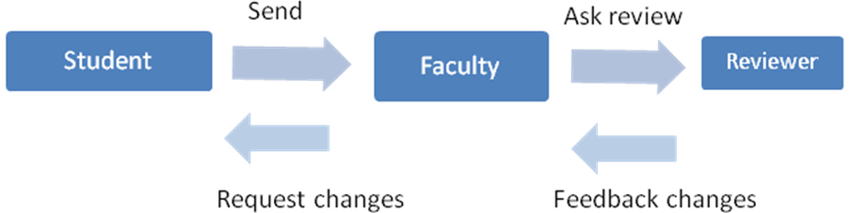

In this scenario, the Faculty has initiated the Request Changes after considering feedback from the Reviewer. The request would require the student to amend the thesis proposal.

##### Request Change

If there is a case where the thesis proposal needs some changes, the Faculty will return it back to the student to amend and resubmit it. For this scenario, the system will notify the student on the proposal status.

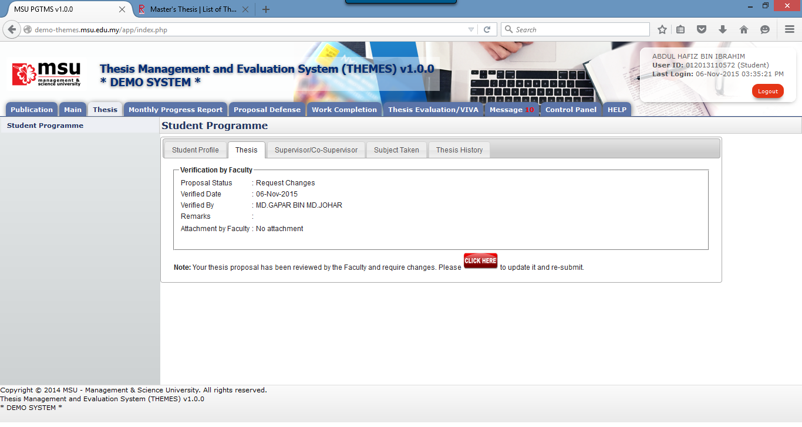

**5**

**4**

**3**

**1**

**2**

Figure 18: Request Changes – Edit Proposal

**Prerequisite**

Faculty has initiated the thesis proposal Change Request

**Steps**

1. Click on the **Thesis** tab on the **Top** panel
2. Click on the **Student Programme** menu on the **Left** panel
3. Click on the Thesis tab on the **Working Area**
4. The system will show the proposal status and the student can read the **Remarks** and download the **Attachment** from Faculty (if any).
5. For this case, the student can amend the proposal according to the advice given by the Faculty. Click on the **Click Here** button to change and resubmit it.

#### View Proposal

##### Approved

The student can view back the proposal once it has been approved by the Senate.

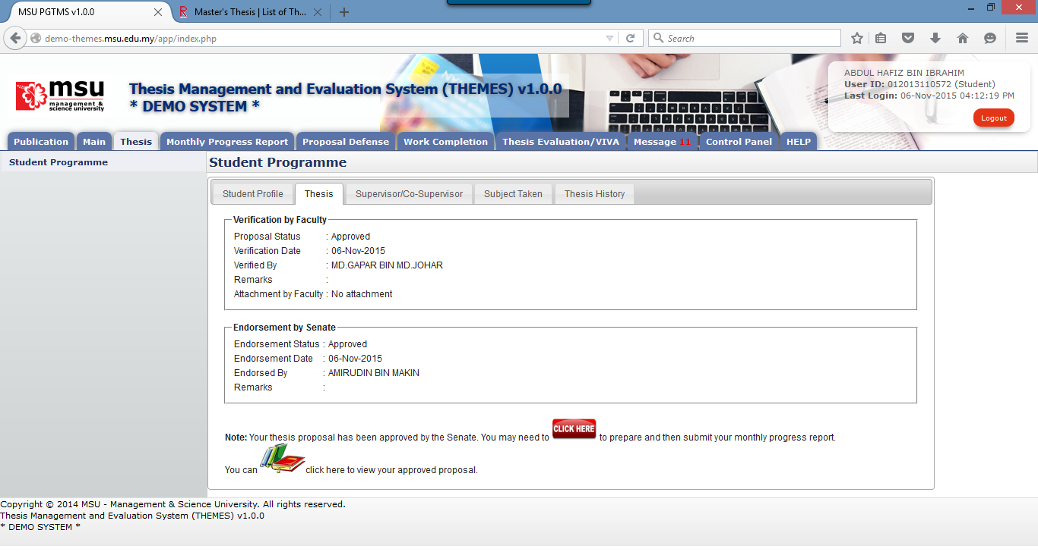

**6**

**5**

**4**

**3**

**1**

**2**

Figure 19: View Proposal – Approved by Senate

**Prerequisite**

Senate has approved the thesis proposal

**Steps**

1. Click on the **Thesis** tab on the **Top** panel
2. Click on the **Student Programme** menu on the **Left** panel
3. Click on the **Thesis** tab on the **Working Area**
4. System will display the notification message to the student indicate that the proposal has been approved by the Faculty and Senate.
5. The student can proceed with the monthly progress report preparation via **Click Here** button.
6. Or the student can view the approved proposal via the click here button. No amendment is allowed on this view.

##### Approved with Changes

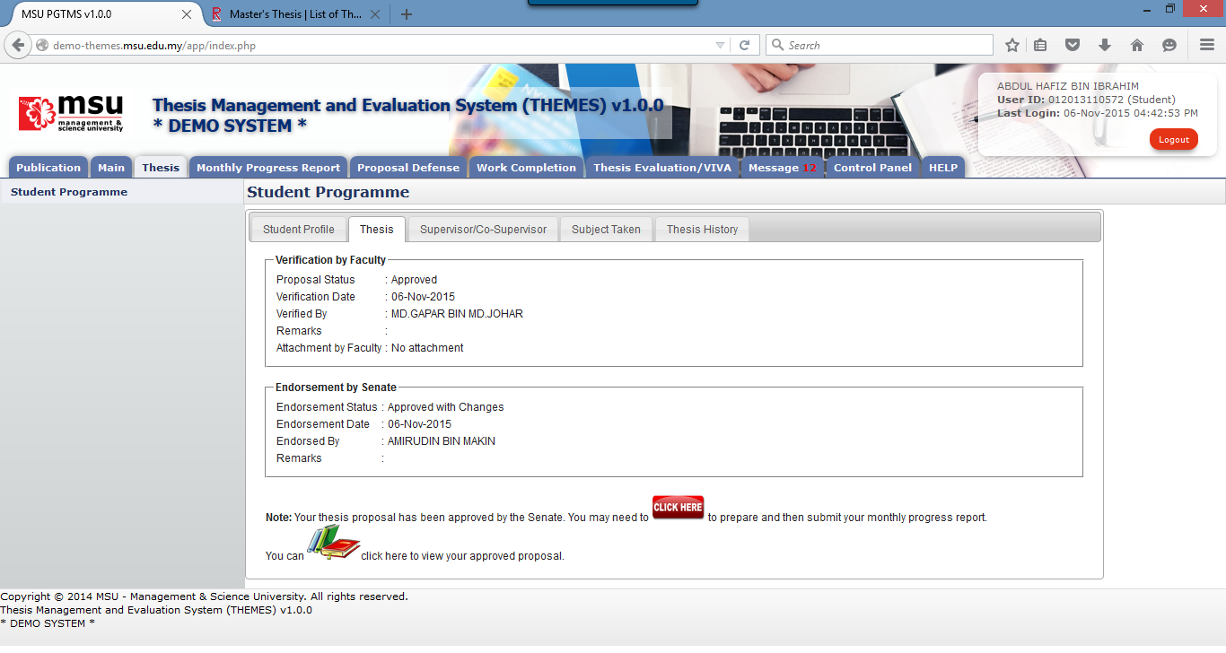

**2**

**1**

**3**

**4**

**5**

**6**

Figure 20: View Proposal – Approved with Changes by Senate

**Prerequisite**

Senate has approved (with changes) the thesis proposal

**Steps**

1. Click on the **Thesis** tab on the **Top** panel
2. Click on the **Student Programme** menu on the **Left** panel
3. Click on the **Thesis** tab on the **Working Area**
4. System will display the notification message to the student indicate that the proposal has been approved (with changes) by the Faculty and Senate.
5. The student can proceed with the monthly progress report preparation via **Click Here** button.
6. Or the student can view the approved proposal via the click here button. No amendment is allowed on this view.

### Supervisor/Co-Supervisor List

Supervisor or Co-Supervisor is the academic staff who has been assigned by Faculty to supervise the student in delivering their thesis from start to the end.

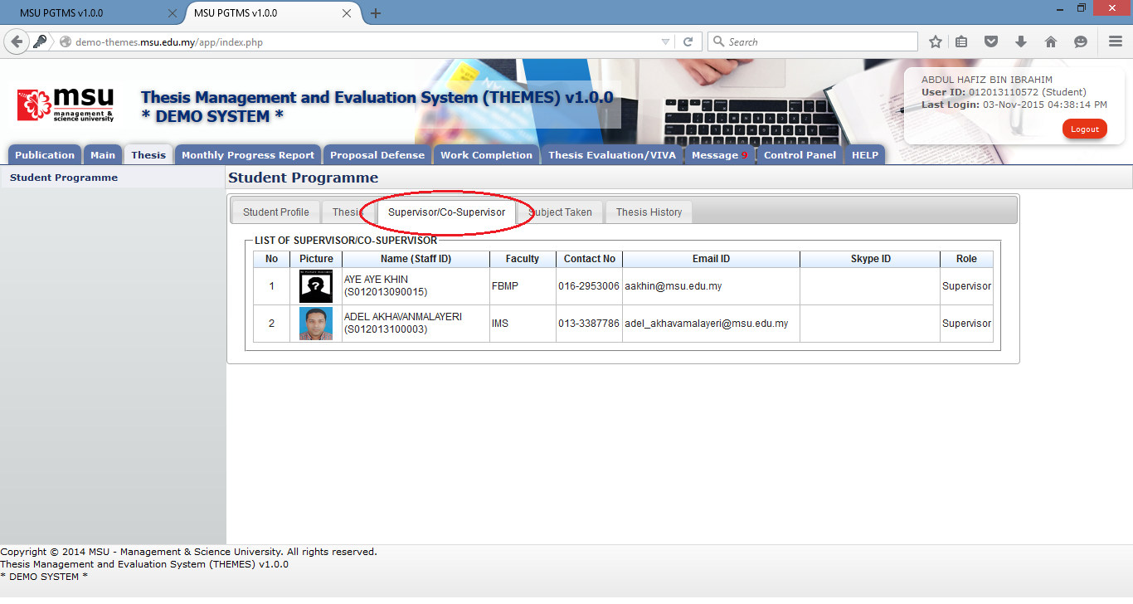

**2**

**1**

**2**

Figure 21: List of Supervisor / Co-Supervisor

**Prerequisite**

There are conditions for the student to see the list of his/her supervisors. The conditions are:-

1. Supervisor/Co-Supervisor has been assigned by Faculty and approved by the Senate
2. Supervisor/Co-Supervisor has accepted the appointment to supervise the student

**Steps**

1. Click on the **Thesis** tab on the **Top** panel
2. Click on the **Student Programme** menu on the **Left** panel
3. Click on the **Supervisor/Co-Supervisor** tab on the **Working Area.** System will display the list of the supervisor/co-supervisor which has been assigned and approved by Senate.

**Warning**

None

**Note**

None

### Subject Taken

Subject Taken tab will list the entire subject registered by the students for all semester during his study.

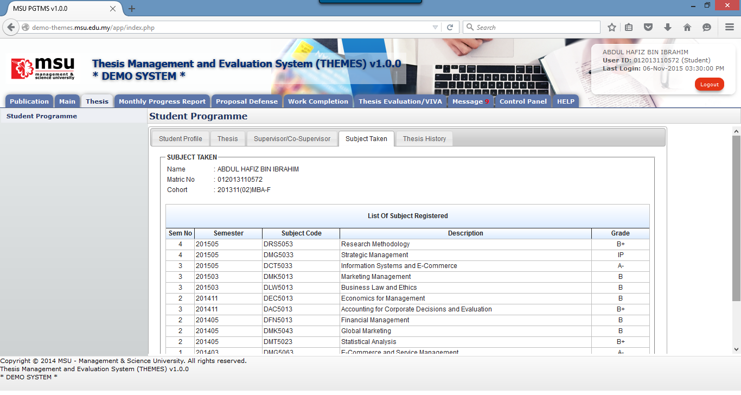

**3**

**1**

**2**

Figure 22: Subject Taken

**Prerequisite**

The student must have the subjects registered in KLAS2.

**Steps**

1. Click on the **Thesis** tab on the **Top** panel
2. Click on the **Student Programme** menu on the **Left** panel
3. Click on the **Subject Taken** tab on the **Working Area.** System will display the list of the subject taken by the student from his/her first semester till current. The list is retrieved from KLAS2 system.

**Warning**

None

**Note**

None

### Thesis History

Thesis History tab contains the proposal progress history starting from its submission by the student tills its approval by the Senate.

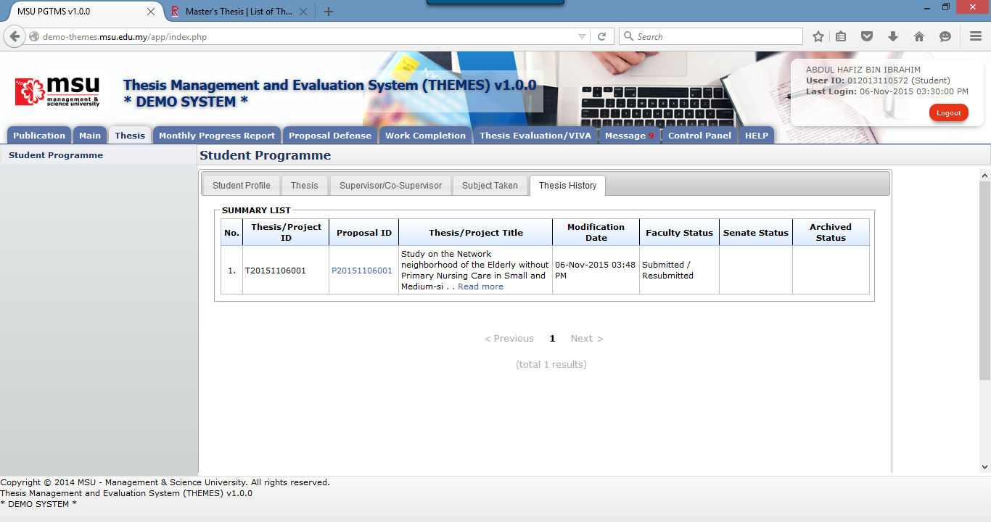

**2**

**3**

**1**

Figure 23: Student Programme – Thesis History

**Prerequisite**

At least the Student has submitted the thesis proposal to the Faculty.

**Steps**

1. Click on the **Thesis** tab on the **Top** panel
2. Click on the **Student Programme** menu on the **Left** panel
3. Click on the **Thesis History** tab on the **Working Area**
4. System will display the list of the thesis history starting from its submission till its approval.

**Warning**

None

**Note**

None

# Monthly Progress Report

## Thesis Chapter

### Add Thesis Chapter

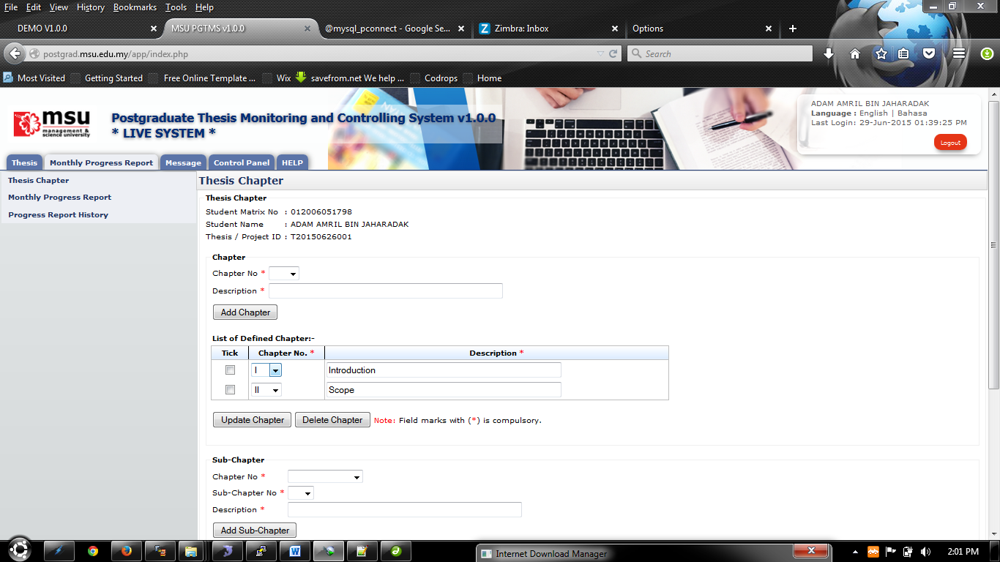

**1**

**2**

**3**

Figure 24: Thesis Chapter

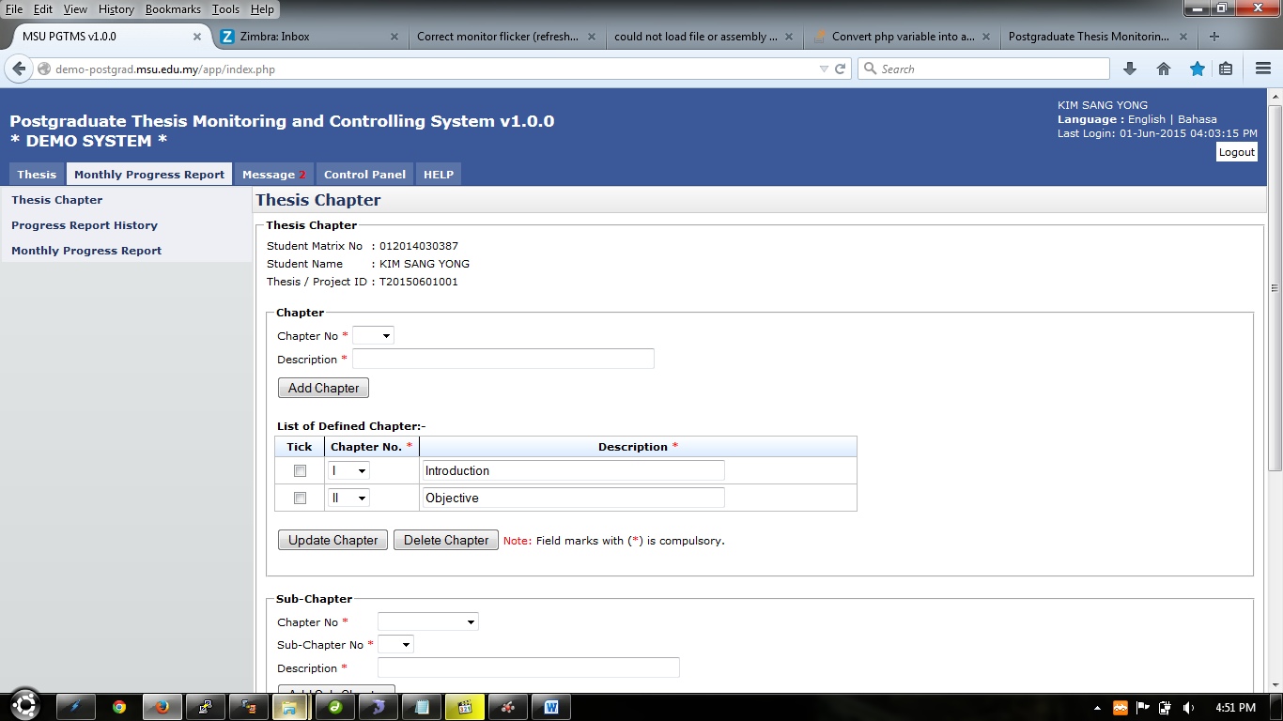

**6**

**5**

**4**

Figure 25: Add Chapter

**Prerequisite**

1. Senate has approved the thesis proposal
2. Supervisor / Co-Supervisor has accepted the invitation

**Steps**

1. Click on the **Monthly Progress Report** tab on the **Top** panel
2. Click on the **Thesis Chapter** menu on the **Left** panel
3. System will display the thesis chapter page on the Working Area panel.
4. To add thesis chapter, select chapter number from the **Chapter No** dropdown field.
5. Then enter the description of the chapter into the **Description** field.
6. Click **Add Chapter** button to save the chapter.

**Next Action**

The student can proceed with the creation of thesis sub-chapter or submission of the monthly progress report to the Supervisor.

**Warning**

System will prompt a notification message if the addition of the thesis chapter without selecting the chapter number and providing its description.

**Note**

None

### Update Thesis Chapter

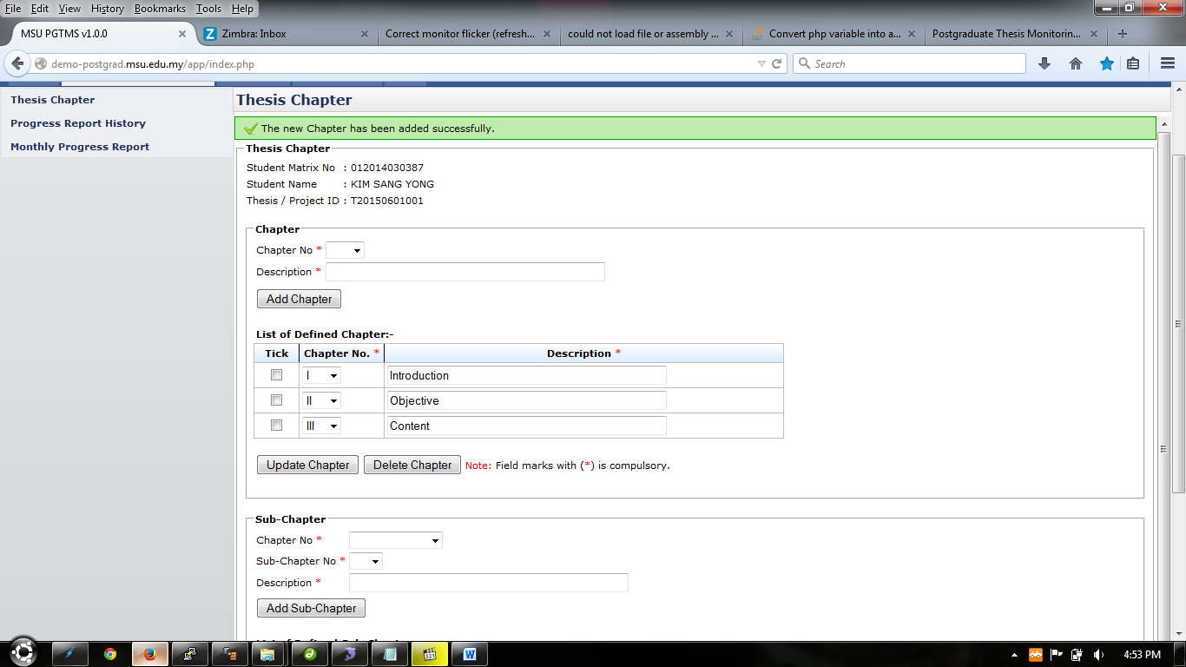

**4**

**3**

**2**

**1**

Figure 26: Update Chapter

**Prerequisite**

The thesis chapter has been created

**Steps**

1. To update chapter, select new chapter number from the **Chapter No** dropdown field. The selection can be done in c.
2. To update the description of the chapter, change it at the **Description** field. The changes can be done in multiple rows.
3. Tick the checkbox of the chapter. It can be done in multiple rows.
4. Then click **Update Chapter** button to save the changes.

**Next Action**

The student can proceed with the submission of the monthly progress report to the Supervisor.

**Warning**

System will prompt a notification message if the update of the thesis chapter without ticking/selecting the chapter and empty chapter description.

**Note**

None

### Delete Thesis Chapter



**1**

**2**

Figure 27: Delete Chapter

**Prerequisite**

The thesis chapter has been created

**Steps**

1. To delete chapter, tick the checkbox. It can be done in multiple rows.
2. Then click **Delete Chapter** button to delete the selected chapter

**Next Action**

The student can add other thesis chapter or proceed with the submission of the monthly progress report to the Supervisor.

**Warning**

System will prompt a notification message if the deletion of the thesis chapter without ticking/selecting the chapter.

**Note**

None

### Add Thesis Sub-chapter

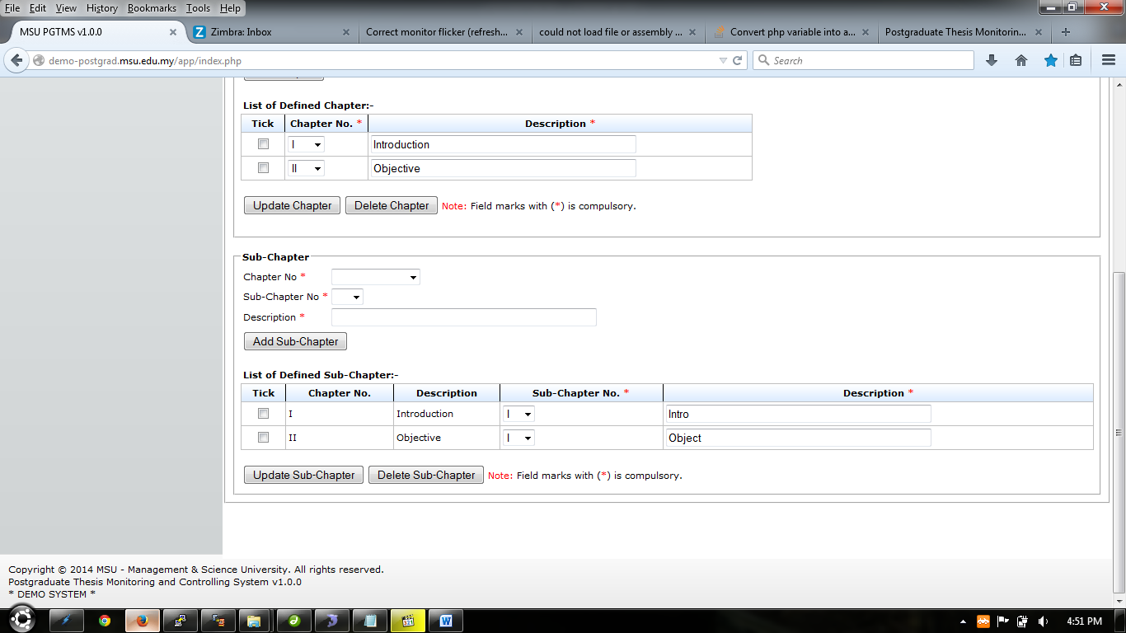

**4**

**3**

**1**

**2**

Figure 28: Add Sub-Chapter

**Prerequisite**

The thesis chapter has been created

**Steps**

1. To add sub-chapter, select chapter number from the **Chapter No**. dropdown field.
2. Select sub-chapter number from the **Sub-Chapter No**. field.
3. Then enter the description of the sub-chapter into the **Description** field.
4. Click **Add Sub Chapter** button to save the sub-chapter.

**Next Action**

The student can proceed with the submission of the monthly progress report to the Supervisor.

**Warning**

System will prompt a notification message if the addition of the thesis sub-chapter without selecting the chapter number, providing the sub-chapter number and its description.

**Note**

None

### Update Sub-Chapter

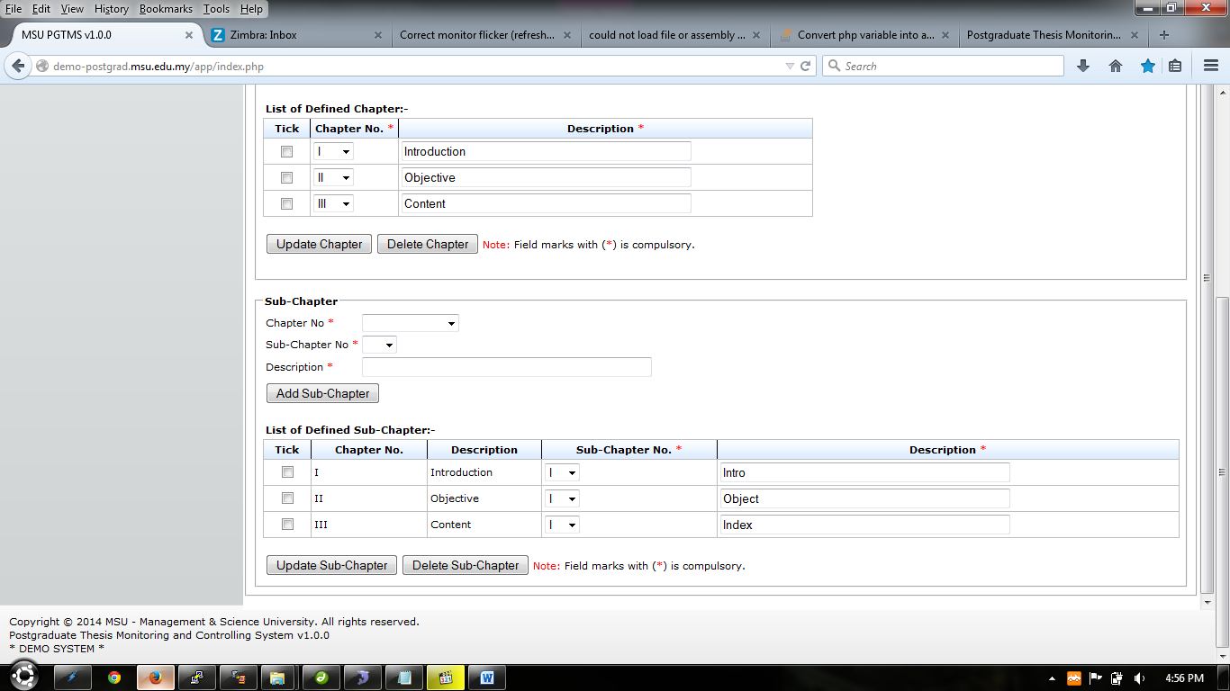

**4**

**3**

**2**

**1**

Figure 29: Update Chapter

**Prerequisite**

The thesis sub-chapter has been created

**Steps**

1. To update chapter, select new chapter number from the **Sub**-**Chapter No** dropdown field. The selection can be done in multiple rows.
2. To update the description of the sub-chapter, change it at the **Description** field. The changes can be done in multiple rows.
3. Tick the checkbox of the sub-chapter. It can be done in multiple rows.
4. Then click **Update Sub-Chapter** button to save the changes.

**Next Action**

The student can proceed with the submission of the monthly progress report to the Supervisor.

**Warning**

System will prompt a notification message if the update of the thesis sub-chapter without ticking/selecting the sub-chapter and empty chapter description.

**Note**

None

## Monthly Progress Report

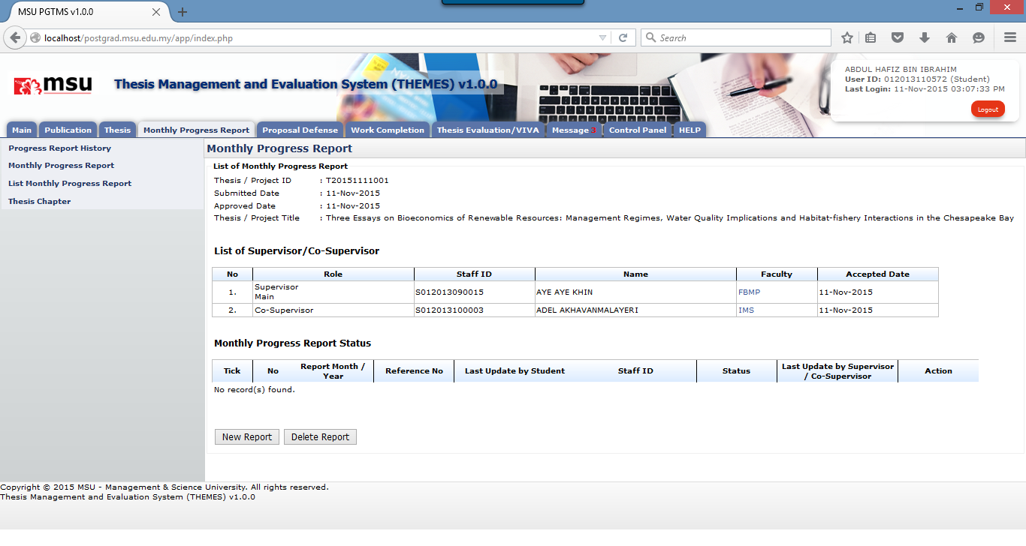

**3**

**1**

**2**

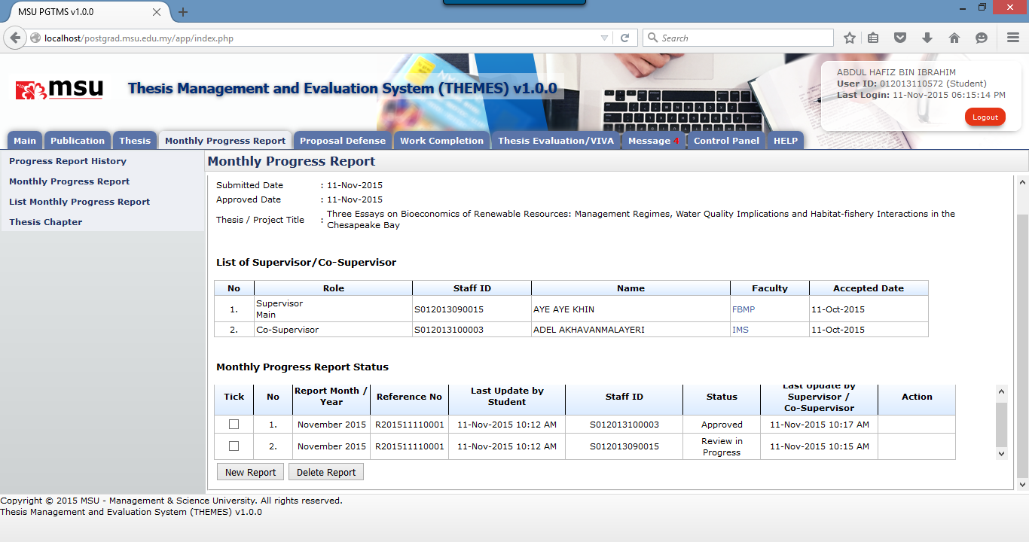

**4**

Figure 30: Monthly Progress Report

**Prerequisite**

1. Thesis proposal has been approved by the Senate
2. The Supervisor / Co-Supervisor has accepted the invitation

**Steps**

1. Click on the **Monthly Progress Report** tab on the **Top** panel
2. Click on the **Monthly Progress Report** menu on the **Left** panel
3. System will display page to create monthly progress report on the Working Area panel. Click **New Report** button to create new report.
4. If the submitted report has been reviewed by the Supervisor / Co-Supervisor, you can check the status either **Review in Progress**, **Request Change** or **Approved**.

### New Monthly Progress Report

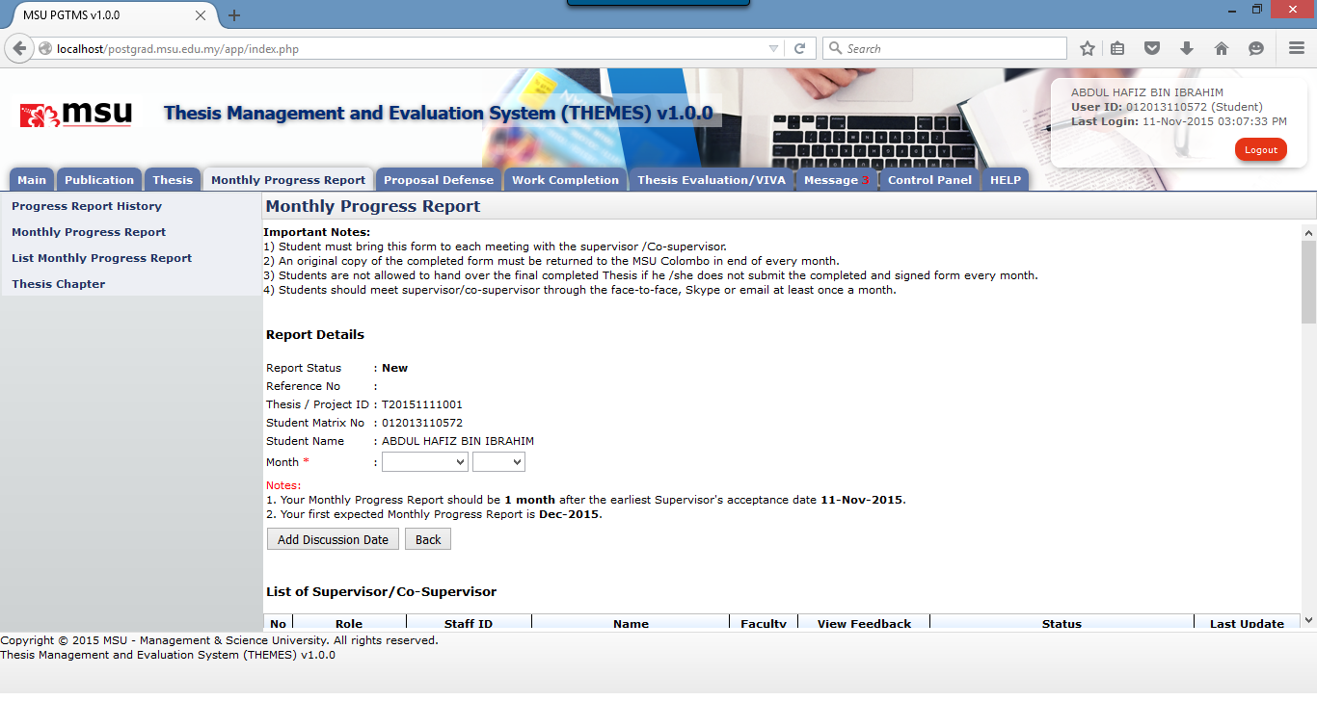

**1**

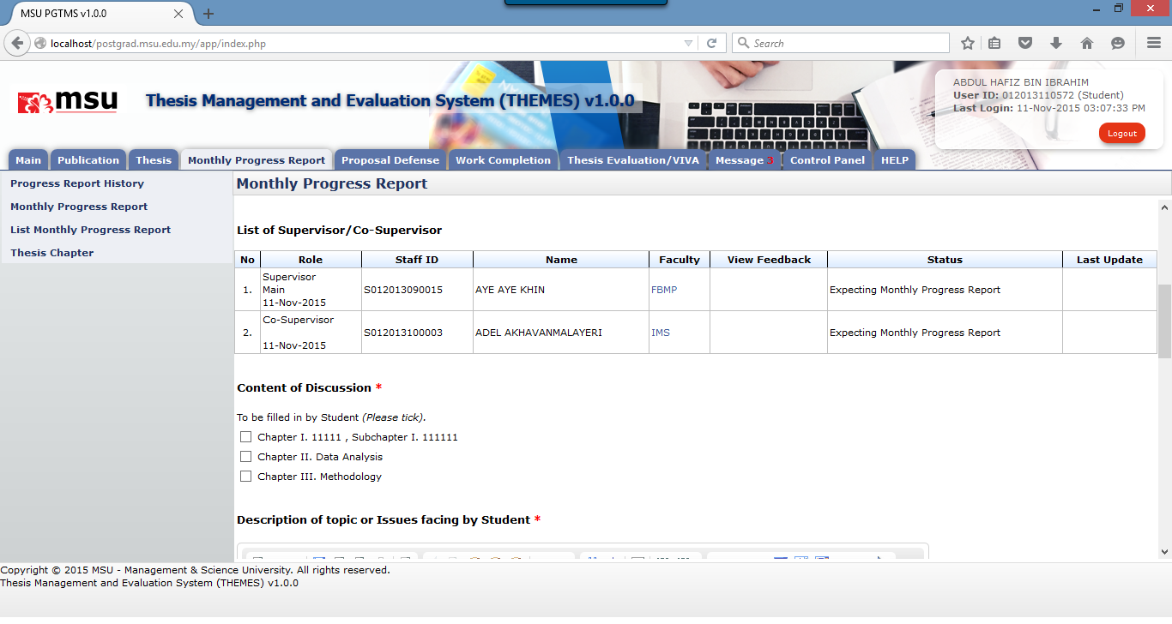

**2**

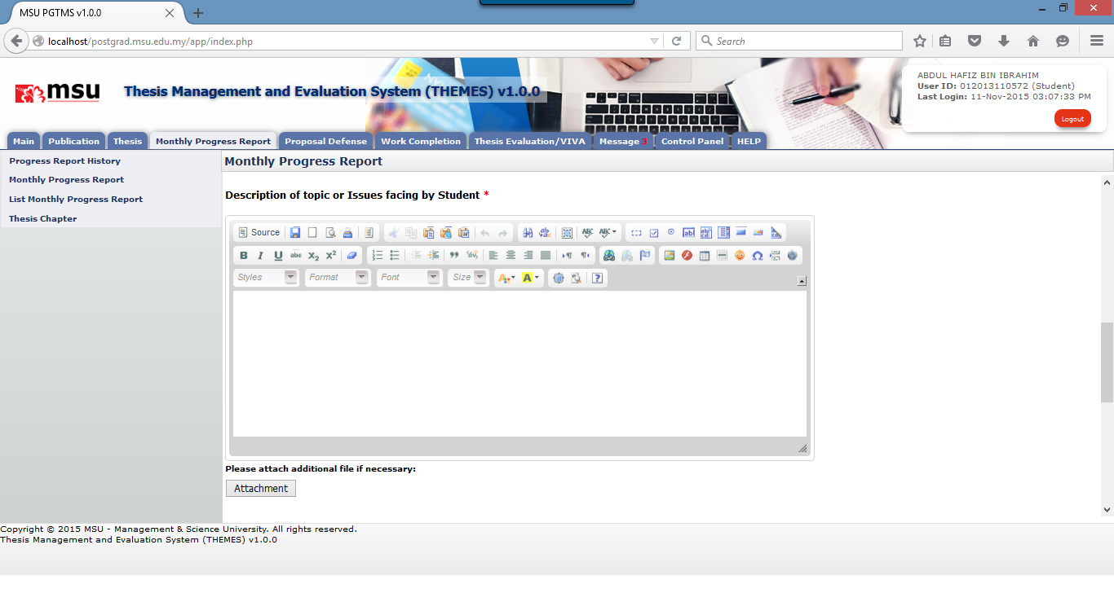

**4**

**3**

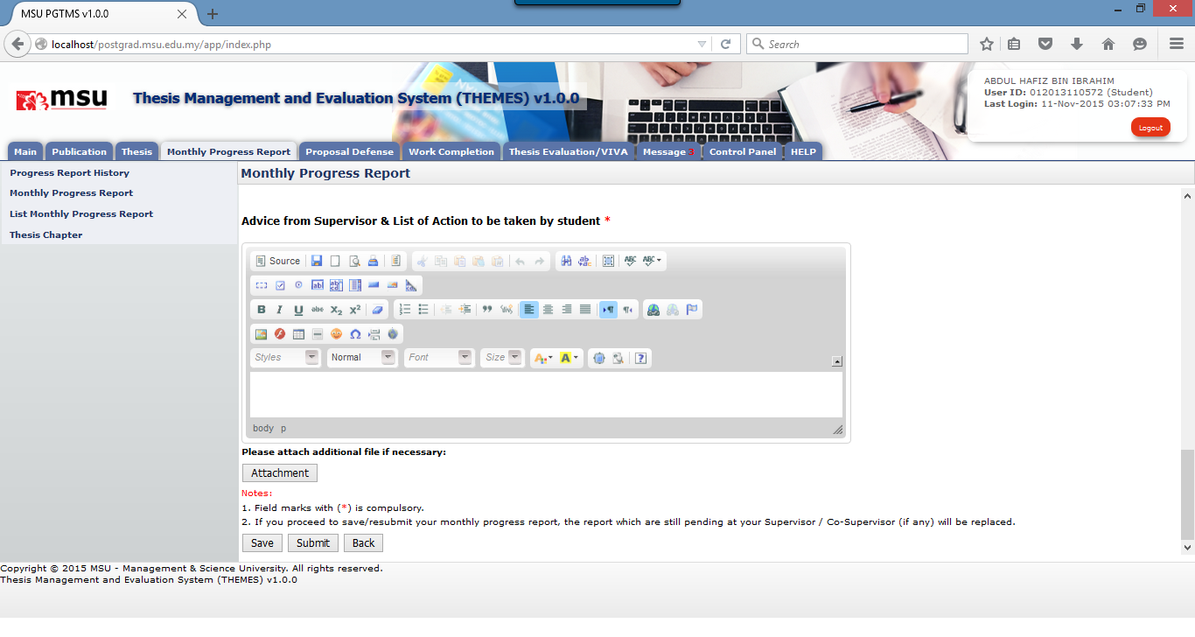

**7**

**6**

**5**

Figure 31: New Monthly Progress Report

**Steps**

1. Select the **Month** and **Date** of the progress report.
2. Tick the **Content of Discussion**. It can be done in multiple rows.
3. Enter the **Description of Topic or Issue Facing by Student**.
4. Add the attachment if any.
5. Enter the **Advice from Supervisor & List of Action to be taken by student**
6. Add the attachment if any.
7. Click **Save** button if you need to do some more changes. Otherwise click **Submit** button.

#### Add Discussion Detail



**1**

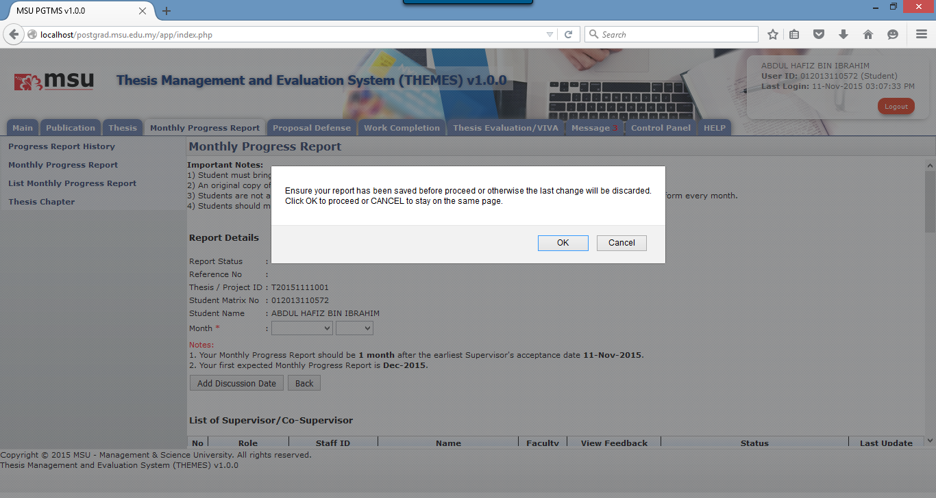

**2**

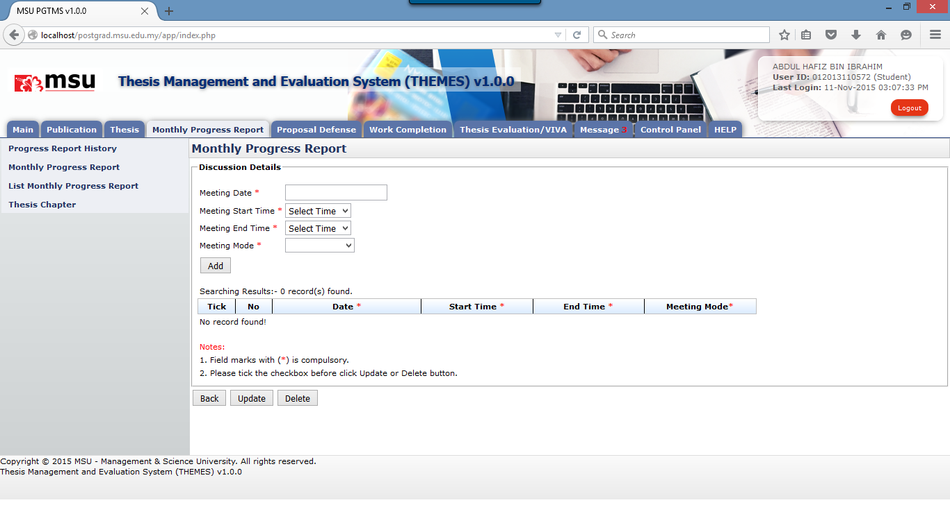

**3**

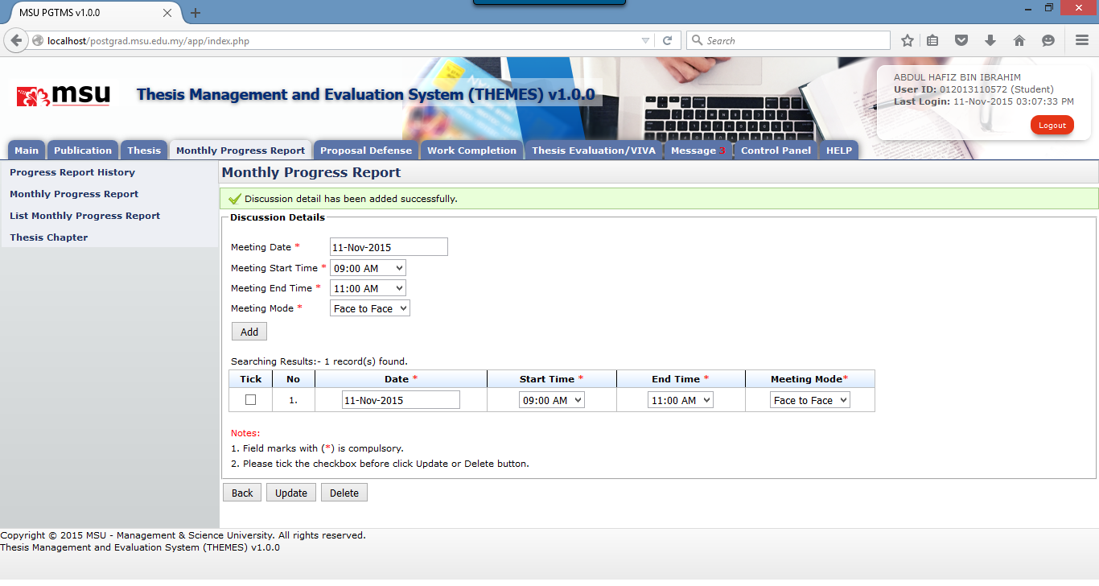

**5**

**6**

**4**



**9**

**8**

**7**

Figure 32: Add Discussion Date

**Steps**

1. Click on **Add Discussion Date** button to add the detail of the discussion
2. You will be prompt to save the report first before proceed or otherwise the last change will be discarded. Click **OK** button to proceed.
3. Enter the required information i.e. Meeting Date, Meeting Start Time, Meeting End Time and Meeting Mode. Click **Add** button once done.
4. To edit discussion detail, choose **Date, Start Time, End Time** or **Meeting Mode.** It can be done in multiple rows.
5. Tick on the checkbox. It can be done in multiple rows.
6. Click **Update** button to update the changes.
7. To delete discussion date, tick on the checkbox of the discussion date.
8. Then click **Delete** button to proceed
9. To go back to the previous page, click **Back** button

#### Add Attachment

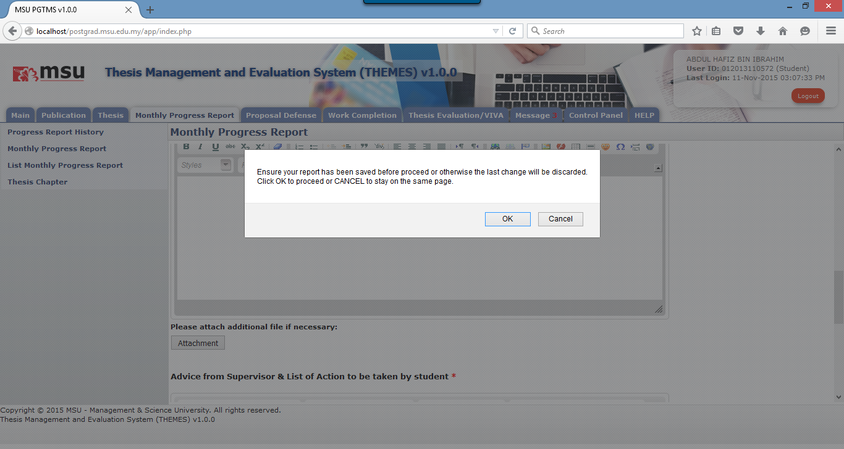

**10**

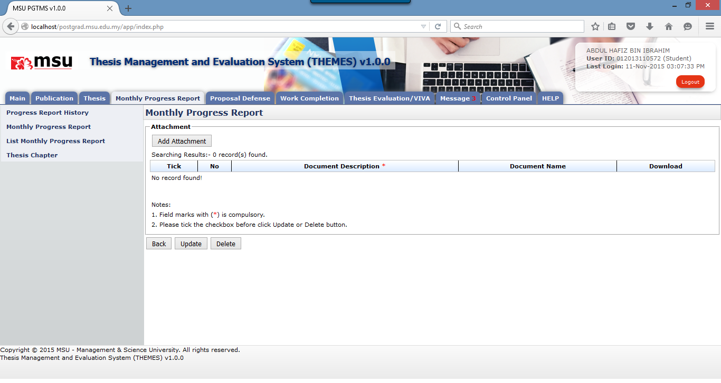

**20**

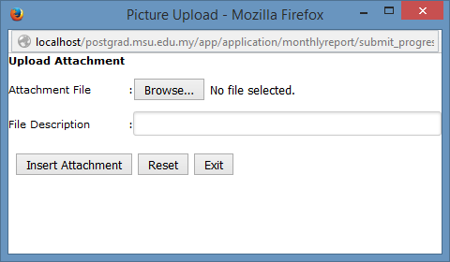

**50**

**40**

**30**

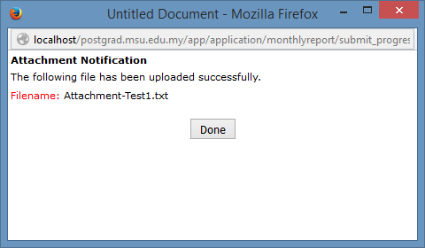

**60**

**Steps**

1. You will be prompt to save the report first before proceed or otherwise the last change will be discarded. Click **OK** button to proceed.
2. Click on **Add Attachment** button to add the attachment.
3. Click **Browse** button to browse and select the attachment.
4. Enter the description of the attachment
5. Click on the **Insert Attachment** button to add the attachment into the list.
6. Click **Done** button to close the page.

**Next Action**

You can proceed to update or delete the attachment.

**Warning**

No action will be performed if no attachment has been selected.

#### Update Attachment

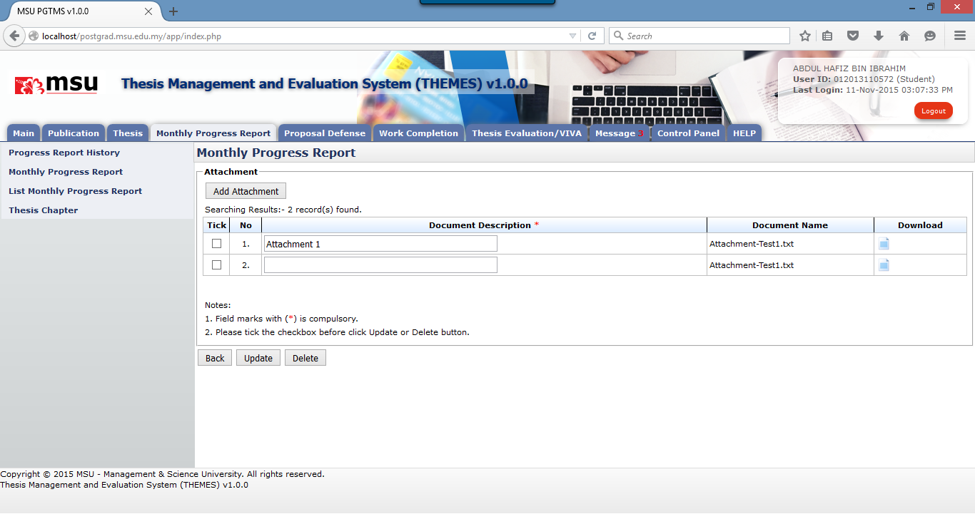

**30**

**20**

**10**

**Prerequisite**

The attachment has been added successfully.

**Steps**

1. Update the **Document Description**.
2. **Tick** the checkbox where the attachment needs to be updated. It can be done in multiple rows.
3. Click on the **Update** button to save the changes.

**Next Action**

You can proceed to submit the monthly progress report.

**Warning**

System will prompt a notification message if no checkbox has been selected to update.

#### Delete Attachment



**20**

**10**

**Prerequisite**

The attachment has been added successfully.

**Steps**

1. **Tick** the checkbox where the attachment needs to be deleted. It can be done in multiple rows.
2. Click on the **Delete** button to delete the attachment from the list.

**Next Action**

You can proceed to submit the monthly progress report.

**Warning**

System will prompt a notification message if no checkbox has been selected to delete.

**Note**

None

#### Delete Discussion Detail

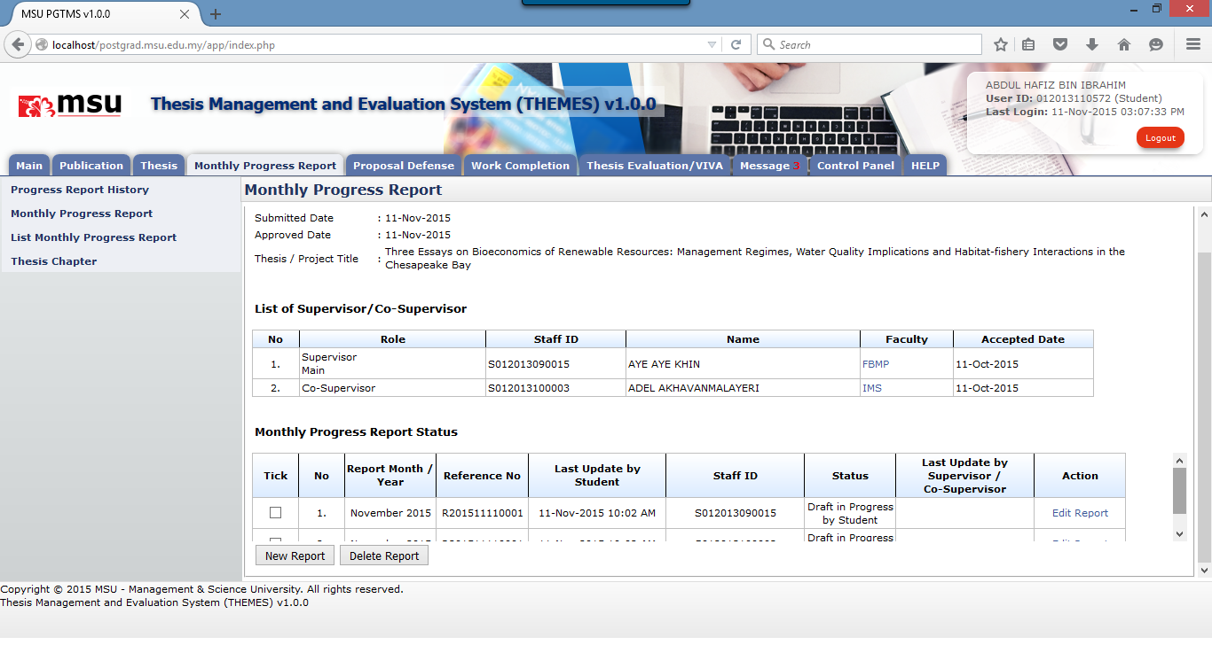

**20**

**10**

**Steps**

1. **Tick** the checkbox where the monthly progress report need to be deleted. It can be done in multiple rows.
2. Click on the **Delete** button to delete the attachment from the list.

**Next Action**

You can proceed to add another monthly progress report.

**Warning**

System will prompt a notification message if the monthly progress report being deleted is already submitted.

**Note**

None

### Edit Monthly Progress Report – Draft in Progress



**10**

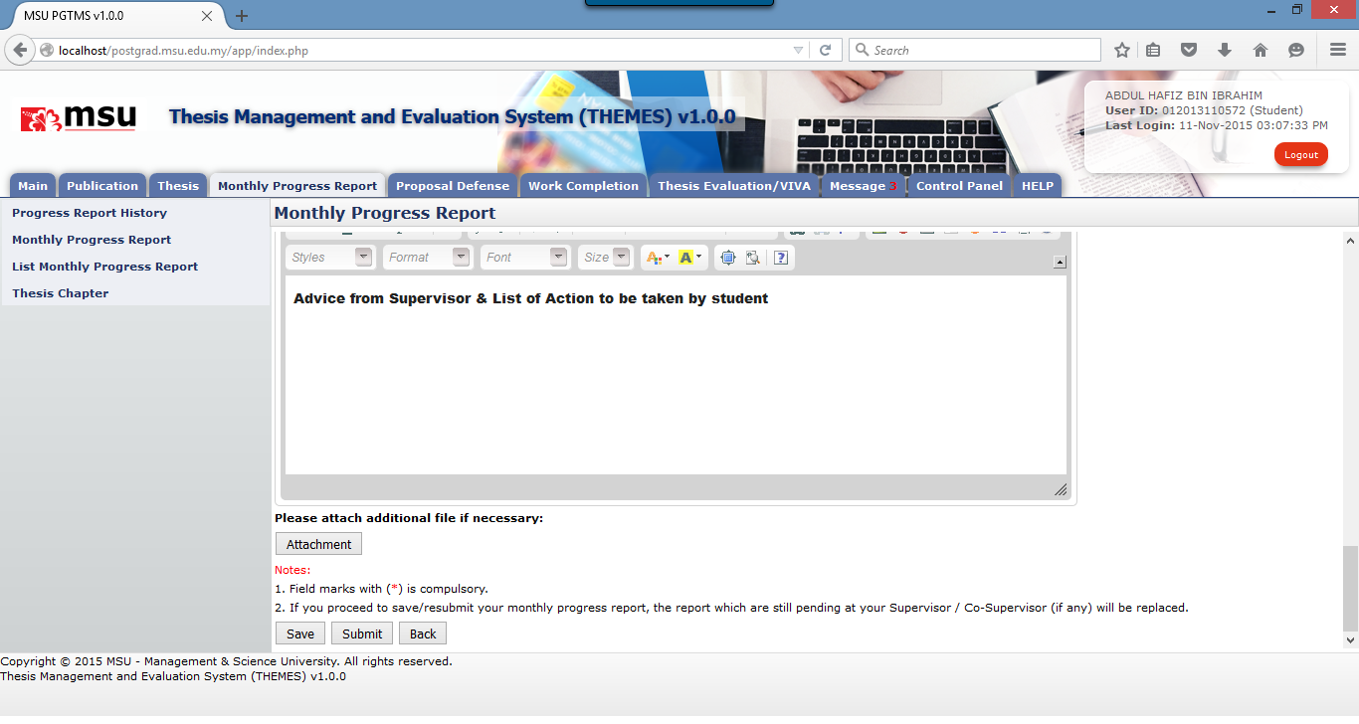

**20**

**Steps**

1. Click on the **Edit Report** link to edit the saved monthly progress report
2. Edit the report. Once done click on **Save** button if need some more changes. Otherwise click on **Submit** button to submit the report to the Supervisor.

**Next Action**

You can proceed to add another monthly progress report.

**Warning**

None

**Note**

None

### Edit Monthly Progress Report – Request Changes

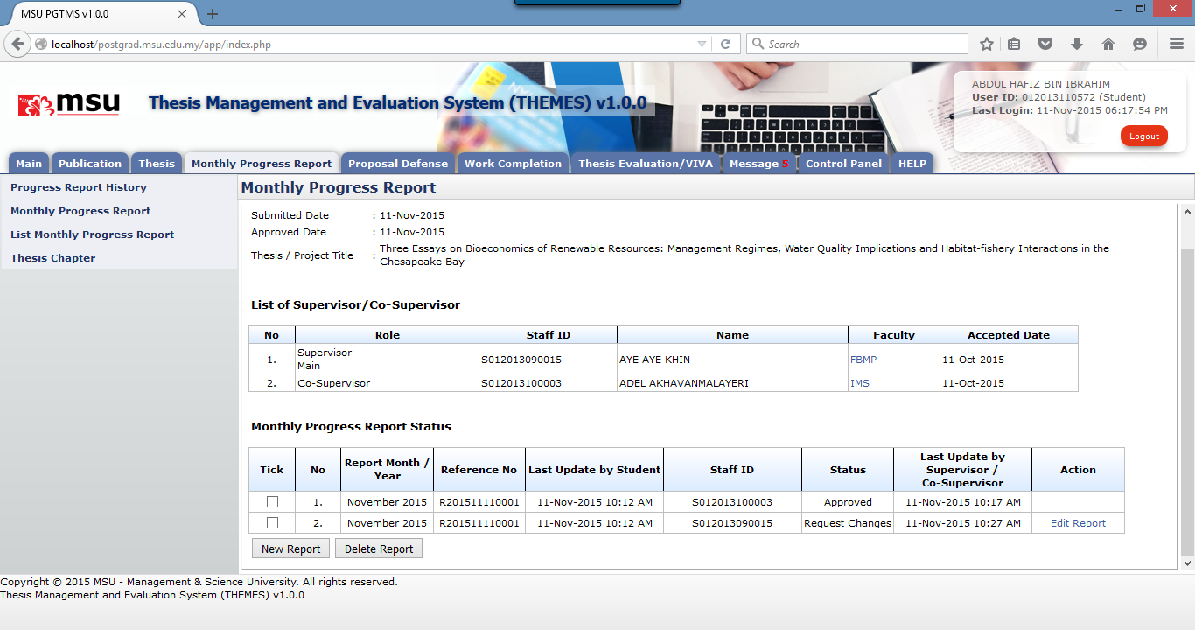

**20**

Figure 33: Edit Report

**Steps**

1. Click on the **Edit Report** link to edit the monthly progress report which is under status **Change Request.**
2. Edit the report. Once done click on **Save** button if need some more changes. Otherwise click on **Submit** button to submit the report to the Supervisor.

**Next Action**

You can keep checking the status of the report. If it is approved already then no further action required, otherwise you need to amend and resubmit the report if it is required changes.

**Warning**

None

**Note**

None

## Progress Report History

This feature will allow the user to view the history progress of the monthly report starting from its submission until approval stage.

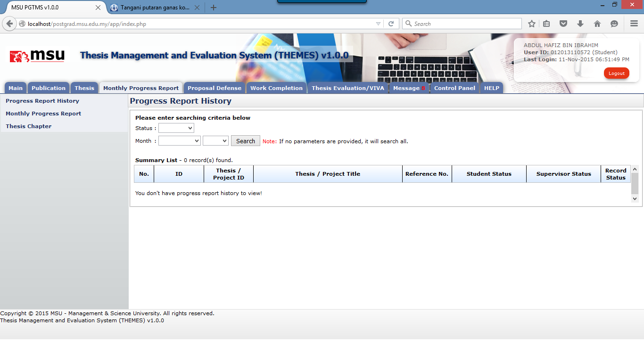

**30**

**20**

**10**

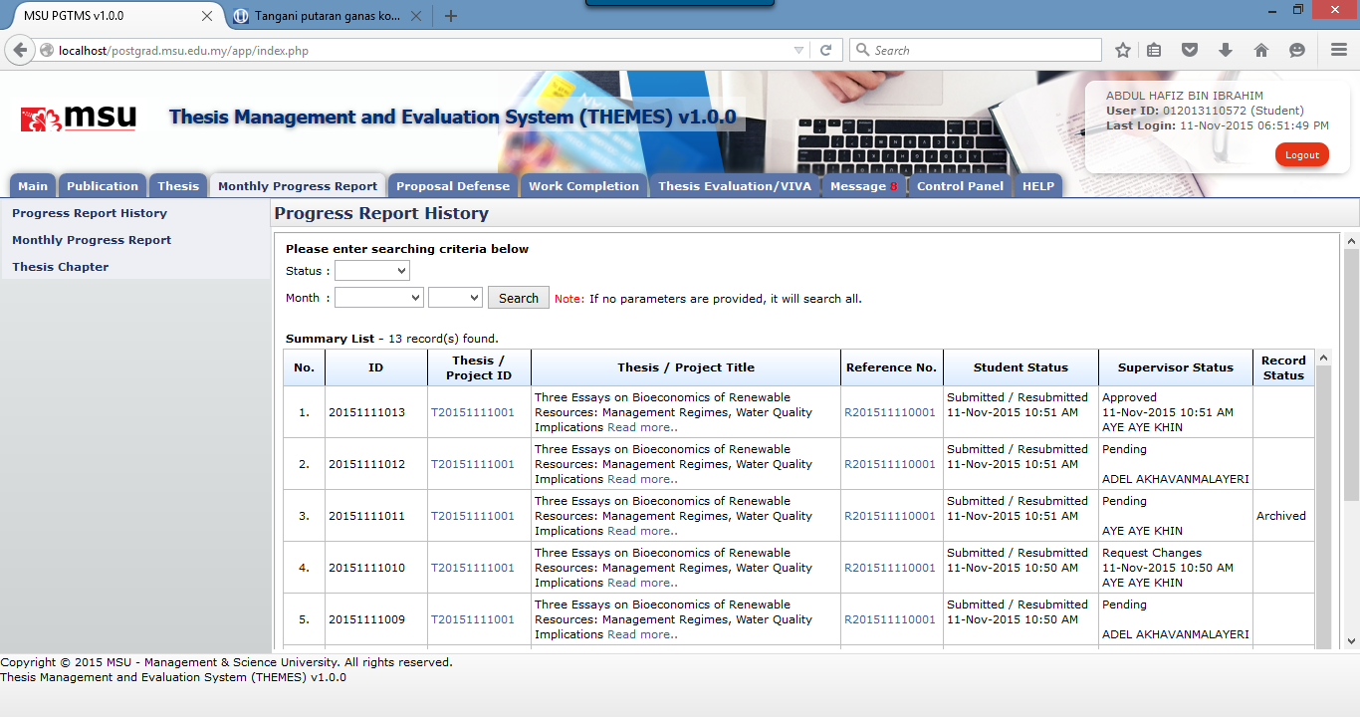

**70**

**60**

**50**

**40**

Figure 34: Progress Report History

**Prerequisite**

At least one monthly progress report has been submitted by the student.

**Steps**

1. Click on the **Monthly Progress Report** at the Top Panel.
2. Click on the **Monthly Progress Report** at the Left Panel
3. By default the system will show no history records on the **Working Area** section.
4. You can list the record by providing the search criteria or just click the **Search** button.
5. The search result will be displayed accordingly.
6. Click on the **Thesis ID** link if to view the thesis detail.
7. Click on the **Reference No** link if to view the monthly progress report detail.

**Next Action**

None

**Warning**

None

**Note**

None

# PROPOSAL DEFENCe

## Defence Proposal

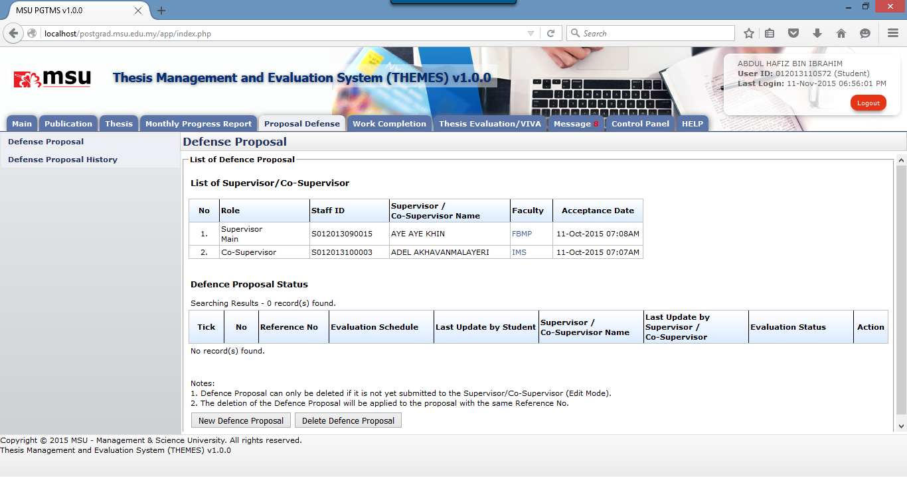

**20**

**10**

**Prerequisite**

1. The Faculty has scheduled the Proposal Defence for the student.
2. The Supervisor / Co-Supervisor have accepted the invitation.
3. The Supervisor has recommended the suitable Proposal Defence date to the student

**Steps**

1. Click on the **Proposal Defence** tab on the Top Panel.
2. Click on the **Defence** **Proposal** link on the Left Panel.
3. The system will display the Proposal Defence page on the Working Area section.

**Next Action**

1. Create New Defence Proposal
2. Delete Defence Proposal

**Warning**

System will prompt a notification message if

1. The Supervisor / Co-Supervisor do not accepted the invitation yet
2. The Defence Proposal date is not scheduled yet.

**Note**

None

### New Defence Proposal

This feature allows the student to submit a defence proposal to the Supervisor for review and approval.



**10**

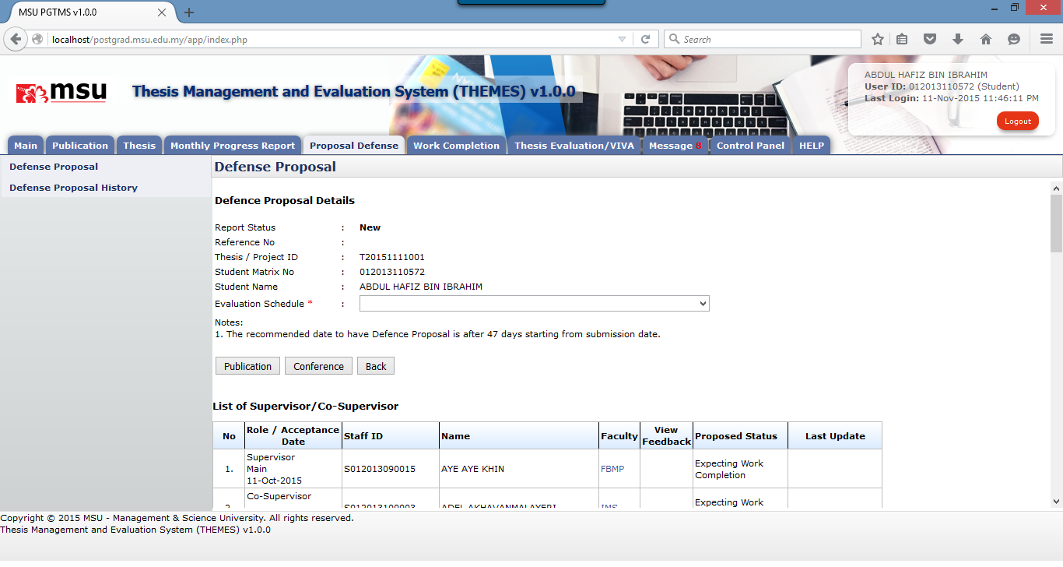

**20**

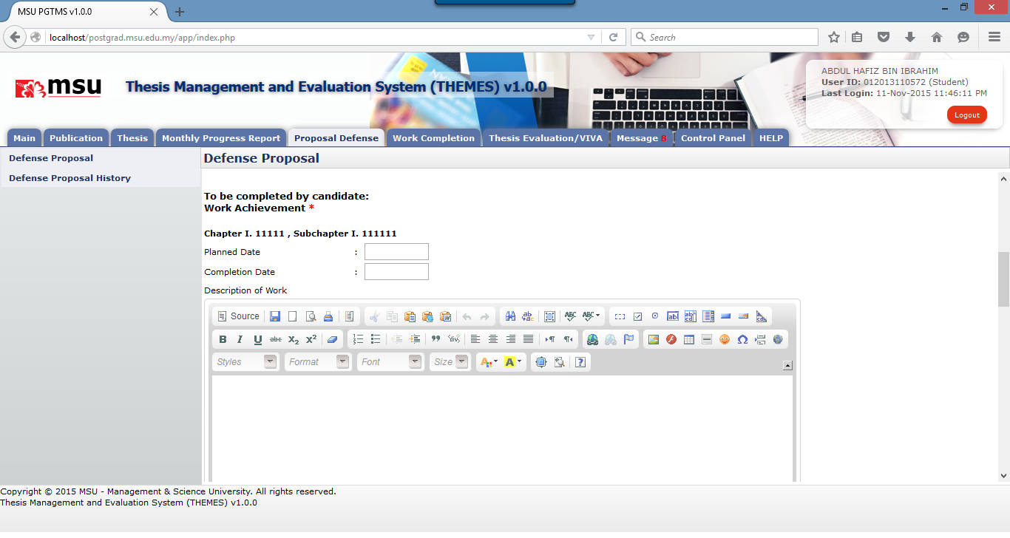

**30**

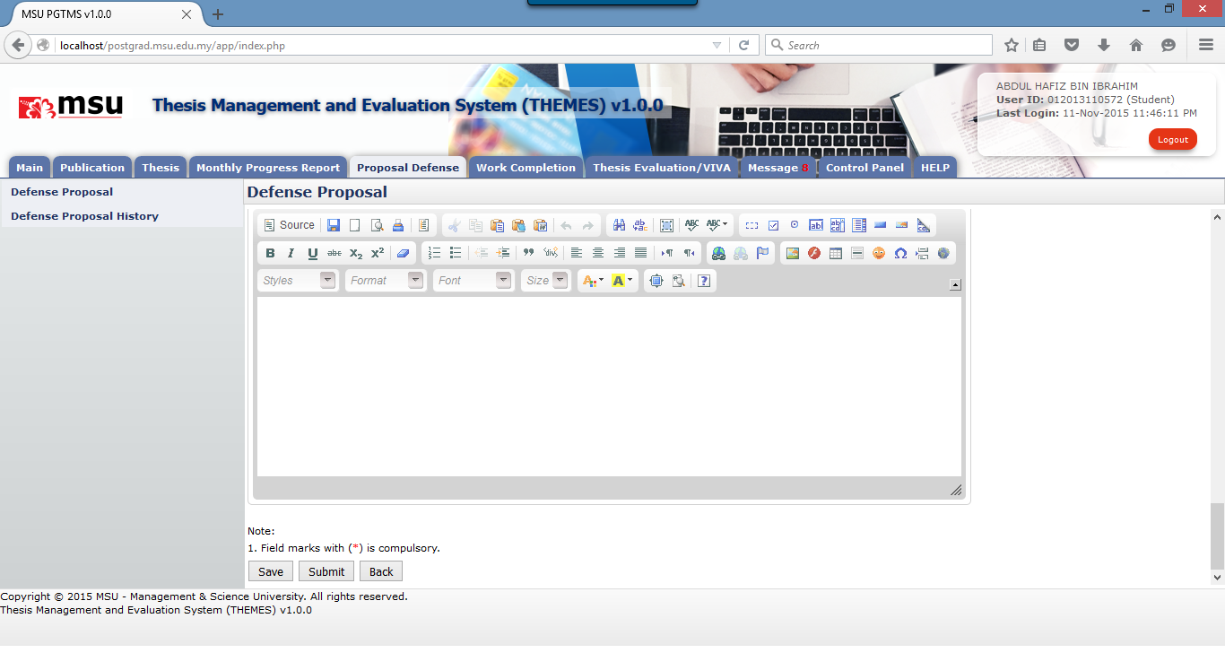

**40**

**Steps**

1. Click on **New Proposal** button to create the defence proposal.
2. The system will open the Defence Proposal page. Select the **Defence Proposal** date from the **Evaluation Schedule** dropdown.
3. Enter the **Work Achievement** details which consist of Planned Date, Completion Date and Description of Work.
4. Click on **Save** button if there is further change is required or otherwise click on **Submit** button to submit the Defence Proposal to the Supervisor.

**Next Action**

1. Create New Defence Proposal
2. Delete Defence Proposal

**Warning**

System will prompt a notification message if the Defence Proposal date and Work Achievement are empty before the submission.

**Note**

None

#### Add Publication



**10**

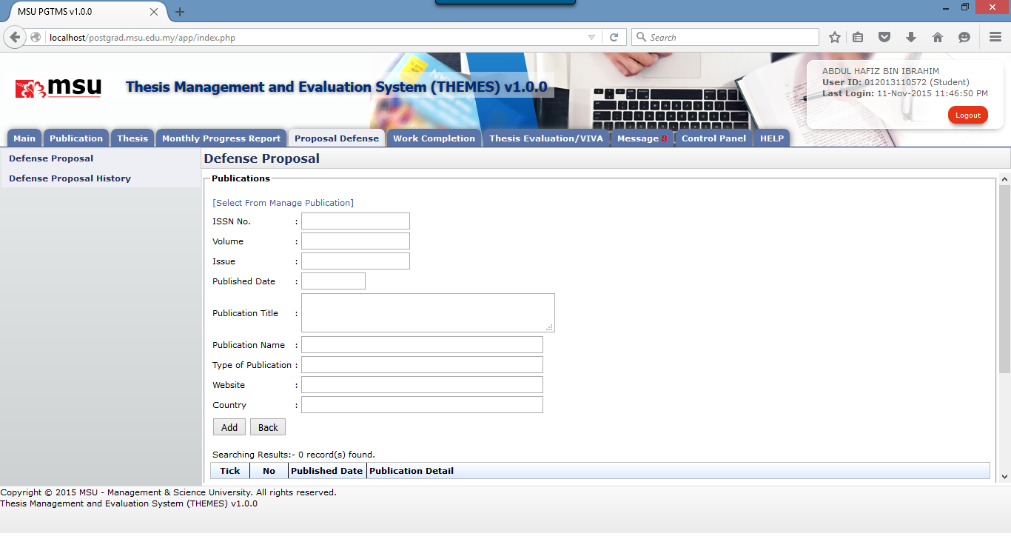

**20**

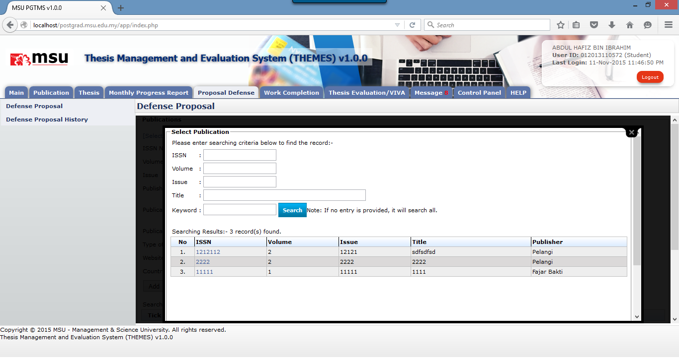

**30**

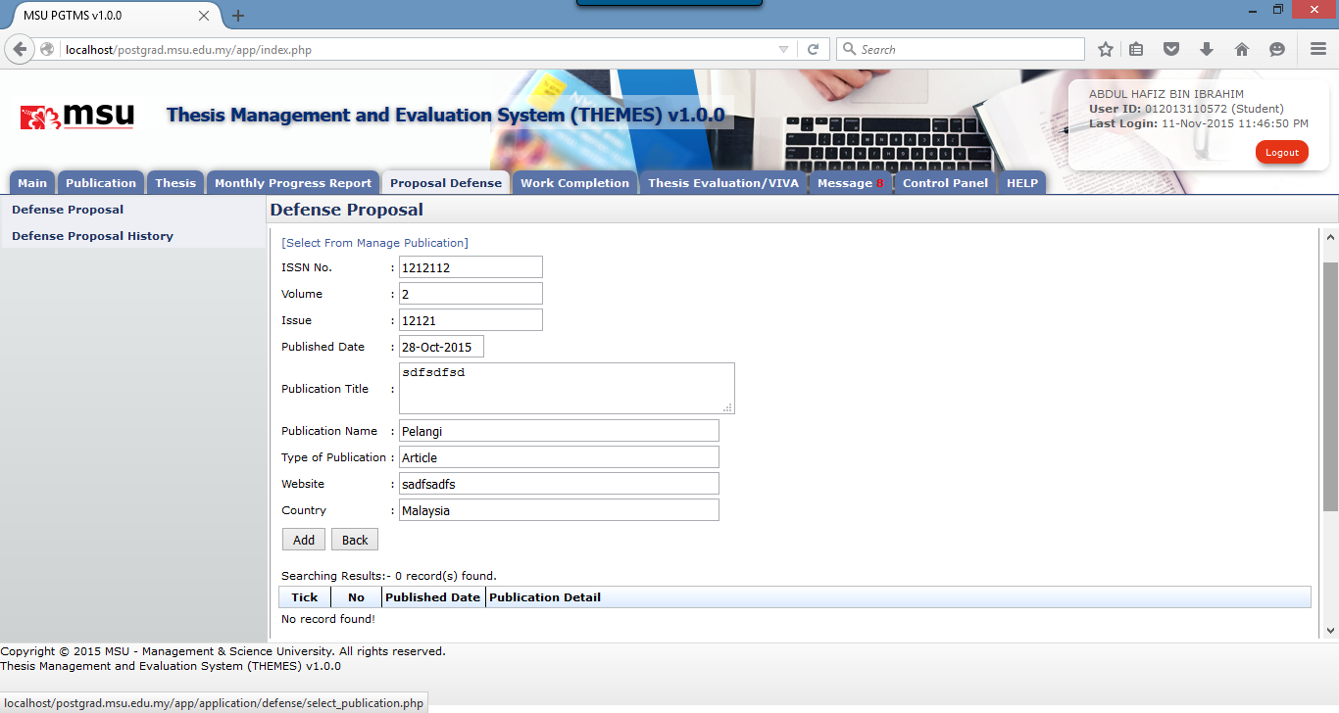

**50**

**40**

**Prerequisite**

The publication has been added by the student via Manage Publication.

**Steps**

1. Click on **Publication** button to add the publication.
2. The system will open the Publication page. Click on **Select From Manage Publication** to open another page to list the already added publication.
3. Enter the searching criteria or just click the button to get the search result.
4. Click on the **ISSN number** on the ISSN **Search** column to populate the record into the Publication detail page.
5. Click **Add** button to add the publication detail into the Publication List

**Next Action**

1. Add another Publication
2. Delete Publication

**Warning**

System will prompt a notification message if no publication has been selected before the addition.

**Note**

None

#### Delete Publication

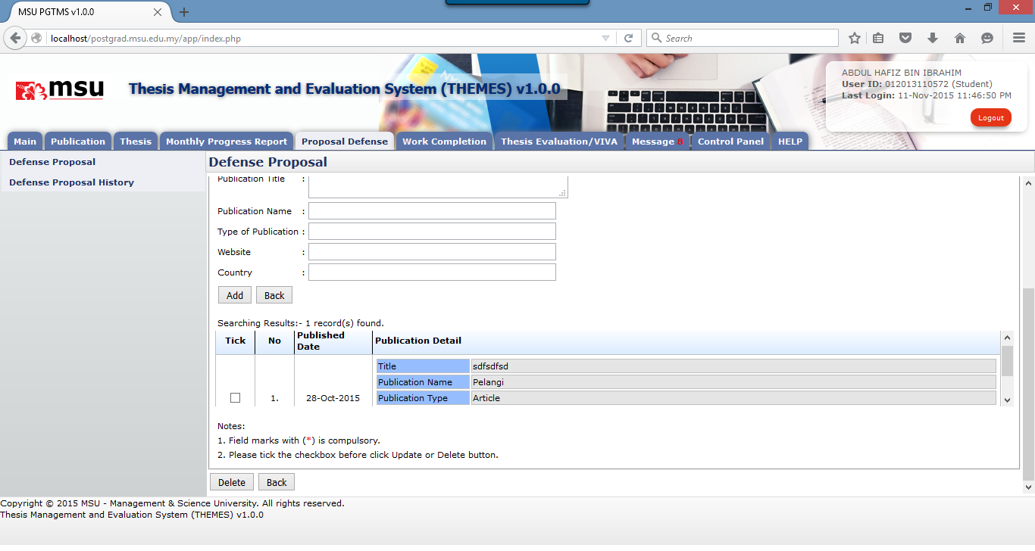

**20**

**10**

**Prerequisite**

The publication has been added by the student into the Publication List via Manage Publication.

**Steps**

1. Tick the checkbox which the publication is going to be deleted.
2. Click **Delete** button to delete the publication from the Publication List

**Next Action**

Add another Publication or back to the Defence Proposal page.

**Warning**

System will prompt a notification message if no publication has been selected before the deletion.

**Note**

None

#### Add Conference



**10**

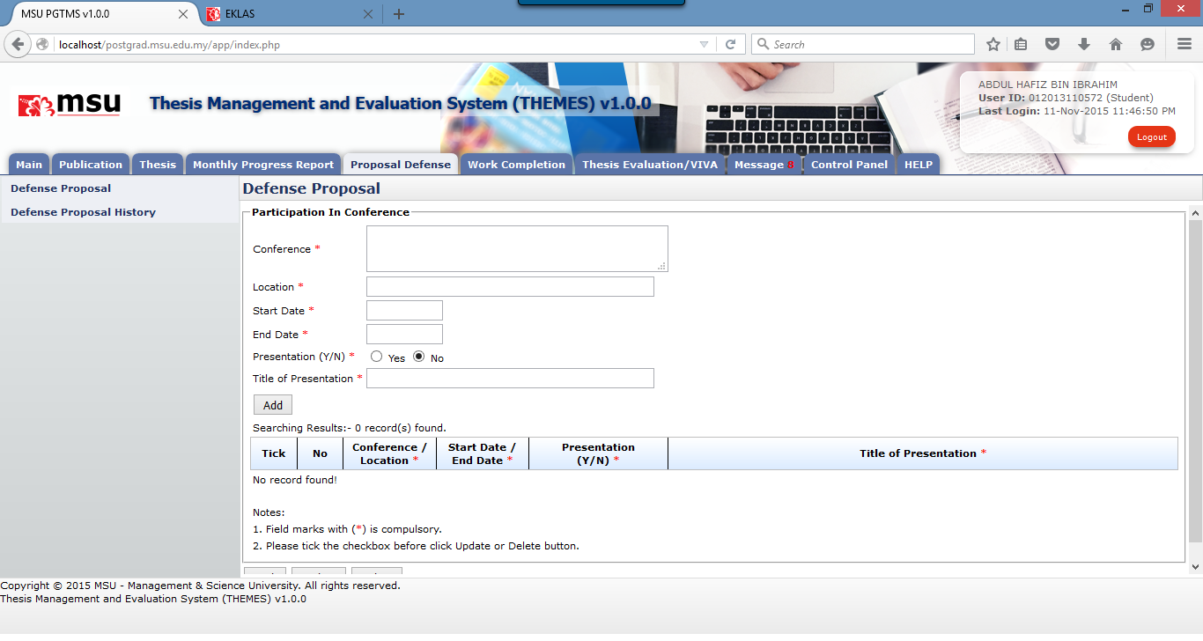

**20**

**Prerequisite**

None

**Steps**

1. Click on **Conference** button to add the conference detail.
2. The system will open the Conference page. Provide the detail and click **Add** button to add it into the list.

**Next Action**

1. Add another Conference
2. Update Conference
3. Delete Conference

**Warning**

System will prompt a notification message if mandatory field indicated by the asterisk (*) is left blank before the addition.

**Note**

None

#### Edit Conference

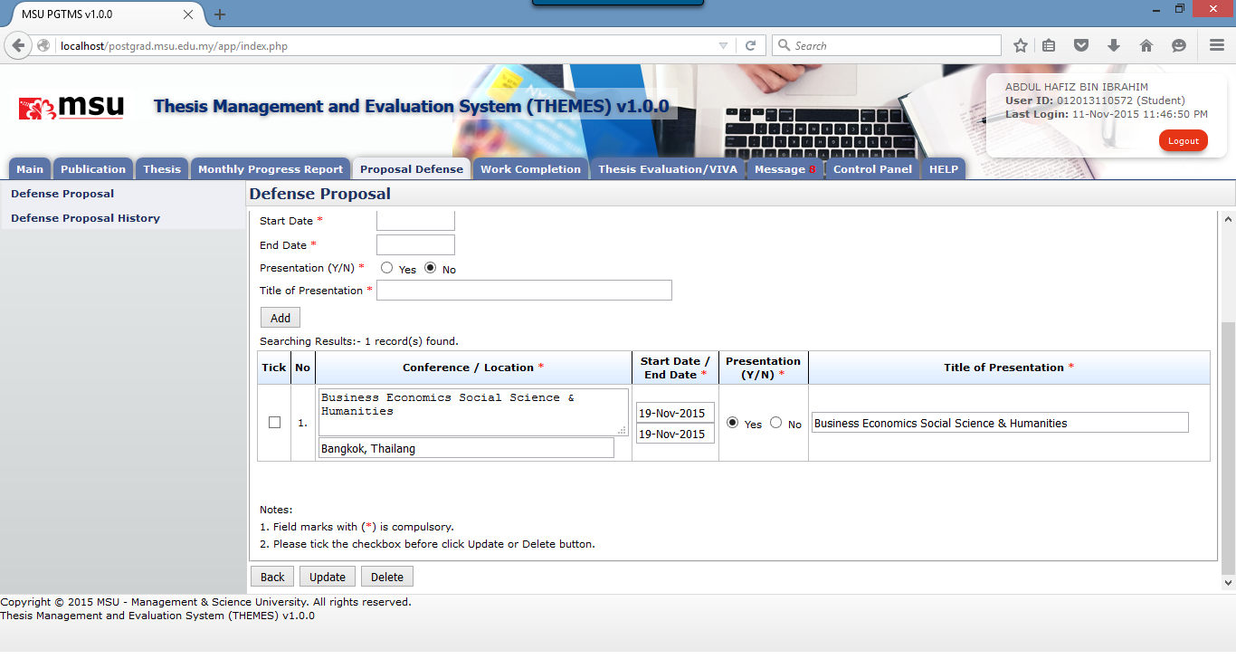

**30**

**20**

**10**

**Prerequisite**

The conference has been added by the student.

**Steps**

1. Update the conference detail. It can be done in multiple rows.
2. Tick the checkbox for the conference which has been updated. It can be done in multiple rows.
3. Click the **Update** button to save the changes.

**Next Action**

1. Add another Conference
2. Update Conference
3. Delete Conference

**Warning**

System will prompt a notification message if mandatory field indicated by the asterisk (*) is left blank before the addition.

**Note**

None

#### Delete Conference



**20**

**10**

**Prerequisite**

The conference has been added by the student.

**Steps**

1. Tick the checkbox for the conference which is going to be deleted. It can be done in multiple rows.
2. Click the **Delete** button to delete the conference from the list.

**Next Action**

1. Add another Conference
2. Update another Conference
3. Delete another Conference

**Warning**

System will prompt a notification message if mandatory field indicated by the asterisk (*) is left blank before the addition.

**Note**

None

### Delete Defence Proposal

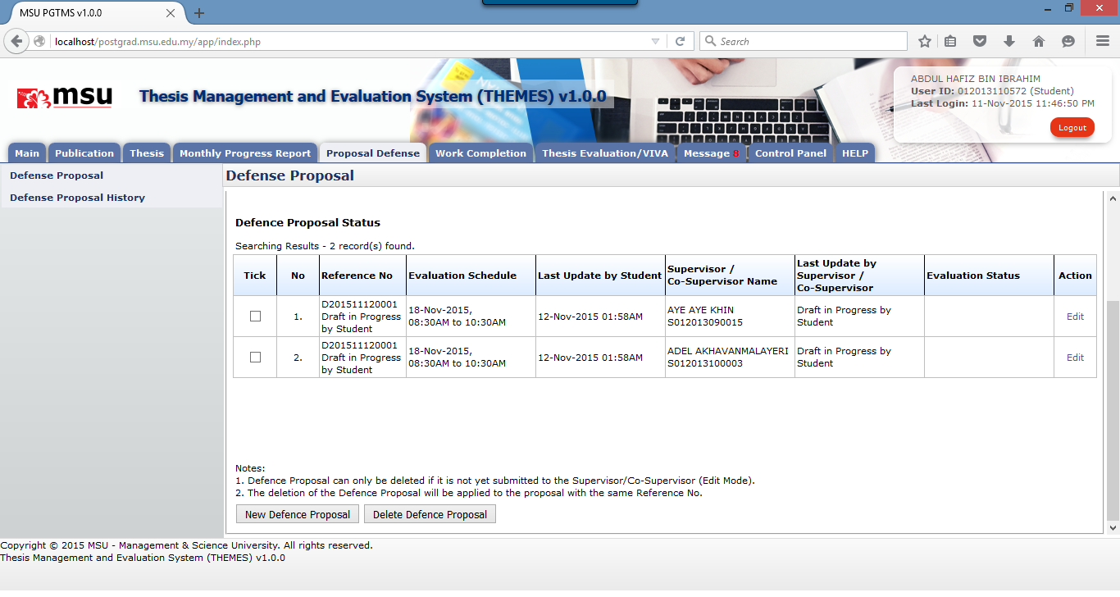

**30**

**20**

**10**

**Prerequisite**

The Defence Proposal has been saved for more changes.

**Steps**

1. The Defence Proposal status must be in **Draft in Progress by Student**.
2. Tick the checkbox for which the Defence Proposal is going to be deleted.
3. Click **Delete Defence Proposal** button to delete the defence proposal from the list.

**Next Action**

Create another New Defence Proposal.

**Warning**

System will prompt a notification message if

1. No Defence Proposal has been selected before the deletion.
2. The selected Defence Proposal to be deleted is already submitted to the Supervisor

**Note**

1. Defence Proposal can only be deleted if it is not yet submitted to the Supervisor/Co-Supervisor (Edit Mode).
2. The deletion of the Defence Proposal will be applied to the proposal with the same Reference Number.

### Edit Defence Proposal



**10**

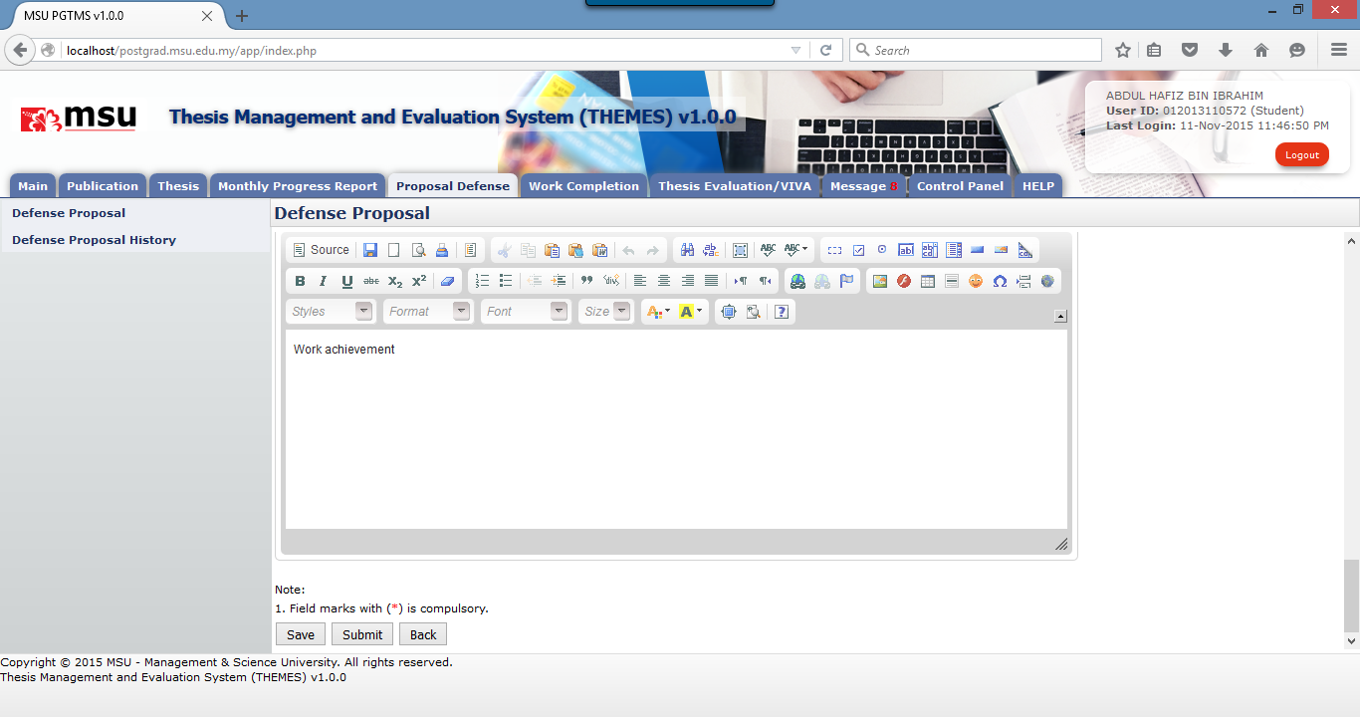

**20**

**Prerequisite**

The Defence Proposal has been saved for more changes.

**Steps**

1. The Defence Proposal status must be in **Draft in Progress by Student**.
2. Click **Edit** link from the list. The Defence Proposal page will be displayed.
3. Edit the defence proposal and Click **Save** button if need to have further changes or otherwise click **Submit** button to submit it to the Supervisor.

**Next Action**

1. If the Defence Proposal in Edit mode, proceed with the changes and submit it once done.
2. If the Defence Proposal is already submitted, keep checking the status for the necessary action.

**Warning**

System will prompt a notification message if mandatory field indicated by asterisk (*) is left blank or unselected.

**Note**

None

## Defence Proposal History

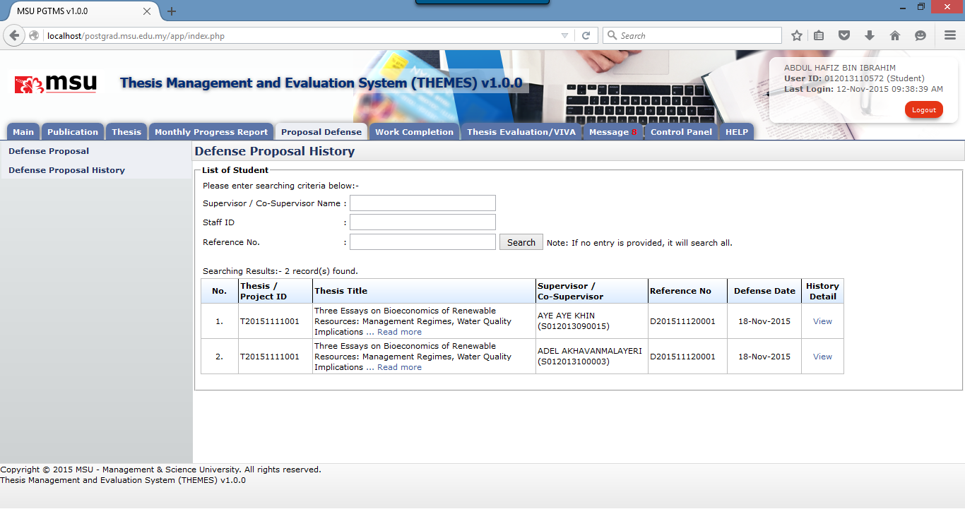

**30**

**20**

**10**

**Prerequisite**

At least the Defence Proposal has been created (in progress status) by the student.

**Steps**

1. Click on the Proposal Defence tab on the Top Panel
2. Click on the Defence Proposal History on the Left Panel. The Defence History page is displayed on the Working Area section
3. Click on the View link at the history list to get the detail information.

**Next Action**

None

**Warning**

None

**Note**

None

# WORK COMPLETION

## Work Completion

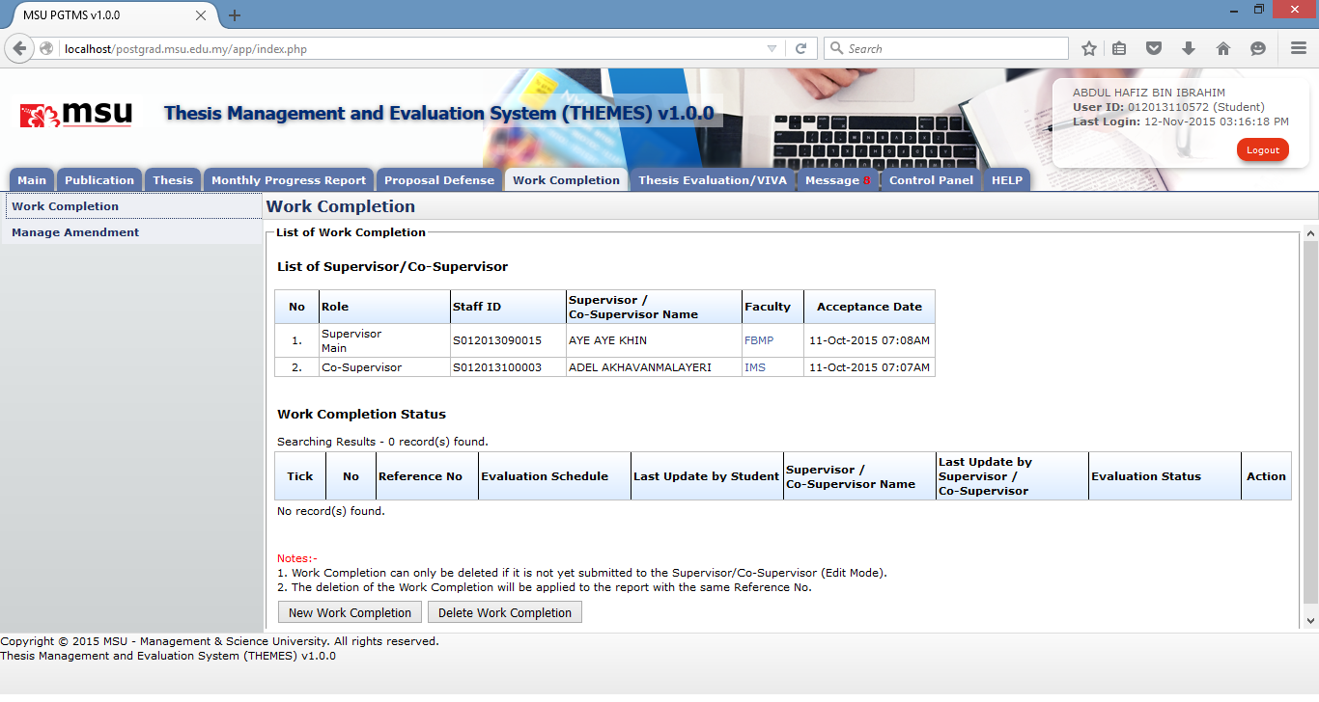

**10**

**20**

**Prerequisite**

1. The Faculty has scheduled the Work Completion session for the student.
2. The Supervisor / Co-Supervisor have accepted the invitation.
3. The Supervisor has recommended the suitable Work Completion date to the student

**Steps**

1. Click on the **Work Completion** tab on the Top Panel.
2. Click on the **Work Completion** link on the Left Panel.
3. The system will display the **Work Completion** page on the Working Area section.

**Next Action**

1. The student can create New Work Completion
2. The student can delete Work Completion

**Warning**

System will prompt a notification message if

1. The Supervisor / Co-Supervisor do not accept the invitation yet
2. The Defence Proposal date is not scheduled yet by Faculty
3. The Defence Proposal date is not recommended yet by Supervisor

**Note**

None

### New Work Completion

This feature allows the student to submit a work completion to the Supervisor for review and approval.



**10**

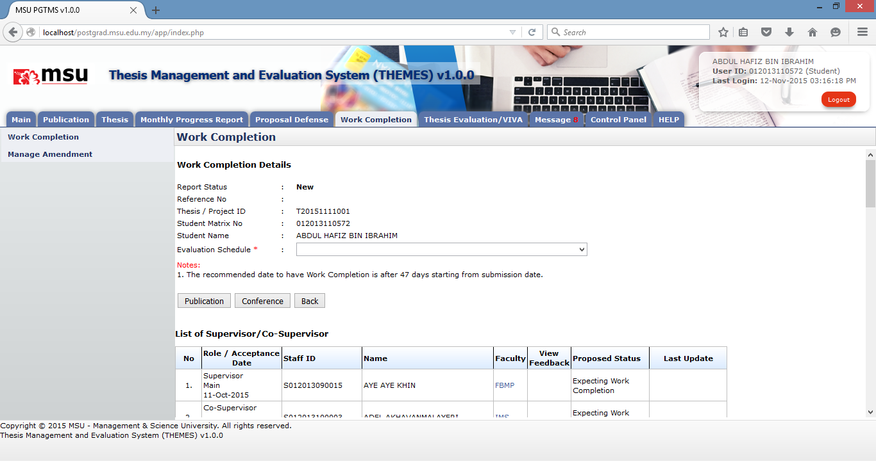

**20**

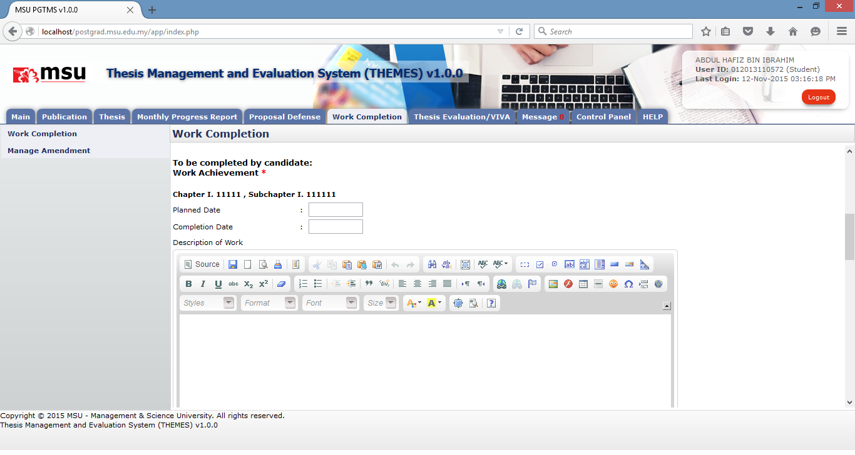

**30**

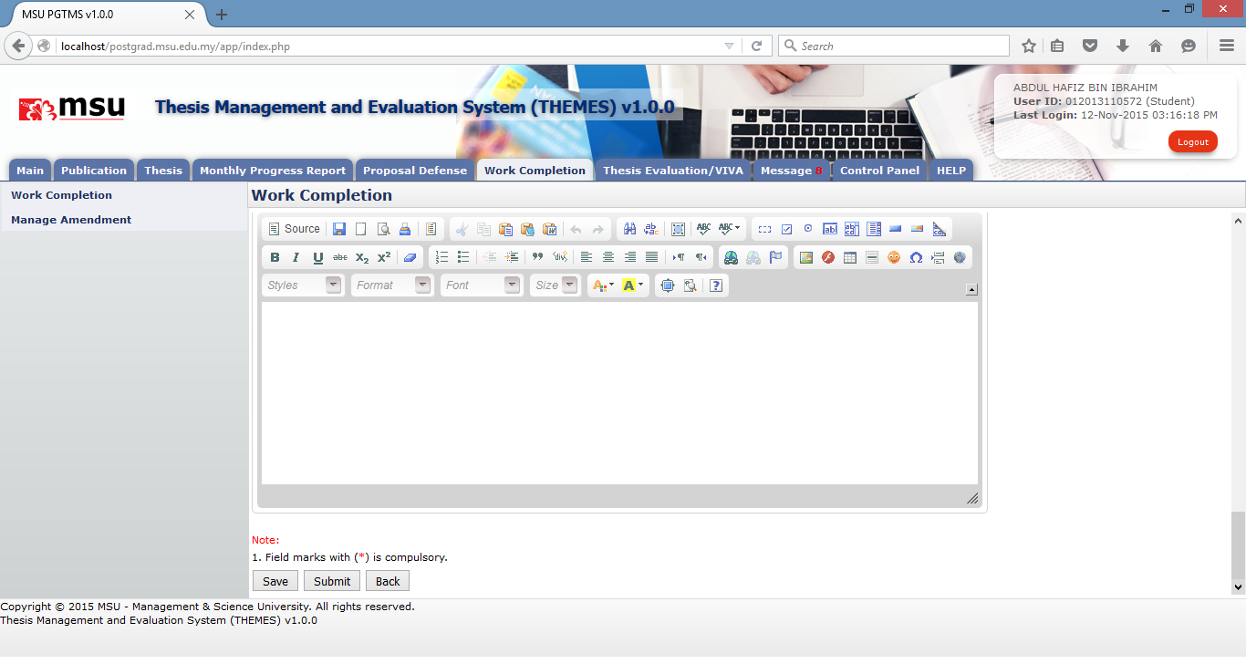

**40**

**Steps**

1. Click on **New Work Completion** button to create the work completion.
2. The system will open the Work Completion page. Select the **Work Completion** date from the **Evaluation Schedule** dropdown.
3. Enter the **Work Achievement** details which consist of Planned Date, Completion Date and Description of Work.
4. Click on **Save** button if there is further change is required or otherwise click on **Submit** button to submit the Work Completion to the Supervisor.

**Next Action**

1. Create New Work Completion
2. Delete Work Completion

**Warning**

System will prompt a notification message if the Work Completion date and Work Achievement are empty before the submission.

**Note**

None

#### Add Publication



**10**

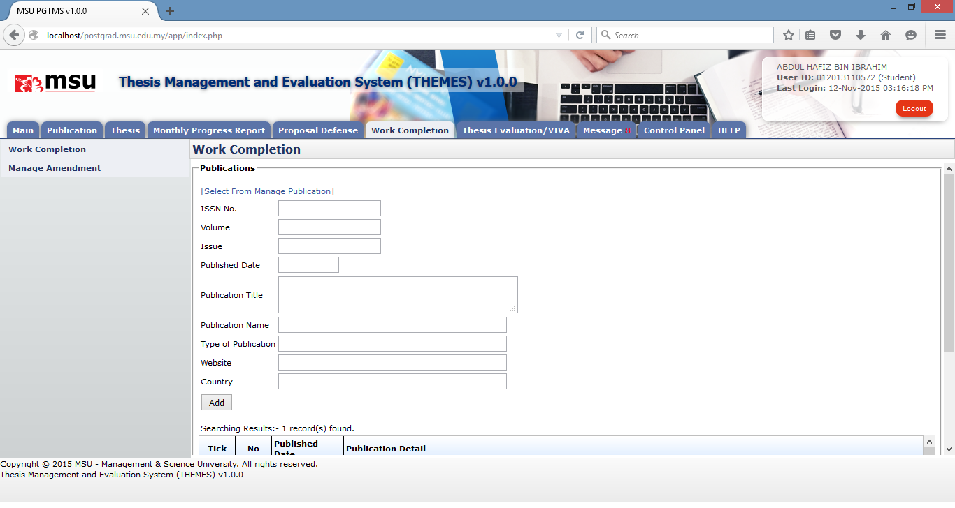

**20**

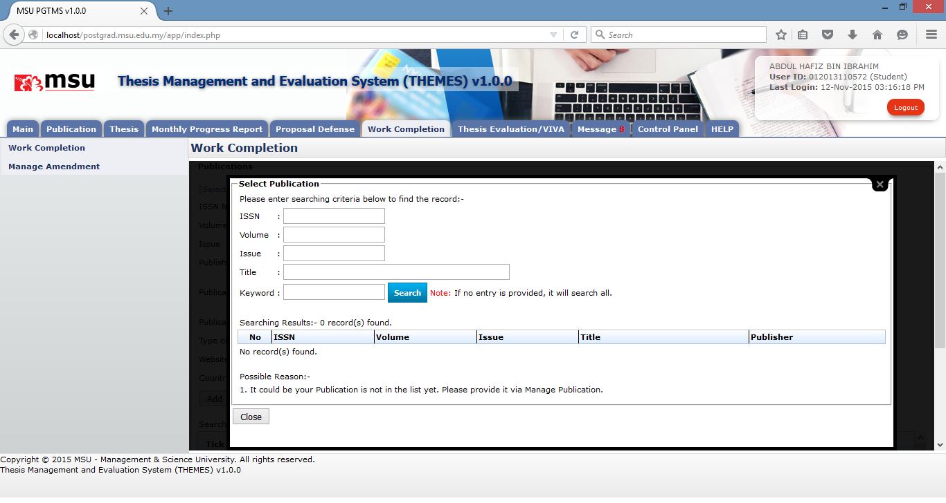

**30**

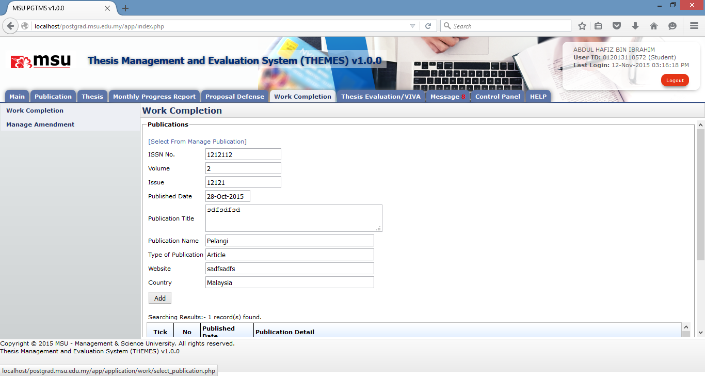

**50**

**40**

**Prerequisite**

The publication has been added by the student via Manage Publication.

**Steps**

1. Click on **Publication** button to add the publication.
2. The system will open the Publication page. Select **Select From Manage Publication** to open another page to list the already added publication.
3. Enter the searching criteria or just click the button to get the search result.
4. Click on the **ISSN number** on the ISSN **Search** column to populate the record into the Publication detail page.
5. Click **Add** button to add the publication detail into the Publication List

**Next Action**

1. Add another Publication
2. Delete Publication

**Warning**

System will prompt a notification message if no publication has been selected before the addition.

**Note**

None

#### Delete Publication

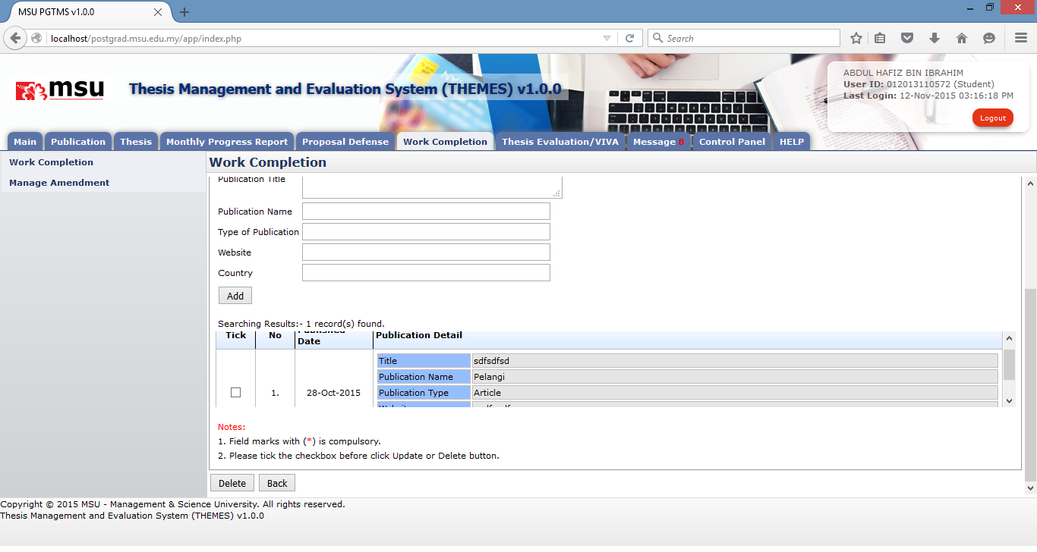

**20**

**10**

**Prerequisite**

The publication has been added by the student into the Publication List via Manage Publication.

**Steps**

1. Tick the checkbox which the publication is going to be deleted.
2. Click **Delete** button to delete the publication from the Publication List

**Next Action**

Add another Publication or back to the Defence Proposal page.

**Warning**

System will prompt a notification message if no publication has been selected before the deletion.

**Note**

None

#### Add Conference

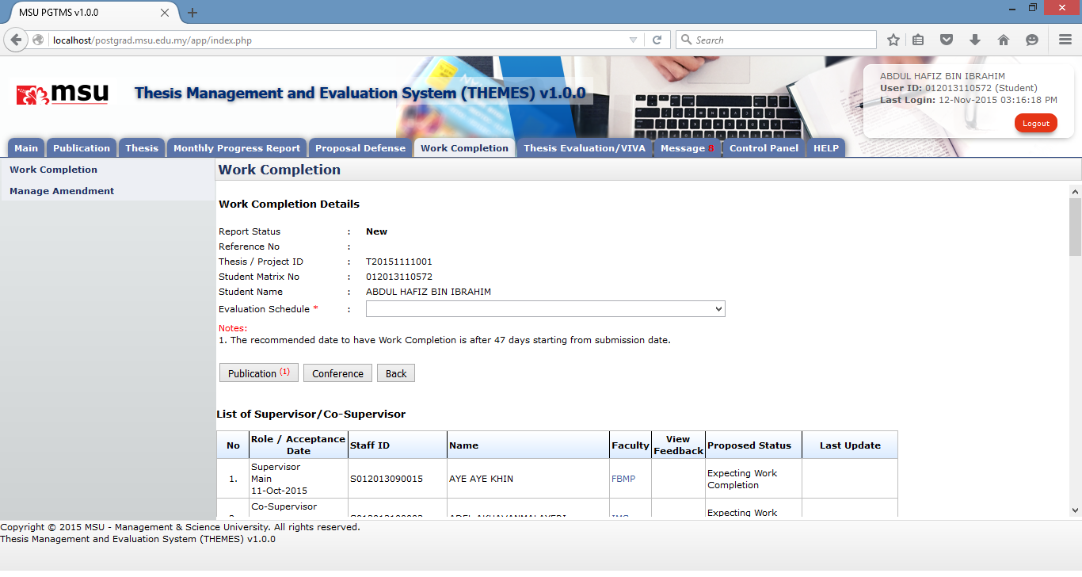

**10**

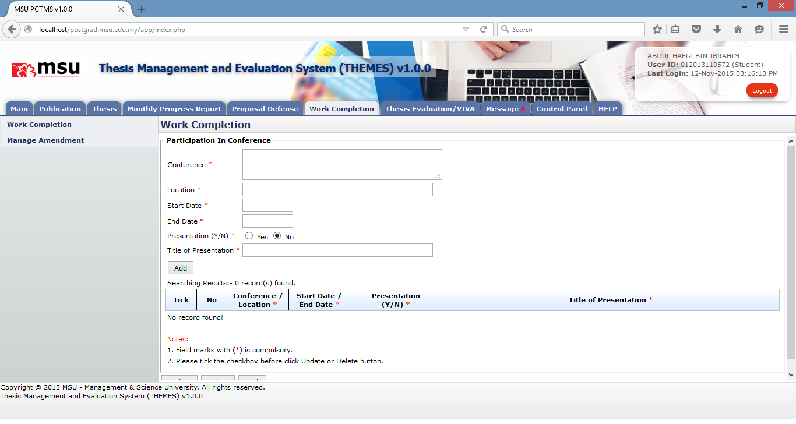

**20**

**Prerequisite**

None

**Steps**

1. Click on **Conference** button to add the conference detail.
2. The system will open the Conference page. Provide the detail and click **Add** button to add it into the list.

**Next Action**

1. Add another Conference
2. Update Conference
3. Delete Conference

**Warning**

System will prompt a notification message if mandatory field indicated by the asterisk (*) is left blank before the addition.

**Note**

None

#### Edit Conference

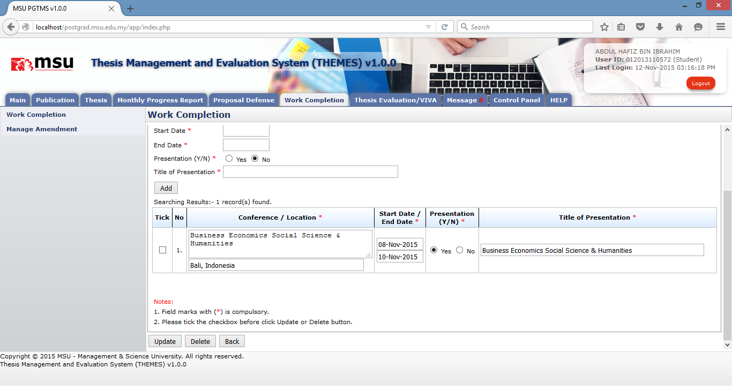

**30**

**20**

**10**

**Prerequisite**

The conference has been added by the student.

**Steps**

1. Update the conference detail. It can be done in multiple rows.
2. Tick the checkbox for the conference which has been updated. It can be done in multiple rows.
3. Click the **Update** button to save the changes.

**Next Action**

The student can

1. Add another Conference
2. Update Conference
3. Delete Conference

**Warning**

System will prompt a notification message if mandatory field indicated by the asterisk (*) is left blank before the addition.

**Note**

None

#### Delete Conference



**20**

**10**

**Prerequisite**

The conference has been added by the student.

**Steps**

1. Tick the checkbox for the conference which is going to be deleted. It can be done in multiple rows.
2. Click the **Delete** button to delete the conference from the list.

**Next Action**

The student can

1. Add another Conference
2. Update another Conference
3. Delete another Conference

**Warning**

System will prompt a notification message if mandatory field indicated by the asterisk (*) is left blank before the addition.

**Note**

None

### Delete Defence Proposal

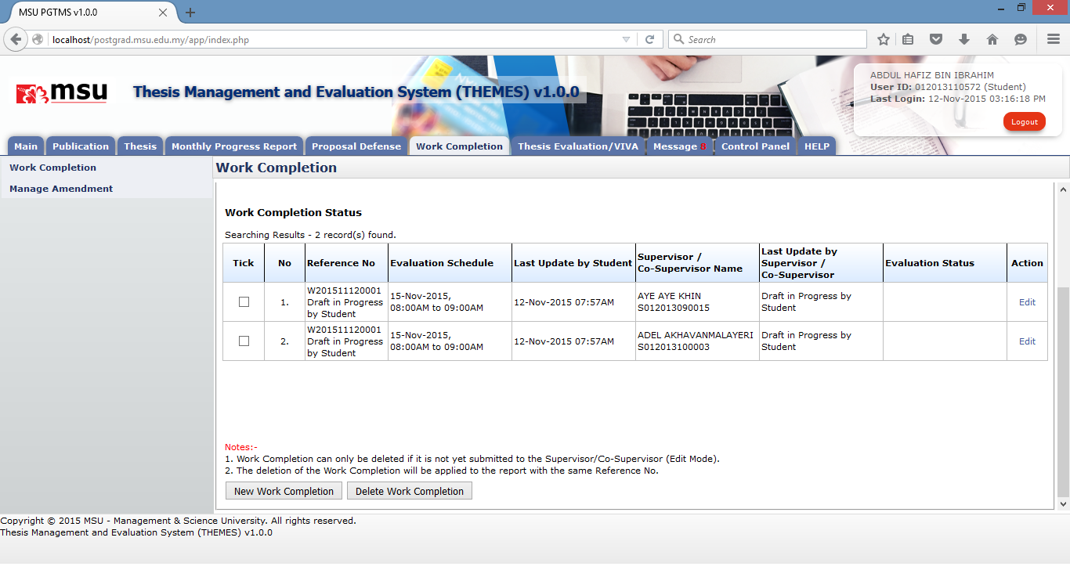

**30**

**20**

**10**

**Prerequisite**

The Work Completion has been saved for more changes.

**Steps**

1. The Work Completion status must be in **Draft in Progress by Student**.
2. Tick the checkbox for which the Work Completion is going to be deleted.
3. Click **Delete Work Completion** button to delete the Work Completion from the list.

**Next Action**

Create another New Work Completion.

**Warning**

System will prompt a notification message if

1. No Work Completion has been selected before the deletion.
2. The selected Work Completion to be deleted is already submitted to the Supervisor

**Note**

1. Work Completion can only be deleted if it is not yet submitted to the Supervisor/Co-Supervisor (Edit Mode).
2. The deletion of the Work Completion will be applied to the one with the same Reference No.

### Edit Work Completion



**10**

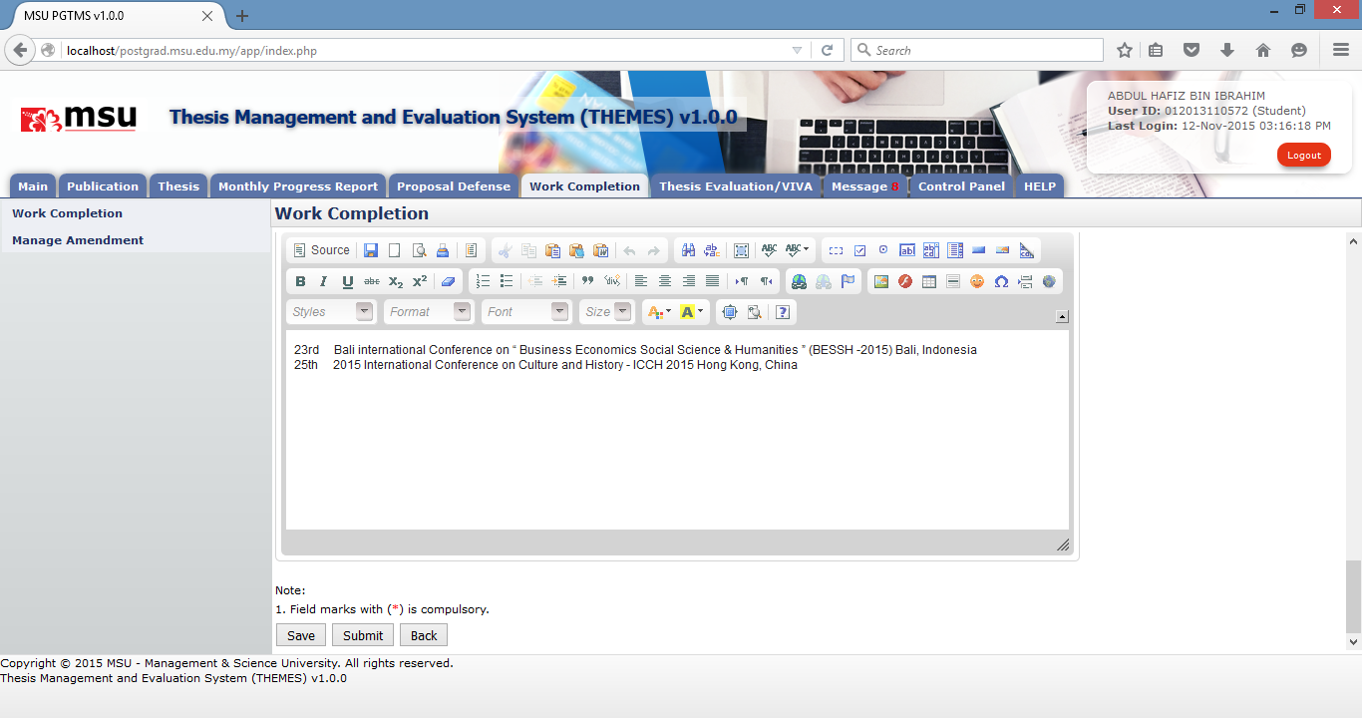

**20**

**Prerequisite**

The Work Completion has been saved for more changes.

**Steps**

1. The Work Completion status must be in **Draft in Progress by Student**.
2. Click **Edit** link from the list. The Work Completion page will be displayed.
3. Edit the Work Completion and Click **Save** button if need to have further changes or otherwise click **Submit** button to submit it to the Supervisor.

**Next Action**

1. If the Work Completion in Edit mode, proceed with the changes and submit it once done.
2. If the Work Completion is already submitted, keep checking the status for the necessary action.

**Warning**

System will prompt a notification message if mandatory field indicated by asterisk (*) is left blank or unselected.

**Note**

None

## Manage Amendment

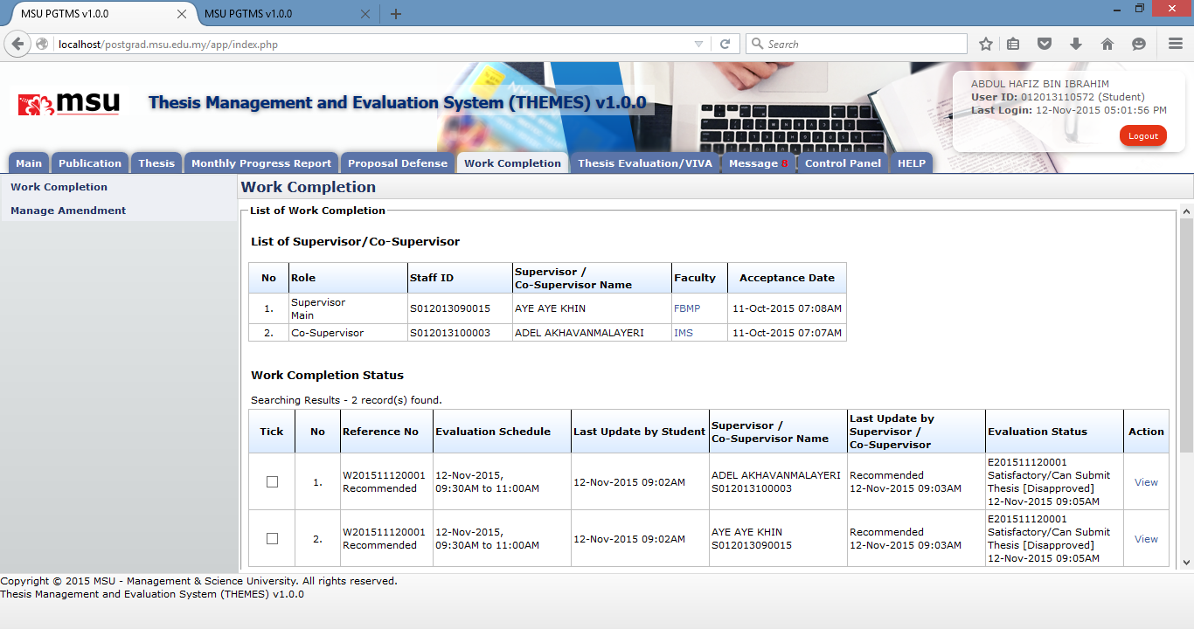

**20**

**10**

**30**

**Prerequisite**

The Work Completion has been disapproved by the Academic Committee or Schoolboard.

**Steps**

1. Click on **Work Completion** tab on the Top Panel.
2. Click on the **Work Completion** menu on the Left Panel.
3. Observe the **Evaluation Status** by the Academic Committee or Schoolboard is disapproved. As such the student needs to amend the thesis and resubmit for next Work Completion approval.

**Next Action**

The student needs to confirm the thesis amendment via Manage Amendment

**Warning**

None

**Note**

None

### Feedback Status

All the feedbacks given by the Evaluation Panel will be recorded and verified by the Supervisor. These feedbacks will be crosscheck against the amendment being updated in the thesis before next work completion evaluation.

#### Add Feedback Status

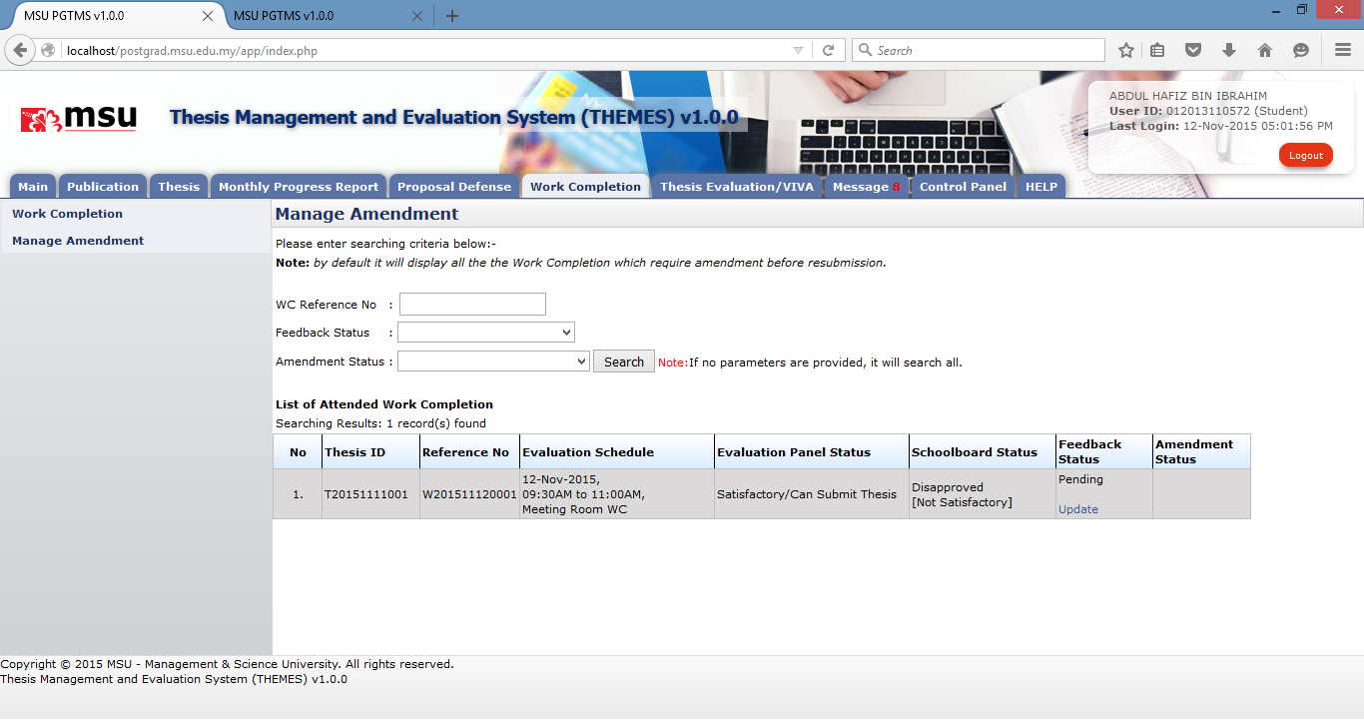

**20**

**30**

**10**

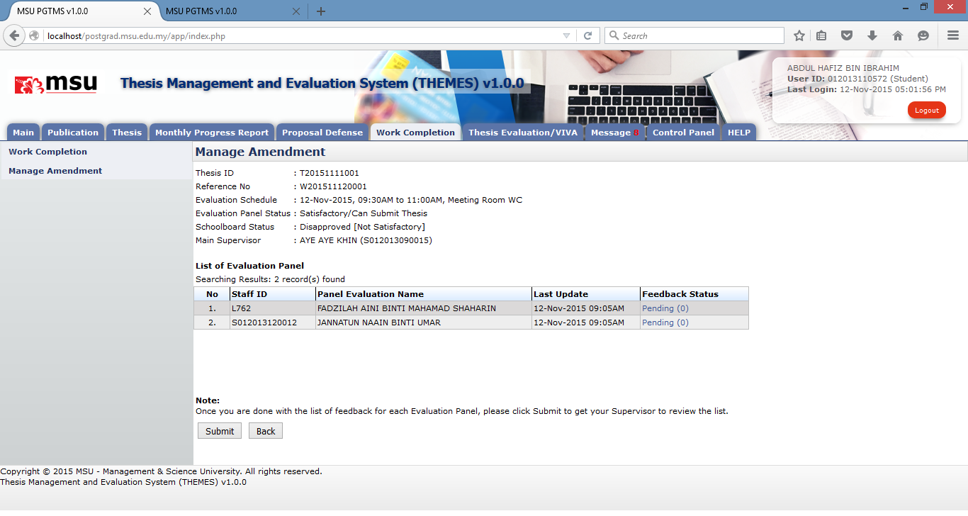

**40**

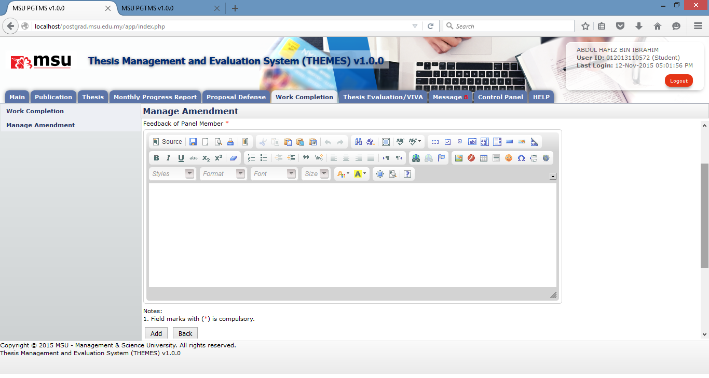

**50**

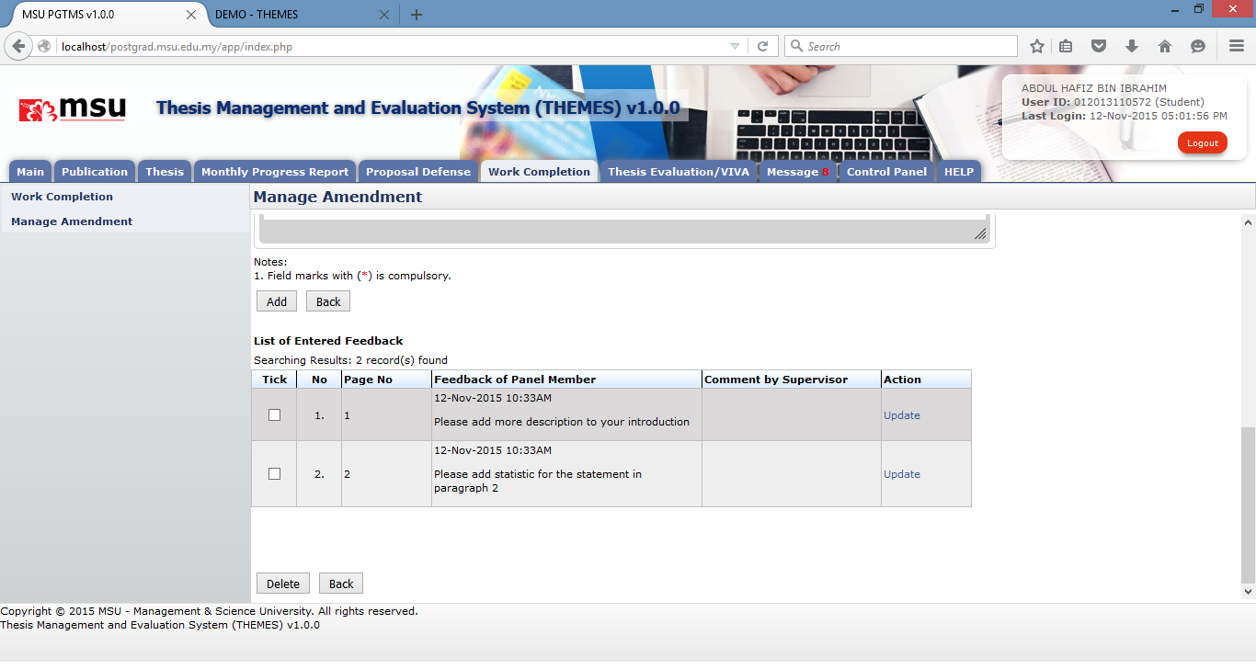

**60**

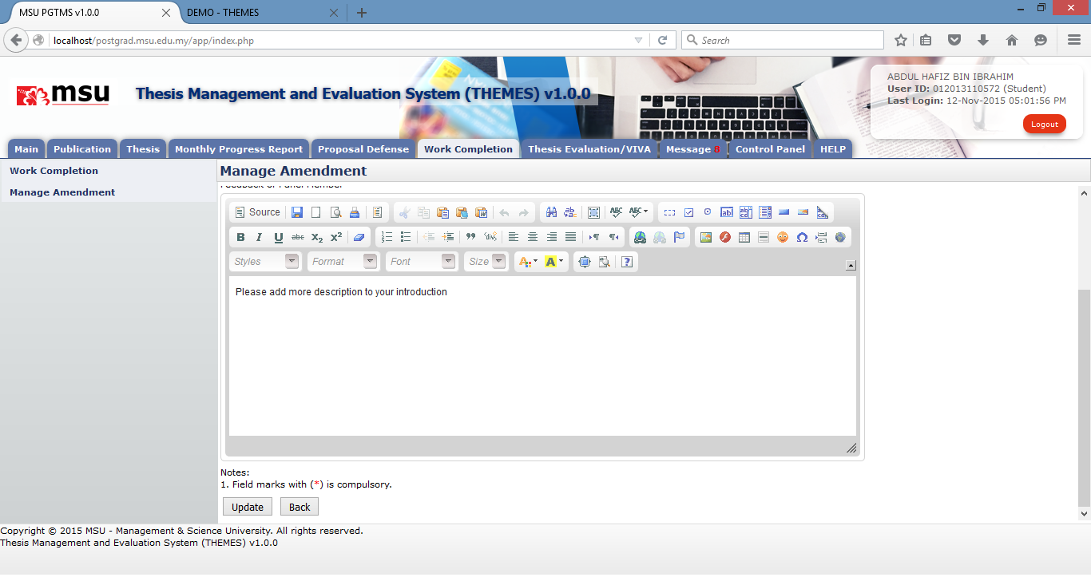

**70**

**Prerequisite**

The Work Completion has been disapproved by the Academic Committee or Schoolboard.

**Steps**

1. Click on the **Manage Amendment** menu on the Left Panel.
2. Enter the search criteria and click **Search** button to get specific result or otherwise just click the **Search** button to get general search result.
3. In the **List of Attended Work Completion**, click on the **Update** link of Feedback Status.
4. The Panel Evaluation page will be displayed with the Panel Evaluation. Click on the **Pending (0)** link to add the feedback raised by the Panel. If there is more than 1 panel, the user needs to repeat the same step.
5. The Feedback page will be displayed for the selected Evaluation panel. Add the feedback which has been raised by the Panel. Click the **Add** button to confirm the addition and add it into the **List of Entered Feedback**.
6. If any changes required after the addition, click on the **Update** link for the selected feedback.
7. The Feedback page for update will be displayed. Once the required changes have been done, click on the **Update** button to confirm the changes.

**Next Action**

The student can

1. update the added feedback
2. delete the added feedback
3. add another new feedback

**Warning**

System will prompt a notification message if the mandatory field indicate as asterisk (*) is left blank or unselected.

**Note**

None

#### Delete Feedback Status



**20**

**30**

**10**

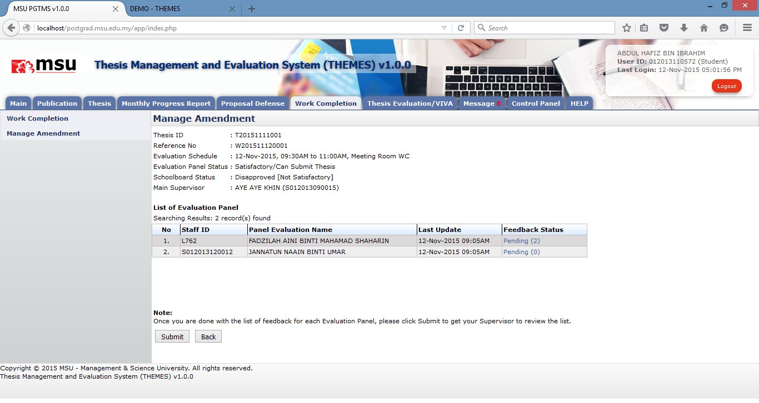

**40**



**60**

**50**

**Prerequisite**

The feedback for the Evaluation Panel has been added by the Student.

**Steps**

1. Click on the **Manage Amendment** menu on the Left Panel.
2. Enter the search criteria and click **Search** button to get specific result or otherwise just click the **Search** button to get general search result.
3. In the **List of Attended Work Completion**, click on the **Update** link of Feedback Status.
4. The Panel Evaluation page will be displayed with the Panel Evaluation. Click on the **Pending (x)** link to add the feedback raised by the Panel. If there is more than 1 panel, the user needs to repeat the same step. X indicates any number of added feedbacks other than 0.
5. The Feedback page will be displayed for the selected Evaluation panel. Find the **List of Entered Feedback**. Tick the checkbox for the feedback going to be deleted. It can be done in multiple rows.
6. Click on the **Delete** button to delete the feedback from the list.

**Next Action**

The student can

1. update the added feedback (if any)
2. delete the added feedback (if any)
3. add another new feedback

**Warning**

System will prompt a notification message if the checkbox is unticking before the deletion.

**Note**

None

#### Submit Feedback Status



**20**

**30**

**10**



**50**

**40**

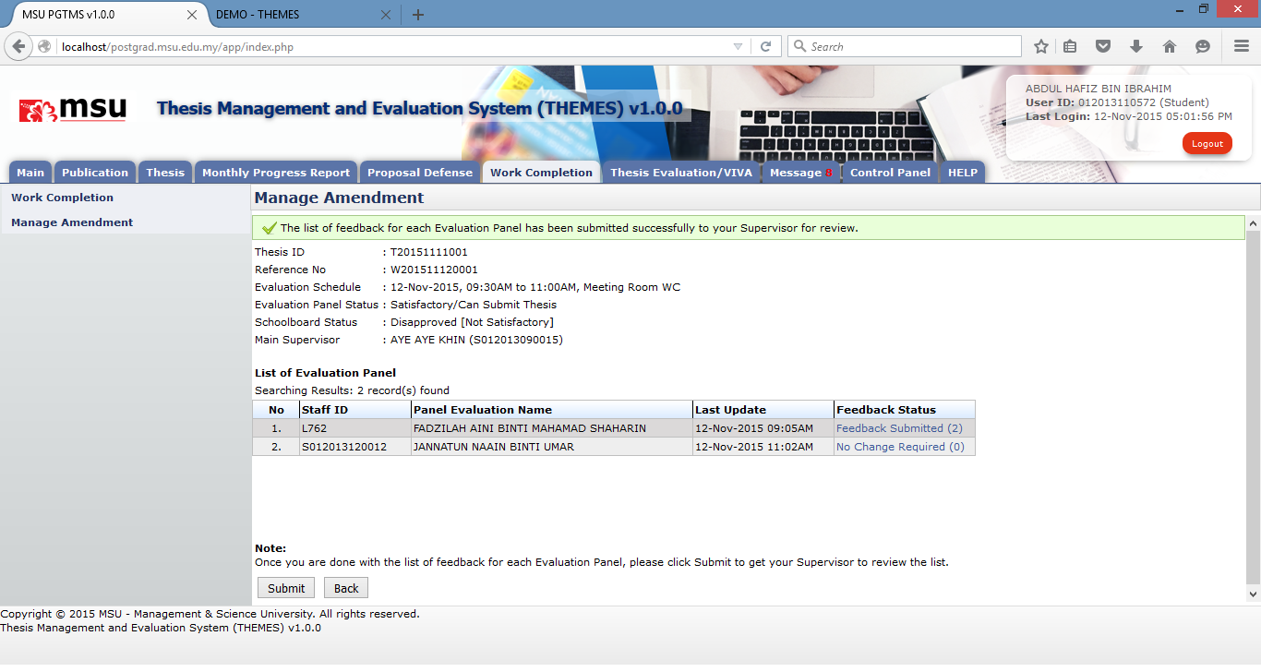

**60**

**Prerequisite**

The feedback for the Evaluation Panel has been added by the Student.

**Steps**

1. Click on the **Manage Amendment** menu on the Left Panel.
2. Enter the search criteria and click **Search** button to get specific result or otherwise just click the **Search** button to get general search result.
3. In the **List of Attended Work Completion**, click on the **Update** link of Feedback Status.
4. The Panel Evaluation page will be displayed with the Panel Evaluation.
5. Click on the **Submit** button to submit the feedback to the Supervisor for confirmation.
6. The Feedback Status will be change from **Pending** to **Feedback Submitted**.

**Next Action**

The student can keep checking the feedback status for necessary action.

**Warning**

System will prompt a notification message if the checkbox is unticking before the deletion.

**Note**

None

### Update Amendment Status

#### Submit Amendment Status

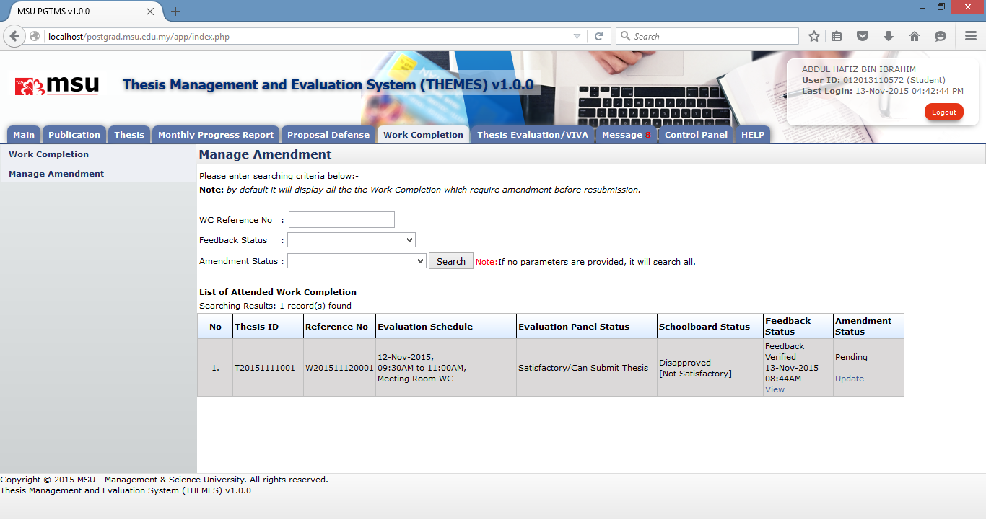

**30**

**20**

**10**

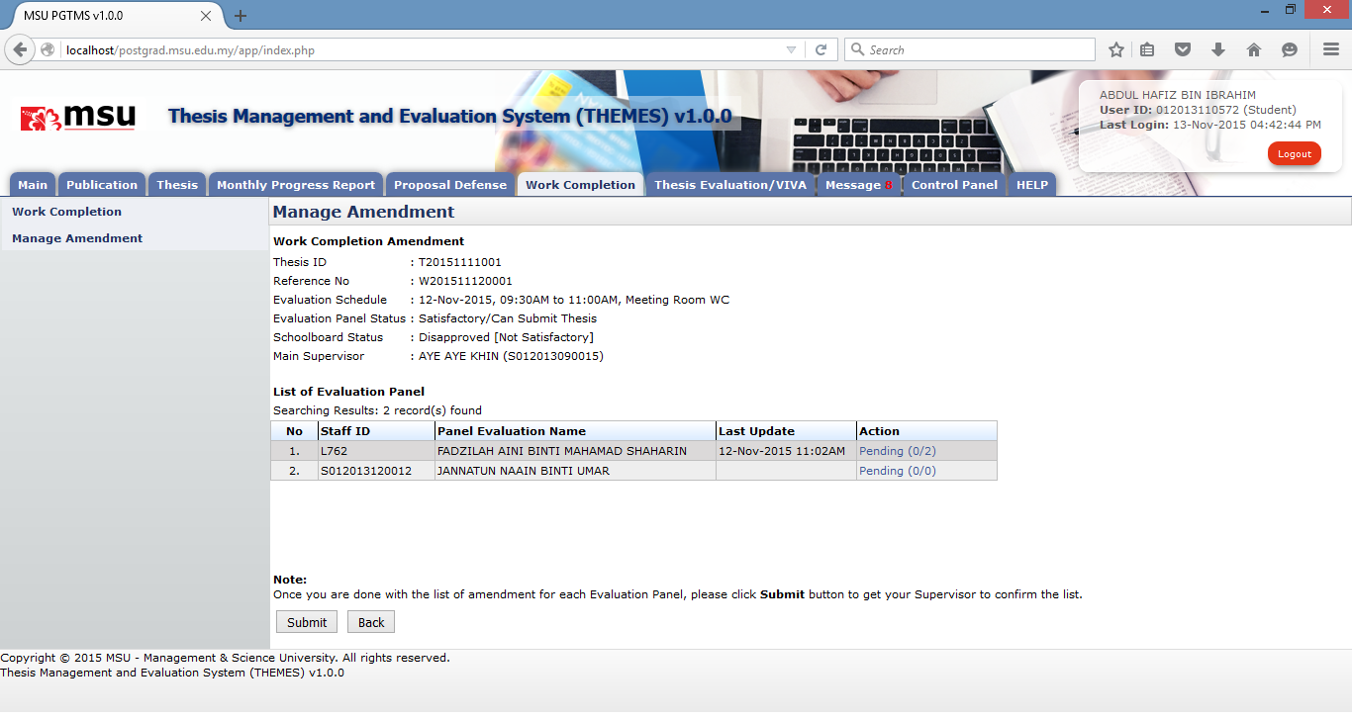

**40**

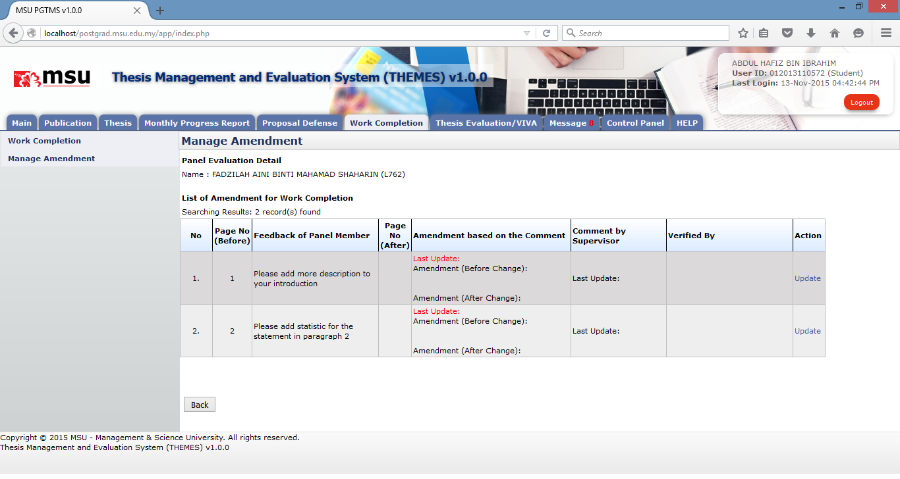

**50**

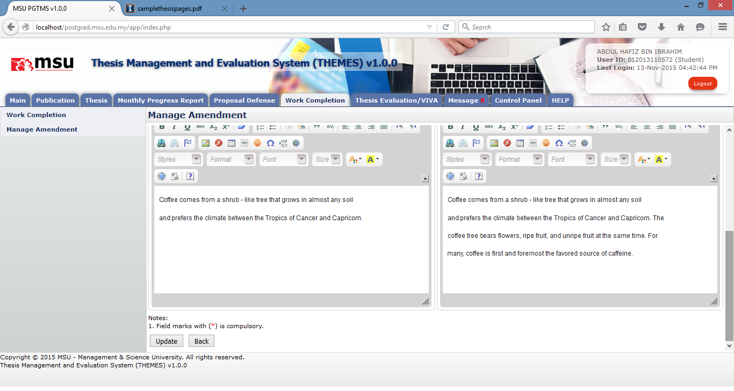

**60**

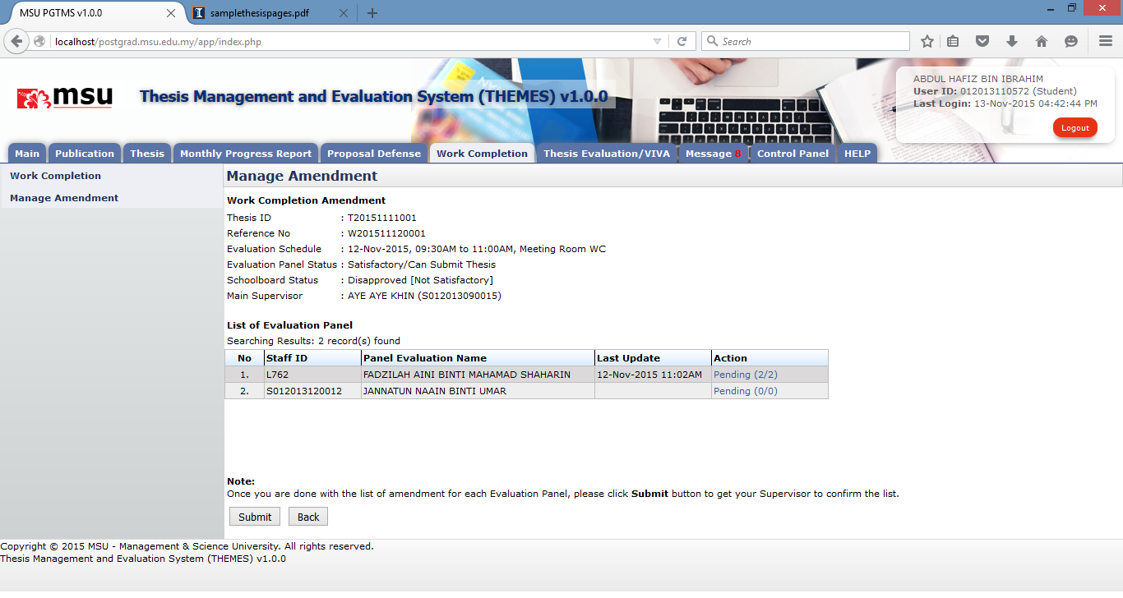

**70**

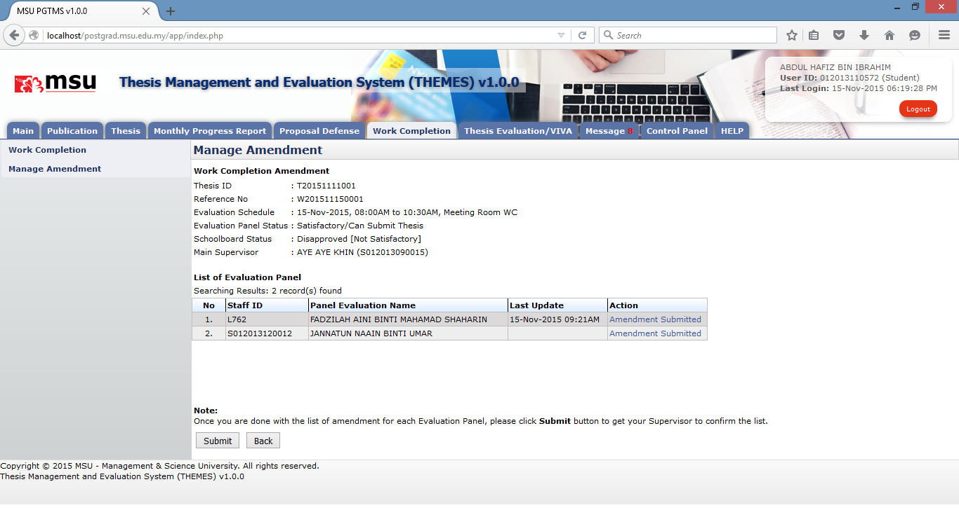

**80**

**Prerequisite**

The feedback for the Evaluation Panel has been verified by the Supervisor.

**Steps**

1. Click on the **Manage Amendment** menu on the Left Panel.
2. Enter the search criteria and click **Search** button to get specific result or otherwise just click the **Search** button to get general search result.
3. In the **List of Attended Work Completion**, click on the **Update** link of Amendment Status.
4. The **Panel Evaluation** page will be displayed with the Panel Evaluation Name. Click on the **Pending** link at **Action** column.
5. The **Panel Evaluation Detail** page will be displayed. Click on the **Update** link at **Action** column to update the changes.
6. On the **Update** page, complete the amendment for the thesis. Click on **Update** button to save the changes.
7. Click the Back button until reach the Panel Evaluation page. Click on the **Submit** button to submit the amendment to the Supervisor for confirmation.
8. The Amendment Status will be changed from **Pending** to **Amendment Submitted**.

**Next Action**

The student can keep checking the amendment status which it should be verified to proceed with the work completion resubmission.

**Warning**

System will prompt a notification message if the Student

1. Submit the amendment without confirm all the required changes.
2. Resubmit the amendment

**Note**

None

# Thesis EVALUATION / VIVA

## Thesis Submission

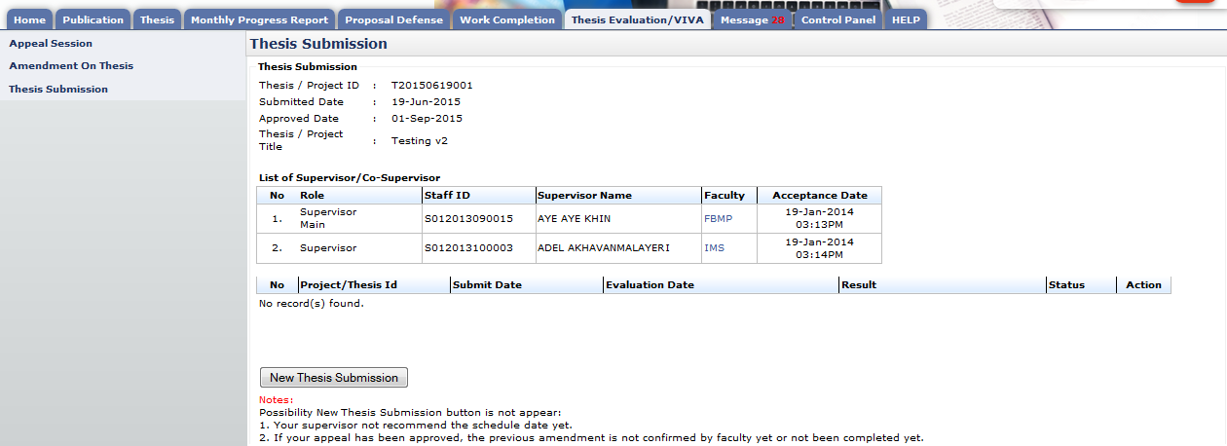

**30**

**20**

**10**

Figure 35: Thesis Submission

**Prerequisite**

1. The Work Completion has been approved by the Schoolboard.
2. The Supervisor has recommended the VIVA date scheduled by the Faculty for viva evaluation

**Steps**

1. Click on the **Thesis Evaluation/VIVA** tab on the **Top** panel
2. Click on the **Thesis Submission** menu on the **Left** panel
3. System will display the thesis for viva that need to be submitted by user. Click **New Thesis Submission** to attach and submit the thesis to Supervisor.

**Next Action**

The student is required to submit the thesis amendment if the Schoolboard request correction to the thesis either it is minor or major correction.

**Warning**

The system will prompt a notification message if the student proceed without completed the work completion and no evaluation date for VIVA.

**Note**

None

### New Thesis Submission

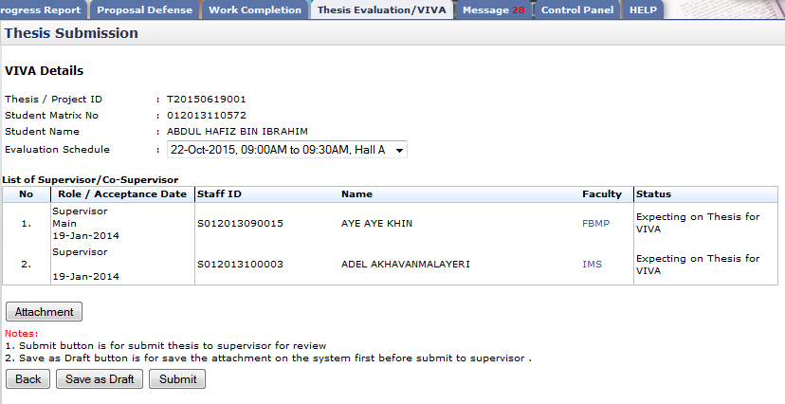

**10**

**40**

**30**

**20**

Figure 36: New Thesis Submission

**Prerequisite**

1. The Work Completion has been approved by the Schoolboard.
2. The Supervisor has recommended the VIVA date scheduled by the Faculty for viva evaluation

**Steps**

1. Select **Evaluation Schedule.**
2. To upload thesis, click **Attachment** button
3. To save thesis before submit to supervisor for review click **Save as Draft**
4. Click **Submit** button to submit thesis to Supervisor for review.

**Next Action**

The student is required to submit the thesis amendment if the Schoolboard request correction to the thesis either it is minor or major correction.

**Warning**

System will prompt a notification message if Evaluation VIVA schedule is not selected.

**Note**

None

#### Upload Attachment

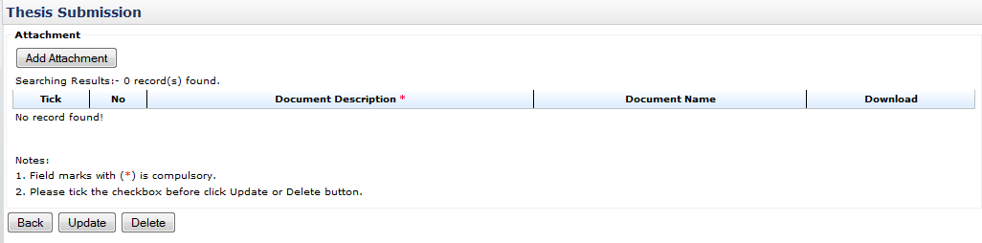

**120**

**10**

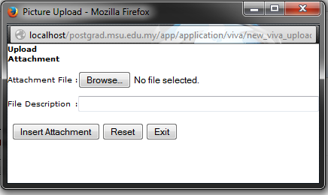

**20**

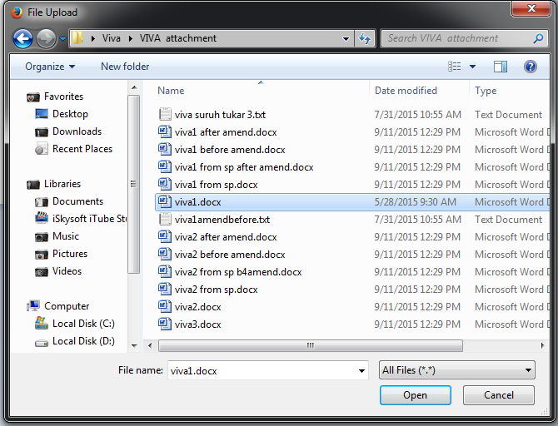

**30**

**30**

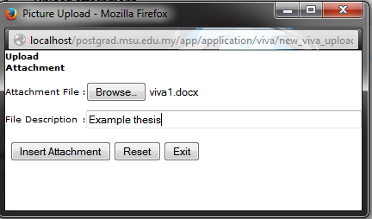

**40**

**60**

**40**

**70**

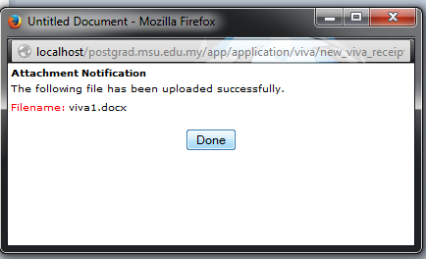

**50**

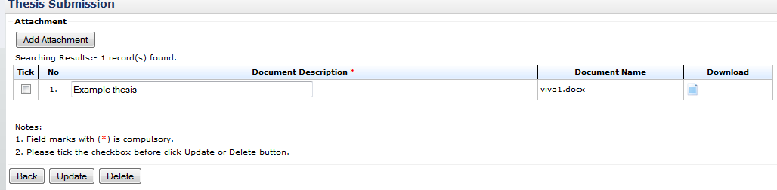

**80**

**100**

**90**

**80**

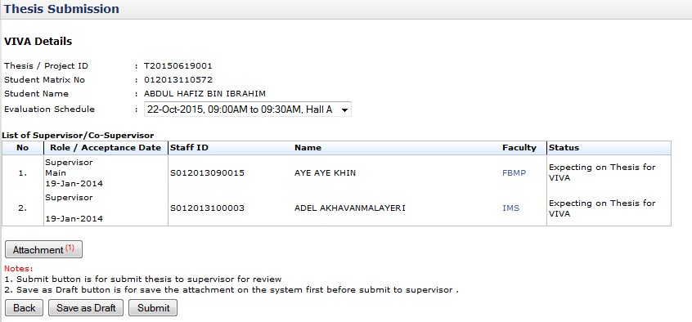

**11**

Figure 37: Upload Attachment

**Prerequisite**

None

**Steps**

1. To upload thesis click **Add Attachment** button
2. Click **browse** button from the popup window.
3. Choose the file and click **Open** button.
4. After done choose file for upload. Enter **File Description** and click **Insert Attachment** button to proceed.
5. Then click **Done** button
6. To change file and file description, click **Reset** button.
7. To close popup window click **Exit** button.
8. To update the file description, change it as reside in the text field. Tick the checkbox and click **Update** button.
9. To download and view the uploaded file, click 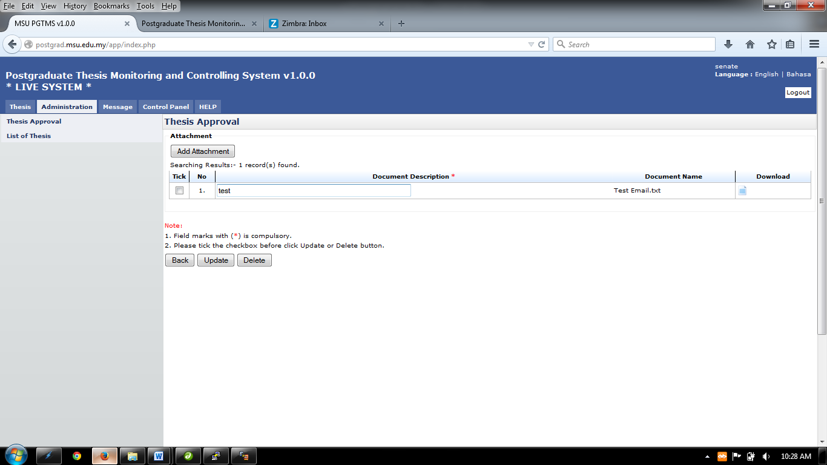button.
10. To delete uploaded file, tick the checkbox and click **Delete** button.
11. The number is indicated the number of uploaded file
12. Click **Back** button to go back to previous page.

**Next Action**

None

**Warning**

The system will prompt a notification message if the Student

1. Update the attachment with the file description left empty and checkbox is unselected.
2. Delete the attachment with the checkbox is unselected

**Note**

None

### Request Changes / Edit Thesis / Re-Submit Thesis

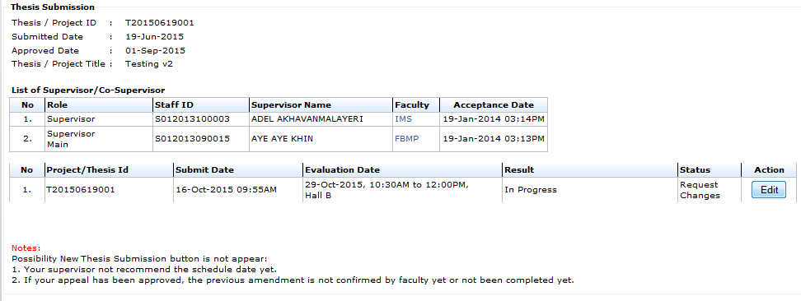

**1**

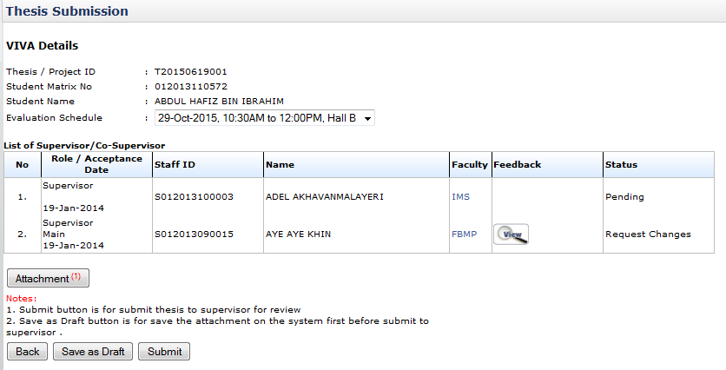

**6**

**5**

**4**

**3**

**2**

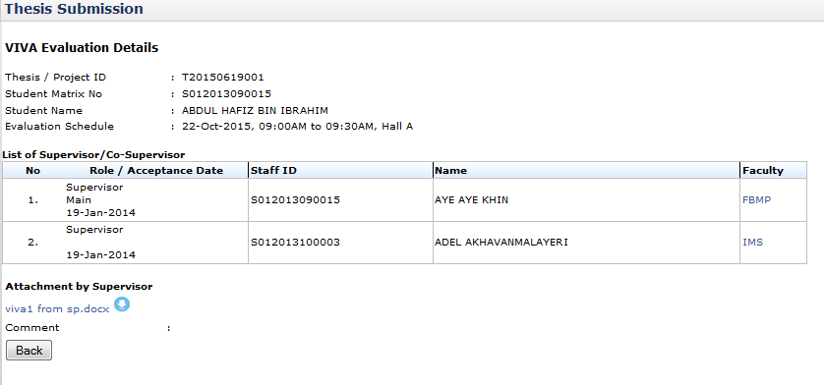

**7**

Figure 38: Re-Submit Thesis

**Prerequisite**

The status of the thesis must be either in **Save as Draft** or **Request Changes**.

**Steps**

1. To edit the thesis, it status must be in **Request Changes** due to the Supervisor’s feedback. Click **Edit** button to proceed
2. On **List of Supervisor/Co-Supervisor** table, there are 2 status are shown **Pending** and **Request** **Changes**. **Pending** means the supervisor is not yet response the thesis whilst for **Request Changes,** it means the supervisor requested changes for the thesis.
3. To see the comment given, click  button.
4. Ensure the **Evaluation Schedule** has the item selected.
5. To save the thesis for review and change, click **Save as Draft**.
6. Click **Submit** button if no more changes to submit it to the Supervisor for review. The **Save as Draft** and **Submit** buttons will be disappeared.
7. The comment and attachment uploaded by Supervisor are optional. It will be appeared if it is provided.

**Next Action**

The student is required to submit the thesis amendment if the Schoolboard request correction to the thesis either it is minor or major correction.

**Warning**

System will prompt a notification message if the **Evaluation Schedule** has no item been selected.

**Note**

None

#### Upload Attachment



**120**

**10**



**20**



**30**

**30**



**60**

**40**

**40**

**70**



**50**



**80**

**100**

**90**

**80**



**11**

Figure 39: Upload Attachment

**Prerequisite**

None

**Steps**

1. Click **Add Attachment** button to upload the thesis
2. Click **browse** button from the popup window.
3. Choose the file and click **Open** button.
4. After done choose file for upload. Enter **File Description** and click **Insert Attachment** button to proceed.
5. Then click **Done** button
6. To change file and file description, click **Reset** button.
7. To close popup window click **Exit** button.
8. To update the file description, change it as reside in the text field. Tick the checkbox and click **Update** button.
9. To download and view the uploaded file, click button.
10. To delete uploaded file, tick the checkbox and click **Delete** button.
11. The number is indicated the number of uploaded file
12. Click **Back** button to go back to previous page.

**Next Action**

None

**Warning**

The system will prompt a notification message if the Student

1. Update the attachment with the file description left empty and checkbox is unselected.
2. Delete the attachment with the checkbox is unselected

**Note**

None

## Amendment on Thesis

### New Amendment Submission

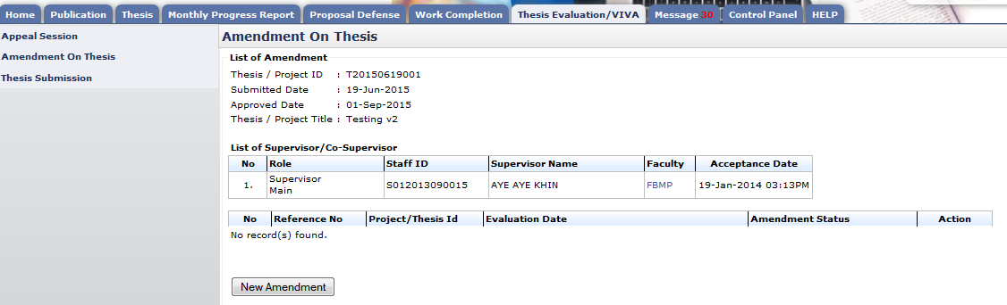

**30**

**20**

**10**

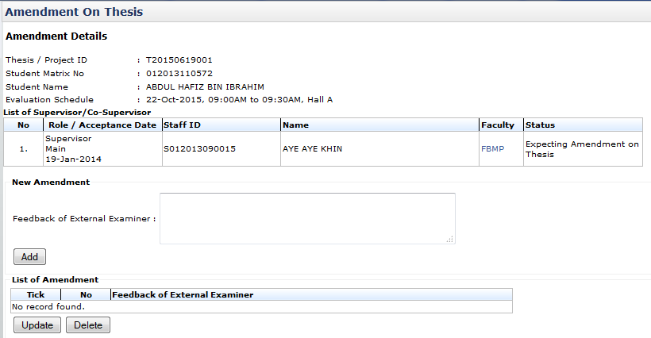

**2**

**1**

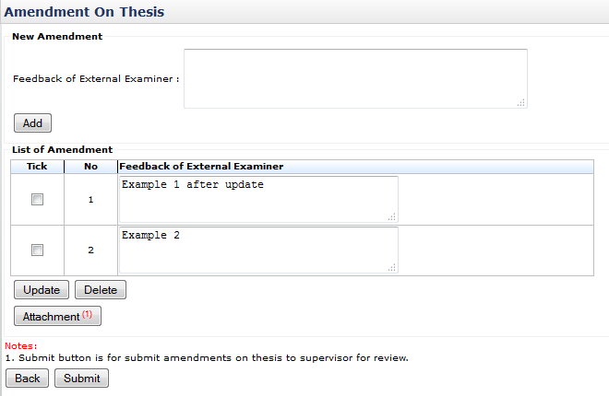

**4**

**6**

**5**

**3**

**3**

Figure 40: New Amendment

**Prerequisite**

The Schoolboard request correction (either it is minor or major correction) to the thesis submitted by the student.

**Steps**

1. Click on the **Thesis Evaluation/VIVA** tab on the **Top** panel
2. Click on the **Amendment On Thesis** menu on the **Left** panel
3. Click on **New Amendment** button to submit the amendment list to the Supervisor
4. Enter the feedback of the Examiner into the text field.
5. Click **Add** button to add the feedback into the list.
6. To update the feedback, edit it in the text field on the table of **List of Amendment**, tick the checkbox and click **Update** button to save it.
7. To delete the feedback, tick the checkbox and click **Delete** button. It will be deleted from the list.
8. To upload attachment, click **Attachment** button
9. Click **Submit** button to submit the amendment to supervisor for review.

**Next Action**

Supervisor to review the amendment submitted and the Student to keep checking the status.

**Warning**

System will prompt a notification message if,

1. No feedback has been added before the submission to the Supervisor.
2. Update of the feedback with no detail and tick the relevant checkbox
3. Delete the feedback without tick the relevant checkbox.

**Note**

None

#### Upload Attachment

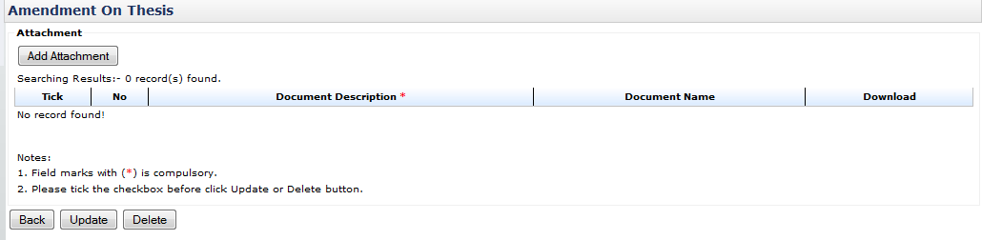

**120**

**10**



**20**

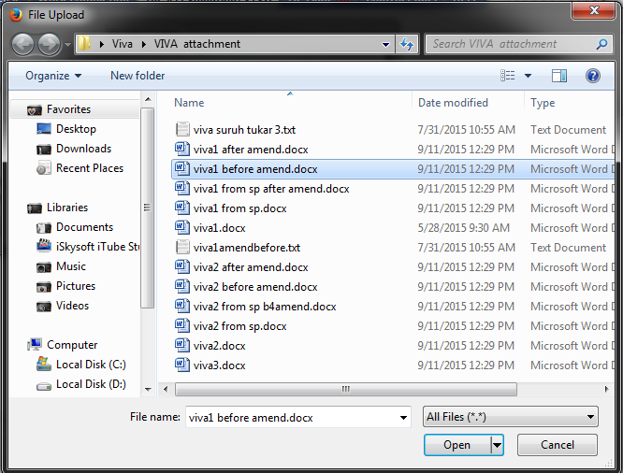

**30**

**30**

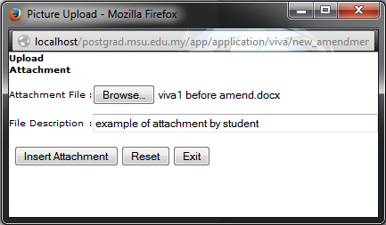

**40**

**40**

**60**

**70**

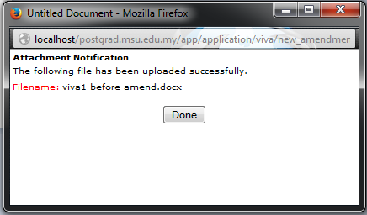

**50**

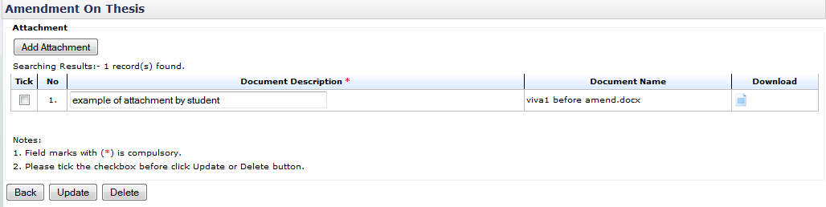

**80**

**100**

**90**

**80**



**11**

Figure 41: Upload Attachment

**Prerequisite**

None

**Steps**

1. To upload thesis click **Add Attachment** button
2. Click **browse** button from the popup window.
3. Choose the file and click **Open** button.
4. After done choose file for upload. Enter **File Description** and click **Insert Attachment** button to proceed.
5. Then click **Done** button
6. To change file and file description, click **Reset** button.
7. To close popup window click **Exit** button.
8. To update the file description, change it as reside in the text field. Tick the checkbox and click **Update** button.
9. To download and view the uploaded file, click button.
10. To delete uploaded file, tick the checkbox and click **Delete** button.
11. The number is indicated the number of uploaded file
12. Click **Back** button to go back to previous page.

**Next Action**

None

**Warning**

The system will prompt a notification message if the Student

1. Update the attachment with the file description left empty and checkbox is unselected.
2. Delete the attachment with the checkbox is unselected

**Note**

None

### Request Changes / Save as Draft

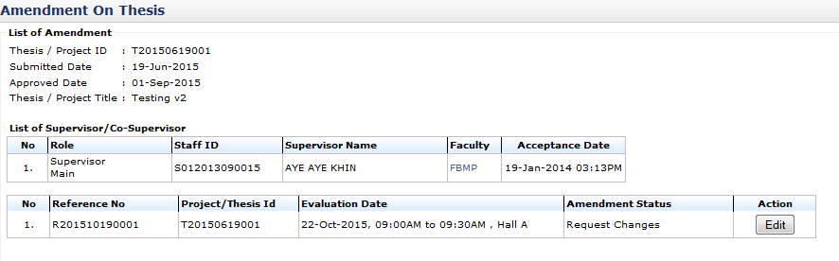

**1**

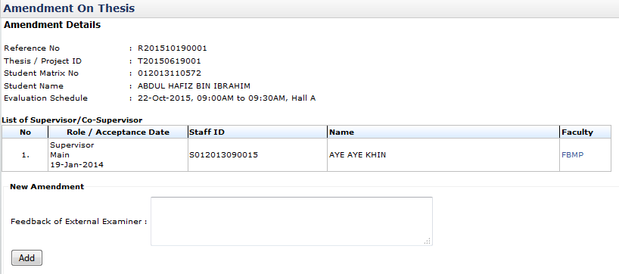

**3**

**2**

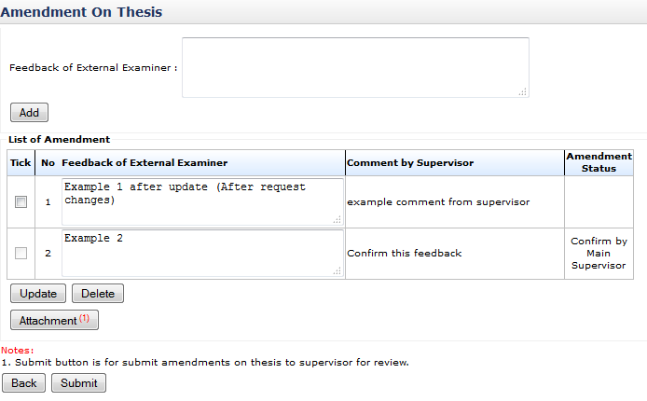

**7**

**8**

**4**

**6**

**6**

**5**

**4**

Figure 42: Request Changes

**Prerequisite**

The Supervisor has requested to change the provided feedback.

**Steps**

1. Click on **Thesis Evaluation /VIVA** on **Top Panel**. Then click on **Amendment on Thesis** on **Left Panel**. The list of thesis will be displayed. Click on **Edit** button to edit the thesis.
2. Enter the feedback of the Examiner into the text field.
3. Click **Add** button to add the feedback into the list.
4. To update the feedback, edit it in the text field on the table of **Feedback of External Examiner**, tick the checkbox and click **Update** button to save it.
5. The amendment status will be shown at **Amendment Status** column.If it is empty, the Student need to update the thesis based on the comment given by the Supervisor.
6. If the amendment status has **Confirm by Main Supervisor** status, it has been accepted by the Supervisor and the checkbox is disabled to indicate no further update or delete is allowed.
7. Tick the checkbox and click **Delete** button if to delete the feedback from the list.
8. Click **Attachment** button if to upload an attachment.
9. Click **Submit** button to submit the amendment list to the Supervisor for review.

#### Upload Attachment



**120**

**10**



**20**



**30**

**30**



**40**

**40**

**60**

**70**



**50**



**80**

**100**

**90**

**80**



**11**

Figure 43: Upload Attachment

**Prerequisite**

None

**Steps**

1. To upload thesis click **Add Attachment** button
2. Click **browse** button from the popup window.
3. Choose the file and click **Open** button.
4. After done choose file for upload. Enter **File Description** and click **Insert Attachment** button to proceed.
5. Then click **Done** button
6. To change file and file description, click **Reset** button.
7. To close popup window click **Exit** button.
8. To update the file description, change it as reside in the text field. Tick the checkbox and click **Update** button.
9. To download and view the uploaded file, click button.
10. To delete uploaded file, tick the checkbox and click **Delete** button.
11. The number is indicated the number of uploaded file
12. Click **Back** button to go back to previous page.

**Next Action**

None

**Warning**

The system will prompt a notification message if the Student

1. Update the attachment with the file description left empty and checkbox is unselected.
2. Delete the attachment with the checkbox is unselected

**Note**

None

### Amendment on Thesis

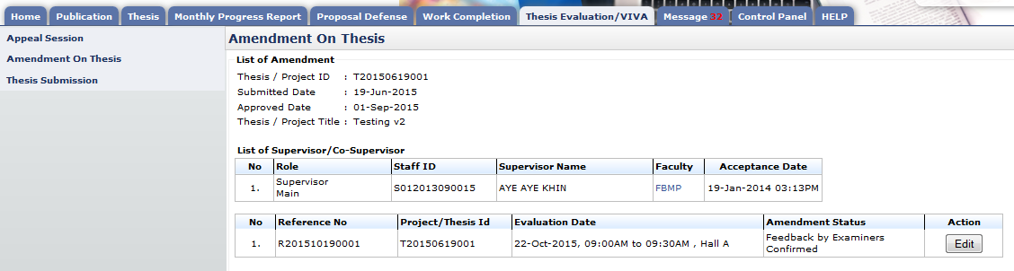

**1**

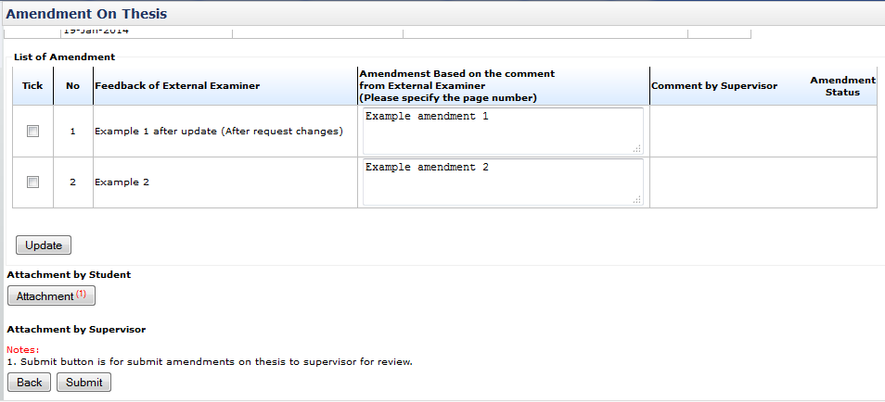

**3**

**2c**

**2b**

**2a**

Figure 44: Amendment on thesis

**Prerequisite**

Supervisor has verified and confirmed all the feedbacks of External Examiner.

**Steps**

1. Click **Edit** button to edit the amendment done on the thesis.
2. Enter the amendment detail into the text field based on the feedback provided by the Examiner. Tick the relevant checkbox and click **Update** button to save it. Do the same if there is change has been done on it.
3. To upload attachment, click **Attachment** button
4. Click **Submit** button to submit amendment to supervisor for review.

**Next Action**

Supervisor need to verify the changes and the Student keep checking the amendment status.

**Warning**

System will prompt a notification message if the checkbox is unselected before the deletion.

**Note**

None

#### Upload Attachment



**120**

**10**



**20**



**30**

**30**



**40**

**40**

**60**

**70**



**50**



**80**

**100**

**90**

**80**



**11**

Figure 45: Upload Attachment

**Prerequisite**

None

**Steps**

1. To upload thesis click **Add Attachment** button
2. Click **browse** button from the popup window.
3. Choose the file and click **Open** button.
4. After done choose file for upload. Enter **File Description** and click **Insert Attachment** button to proceed.
5. Then click **Done** button
6. To change file and file description, click **Reset** button.
7. To close popup window click **Exit** button.
8. To update the file description, change it as reside in the text field. Tick the checkbox and click **Update** button.
9. To download and view the uploaded file, click button.
10. To delete uploaded file, tick the checkbox and click **Delete** button.
11. The number is indicated the number of uploaded file
12. Click **Back** button to go back to previous page.

**Next Action**

None

**Warning**

The system will prompt a notification message if the Student

1. Update the attachment with the file description left empty and checkbox is unselected.
2. Delete the attachment with the checkbox is unselected

**Note**

None

### Request Changes on Amendment

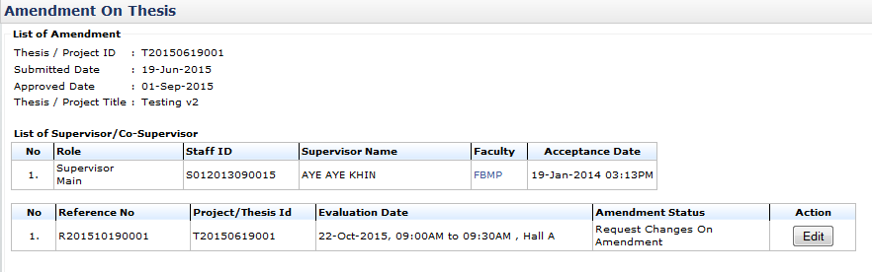

**4**

**10**

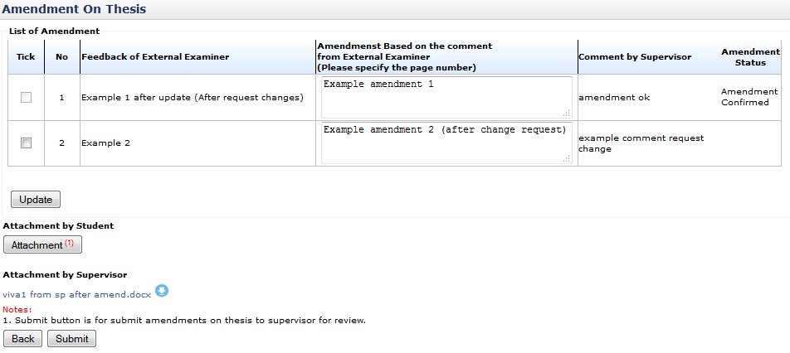

**7**

**6**

**5**

**3**

**2c**

**2b**

**2a0**

Figure 46: Request Changes

**Prerequisite**

The Supervisor has requested the changes to the submitted amendment list.

**Steps**

1. Click **Edit** button to edit the amendment list.
2. To update or edit or add Amendment on thesis, edit detail in text field on the table of **List of Amendment**, tick the checkbox and click **Update** button.
3. The amendment status will be shown at **Amendment Status** column.If it is empty, the Student need to update the thesis based on the comment given by the Supervisor.
4. If the amendment status has **Amendment Confirmed** status, it has been accepted by the Supervisor and the checkbox is disabled to indicate no further update or delete is allowed.
5. Click **Attachment** button if to upload an attachment.
6. Click the filename link if to download the attachment.
7. Click **Submit** button to submit the amendment list to the Supervisor for review.

**Next Action**

Supervisor need to verify the changes and the Student keep checking the amendment status.

**Warning**

System will prompt a notification message if the checkbox is unselected before the updation.

**Note**

None

#### Upload Attachment



**120**

**10**



**20**



**30**

**30**



**40**

**40**

**60**

**70**



**50**



**80**

**80**

**100**

**90**



**11**

Figure 47: Upload Attachment

**Prerequisite**

None

**Steps**

1. To upload thesis click **Add Attachment** button
2. Click **browse** button from the popup window.
3. Choose the file and click **Open** button.
4. After done choose file for upload. Enter **File Description** and click **Insert Attachment** button to proceed.
5. Then click **Done** button
6. To change file and file description, click **Reset** button.
7. To close popup window click **Exit** button.
8. To update the file description, change it as reside in the text field. Tick the checkbox and click **Update** button.
9. To download and view the uploaded file, click button.
10. To delete uploaded file, tick the checkbox and click **Delete** button.
11. The number is indicated the number of uploaded file
12. Click **Back** button to go back to previous page.

**Next Action**

None

**Warning**

The system will prompt a notification message if the Student

1. Update the attachment with the file description left empty and checkbox is unselected.
2. Delete the attachment with the checkbox is unselected

**Note**

None

## Appeal Session

### Request for Appeal

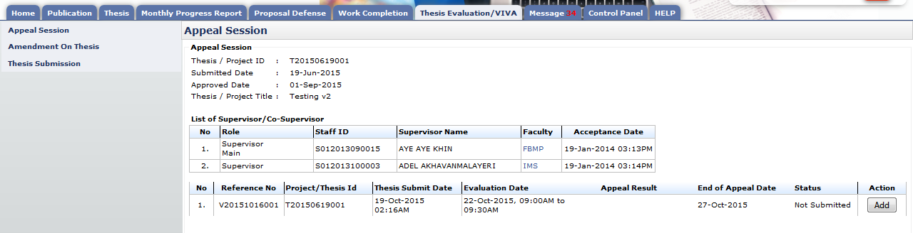

**30**

**20**

**10**

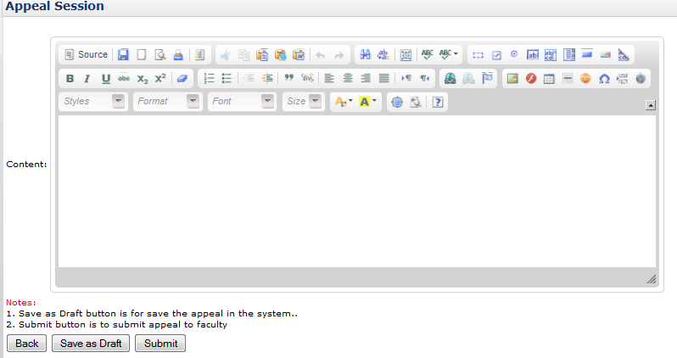

**60**

**50**

**40**

Figure 48: Appeal Session

**Prerequisite**

1. Schoolboard has approved the recommendation of the Evaluation Committee to fail the thesis
2. Schoolboard has given the due date to the student to appeal and resubmit the thesis for VIVA

**Steps**

1. Click on the **Thesis Evaluation/VIVA** tab on the **Top** panel
2. Click on the **Appeal Session** menu on the **Left** panel
3. Click on the **Add** button to submit the appeal request to the Faculty.
4. Enter the remarks or reason for Faculty consideration.
5. Click **Save as Draft** button if to save changes
6. Click **Submit** button to request appeal approval from the Faculty

**Next Action**

1. If the appeal is approved by the Faculty, the student needs to resubmit the thesis for VIVA and follow the required steps in VIVA process.
2. If the appeal is disapproved by the Faculty, the VIVA result is considered failed and will be forwarded to Senate for endorsement.

**Notes**

1. Appeal session can be made within date given.
2. If request appeal is not submitted within the given duration time, VIVA result is considered failed.

# Message

## Inbox

### New and Read Message

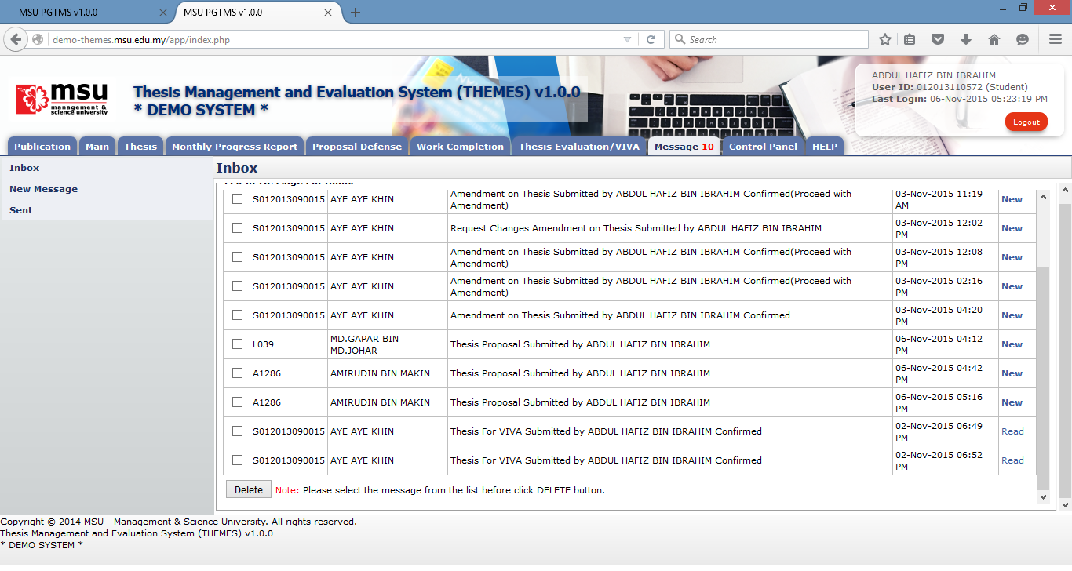

**3**

**2**

**1**

**Prerequisite**

None

**Steps**

1. Click on the **Message** tab on the **Top** panel. If there is a number with it, that’s mean there are unread messages available pending action from the student.
2. Click on the **Inbox** menu on the **Left** panel. System will display the list of message on the **Working Area** section.
3. On the far right side, it will display the status of the message whether is **New** or **Read.** To read the message, click on it.
4. To delete message, tick on the checkbox in **Tick** column, and click **Delete** button

**Next Action**

None

**Warning**

None

**Note**

None.

### Delete Message



**4**

**3**

**2**

**1**

**Prerequisite**

None

**Steps**

1. Click on the **Message** tab on the **Top** panel. If there is a number with it, that’s mean there are unread messages available pending action from the student.
2. Click on the **Inbox** menu on the **Left** panel. System will display the list of message on the **Working Area** section.
3. Tick the checkbox in which the message is going to be deleted. It can be done in multiple rows.
4. Click on the **Delete** button to delete the message from the list.

**Next Action**

None

**Warning**

System will prompt a notification message if the checkbox is untick before the deletion.

**Note**

None.

## New Message

### Send Message

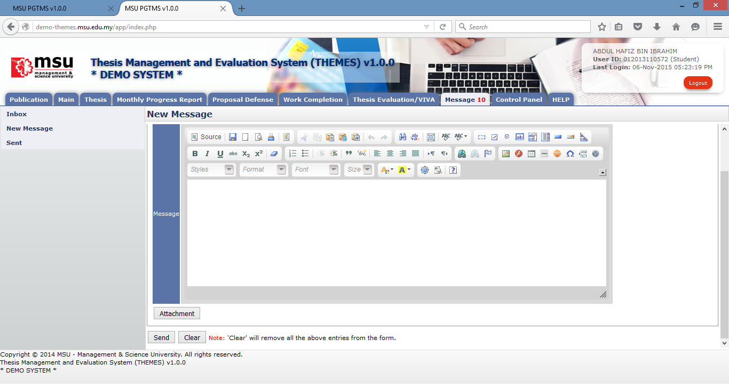

**3**

**2**

**1**

Figure 49: New Message

**Prerequisite**

None

**Steps**

1. Click on the **Message** tab on the **Top** panel
2. Click on the **New Message** menu on the **Left** panel
3. Once the Recipient, the message and the attachment (if any) are in place, then click **Send** button to send it to the Recipient.

**Next Action**

None

**Warning**

System will prompt a notification message if the checkbox is unticking before the deletion.

**Note**

None.

### Select Recipient

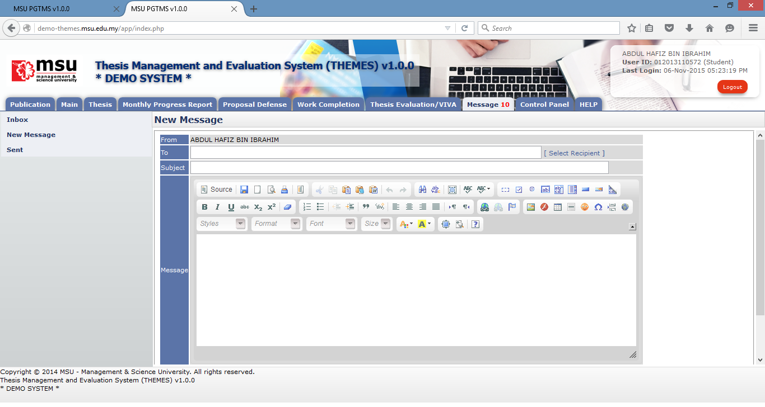

**1**

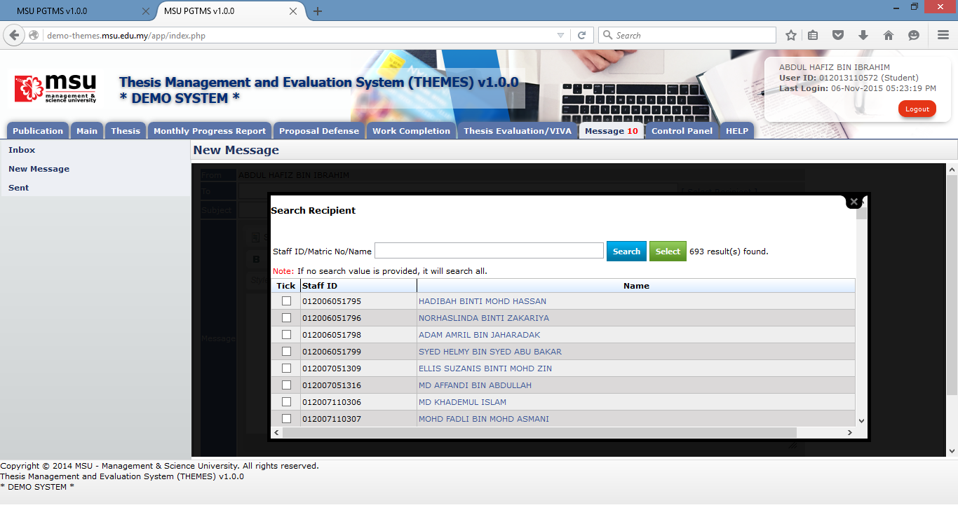

**4**

**2**

**3**

Figure 50: Select Recipient

**Prerequisite**

None

**Steps**

1. Click on the **Select Recipient** link to open the Recipient List page.
2. Enter the searching criteria and click **Search** button to search the specific search result or just click the **Search** button to search the general result.
3. Tick on the checkbox for the identified recipient.
4. Click on the **Select** button to populate the selected recipient into the **To** field on the New Message page.

**Next Action**

None

**Warning**

None

**Note**

None

### Upload Attachment - Add



**1**

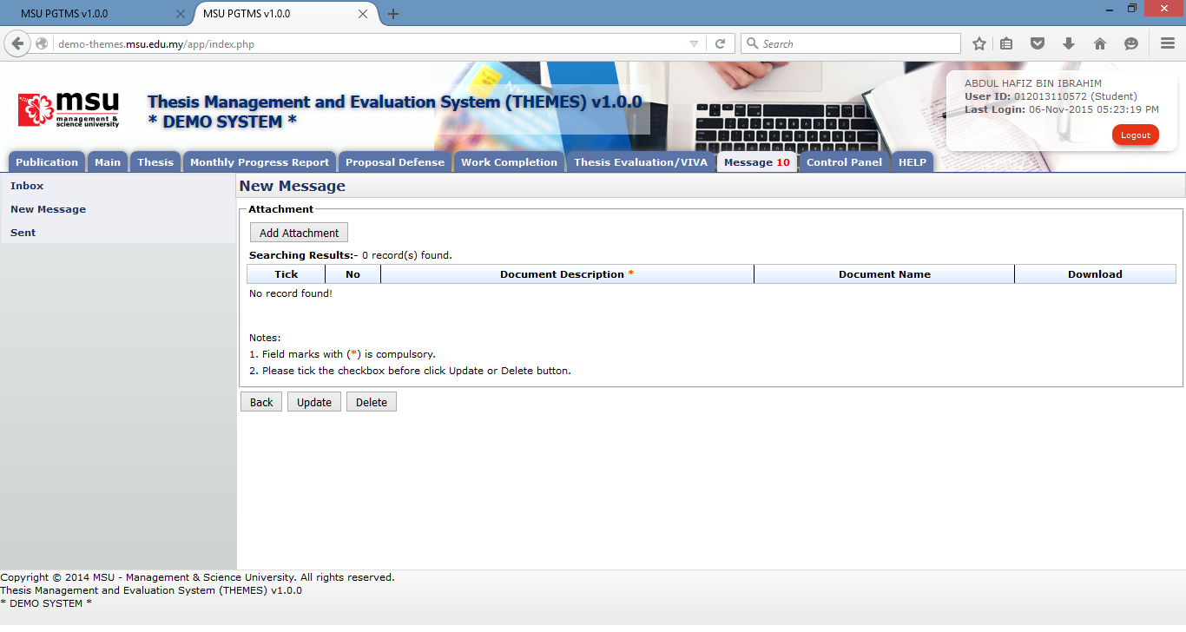

**2**

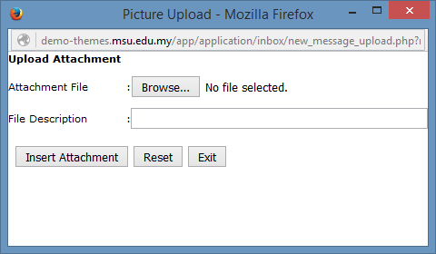

**4**

**3**

Figure 51: Upload Attachment

**Prerequisite**

None

**Steps**

1. Click on the **Attachment** button to open the Attachment page.
2. On Attachment page, click on the **Add Attachment** button.
3. Click on the **Browse** button to select the attachment. File Description field is optional.
4. Click on the **Insert Attachment** button to add the select attachment into the attachment list.

**Next Action**

1. Send the message
2. Update the attachment’s description
3. Delete the attachment

**Warning**

None

**Note**

None

### Upload Attachment - Update

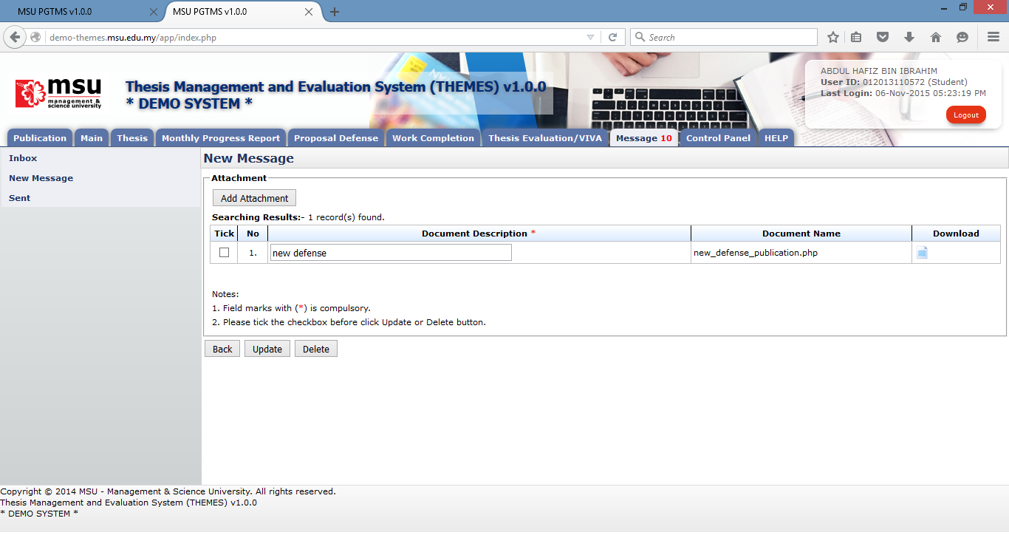

**3**

**1**

**2**

Figure 52: Upload Attachment

**Prerequisite**

The attachment has been added into the attachment list.

**Steps**

1. Update the document’s description. It can be done in multiple rows.
2. Tick the checkbox for the document’s description being updated. It can be done in multiple rows.
3. Click on the **Update** button to update the changes.

**Next Action**

1. Send the message
2. Update the attachment’s description
3. Delete the attachment

**Warning**

None

**Note**

None

### Upload Attachment - Delete



**1**

**2**

Figure 53: Upload Attachment

**Prerequisite**

The attachment has been added into the attachment list.

**Steps**

1. Tick the checkbox for the document to be deleted. It can be done in multiple rows.
2. Click on the **Delete** button to delete the attachment from the list.

**Next Action**

1. Send the message
2. Add other new attachment
3. Delete other attachment

**Warning**

None

**Note**

None

## Sent Message

### View Sent Message

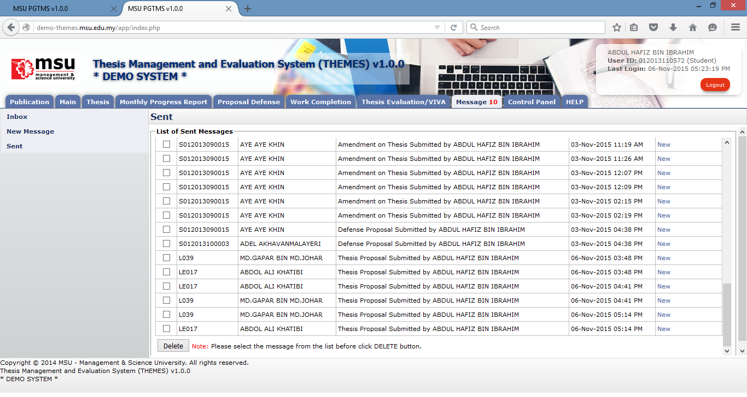

**1**

**3**

**2**

Figure 54: View Sent Message

**Prerequisite**

The message has been sent to the Recipient.

**Steps**

1. Click on the **Message** tab on the **Top Panel**.
2. Click on the **Sent** menu on the **Left Panel**.
3. To view the sent message, click on the message status

**Next Action**

None

**Warning**

None

**Note**

None

### Delete Sent Message



**3**

**1**

**4**

**2**

Figure 55: Delete Sent Message

**Prerequisite**

The message has been sent to the Recipient.

**Steps**

1. Click on the **Message** tab on the **Top Panel**.
2. Click on the **Sent** menu on the **Left Panel**.
3. Tick the checkbox for which the messages need to be deleted. It can be done in multiple rows.
4. Click on the Delete button to delete the messages from the list.

**Next Action**

None

**Warning**

None

**Note**

None

# Control Panel

## Change Password

### Before Login



**1**

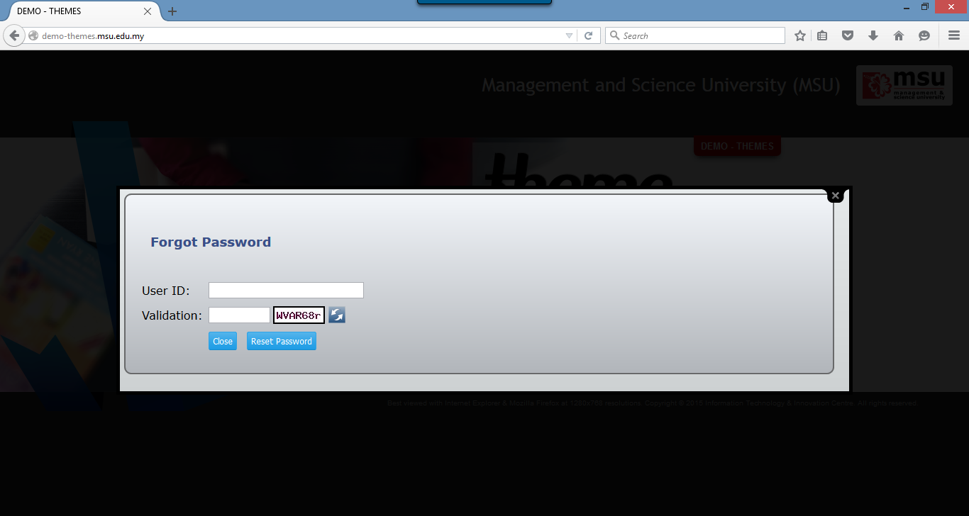

**3**

**2**

Figure 56: Change Password Page Before Login

**Prerequisite**

The User must have the email ID registered in KLAS2 system which failure to provide the valid email ID causing the system to do not generate and email a new reset password.

**Steps**

1. Click on the **Forgot Your Password** at the Login Page. The **Forgot Password** page will be displayed
2. Enter your **User ID** and **Validation Code**. The Validation Code can be refreshed if you want to change it.
3. Click on the **Reset Password** button. The system will generate the new password and send it to the registered user’s email ID.

**Warning**

System will prompt a message if no email ID found in KLAS2 system. The User needs to register it in KLAS2 first before request to reset the password.

**Note**

None.

### After Login

For the security reason, the user is strongly recommended to change the password at first successful login to the system.

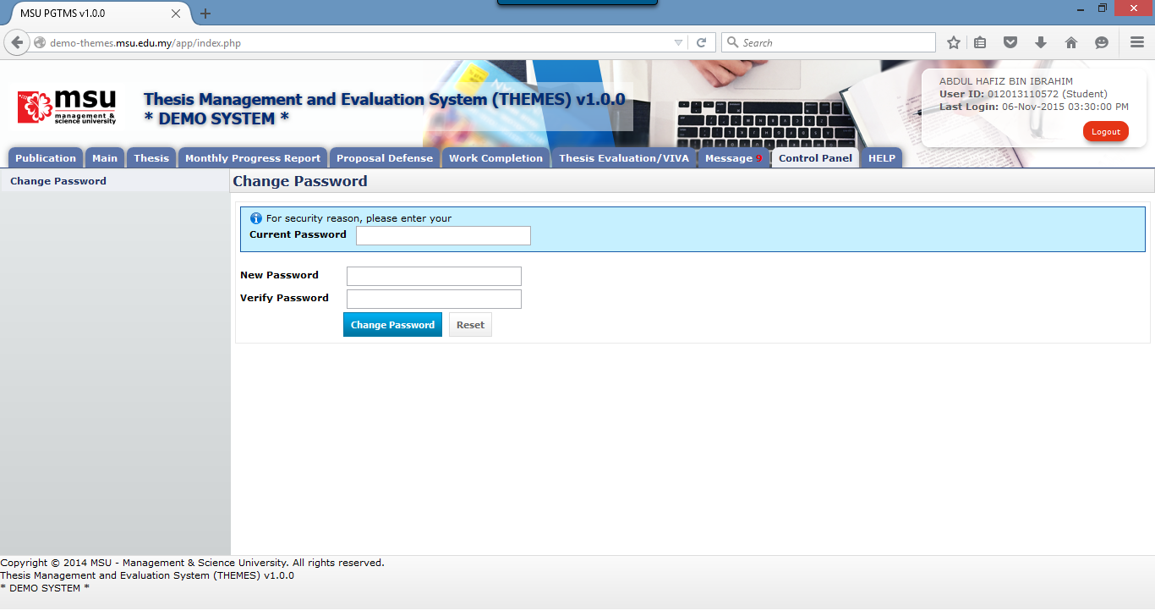

**6**

**5**

**4**

**3**

**2**

**1**

Figure 57: Change Password Page After Login

**Prerequisite**

None

**Steps**

1. Click on the **Control Panel** tab from the system **Top** panel section.
2. The **Change Password** menu will be displayed and click on it.
3. As security measure, the system will ask **Current Password** from the user.
4. Then follow by the **New Password** and **Verify Password**.
5. Click **Change Password** button to save the newly change password into the system successfully.
6. User can use **Reset** button if wanted to clear the entry on each fields.

**Warning**

1. If the provided **Current Password** is incorrect, the system will prompt an error message and the user needs to redo the above step 3 onwards.
2. If the provided **New Password** and **Verify Password** are mismatched, the system will prompt an error message and the user needs to provide the match password for both.
3. The user cannot reuse the last 3 passwords which have been used before.
4. The password shall have the numeric (0-9) and characters (a-z, A-Z)

**Note**

None.

# Help

## Online Help - Student

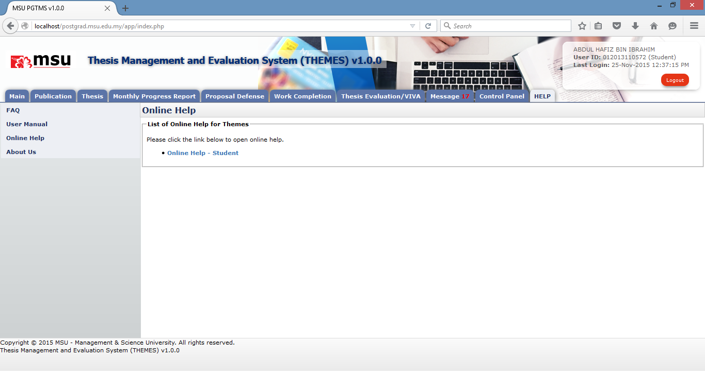

**2**

**3**

**1**

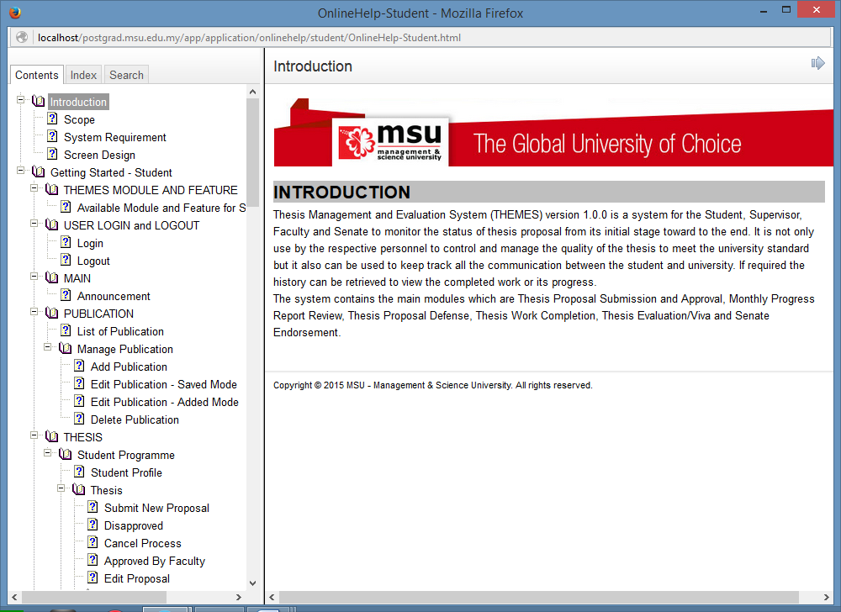

**4**

Figure 58: Online Help

**Prerequisite**

None

**Steps**

1. Click on the **HELP** tab from the system **Top** **Panel** section.
2. Click on the **Online Help** on the **Left Panel** section.
3. The online help will be displayed on the **Working Area** section which listed the applicable help to the Student. Click on the online help link.
4. The Online Help page will be displayed. The student can browse through the content to find the required help.

**Next Action**

None

**Warning**

None

**Note**

None.

## User Manual

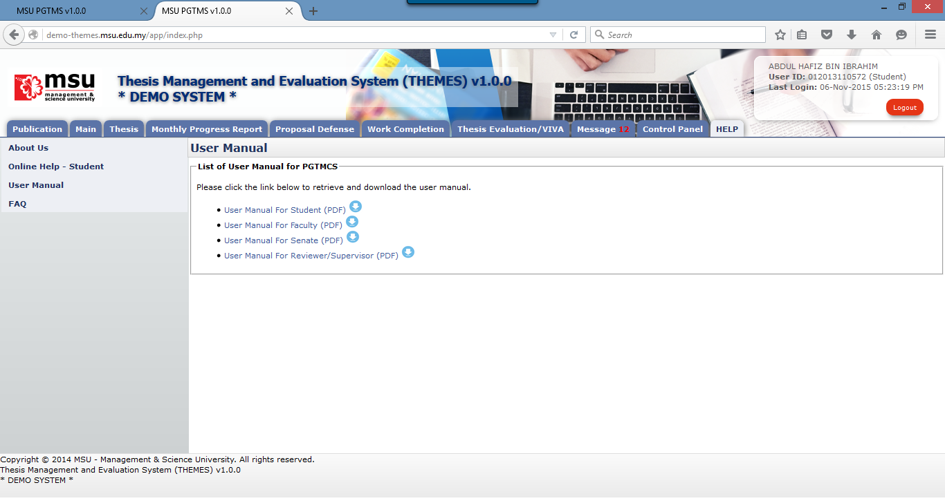

**3**

**2**

**1**

Figure 59: User Manual

**Prerequisite**

None

**Steps**

1. Click on the **Help** tab on the **Top** panel
2. Click on the **User Manual** menu on the **Left** panel
3. System will display the link to download user manual on the **Working Area** section.

**Next Action**

None

**Warning**

None

**Note**

None.

## Frequently Asked Question

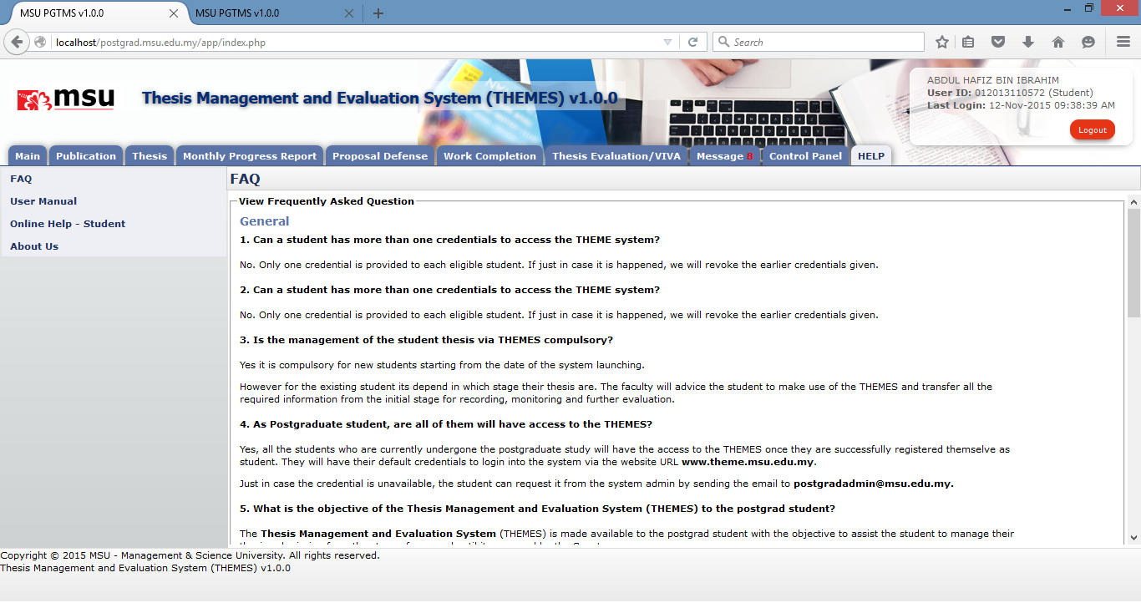

**2**

**1**

Figure 60: FAQ

**Prerequisite**

None

**Steps**

1. Click on the **Help** tab on the **Top** panel
2. Click on the **FAQ** menu on the **Left** panel
3. System will display the list of FAQ on the **Working Area** section.

**Next Action**

None

**Warning**

None

**Note**

None.

## About Us

The page where indicate the current system’s version and email to send comment and report bugs.

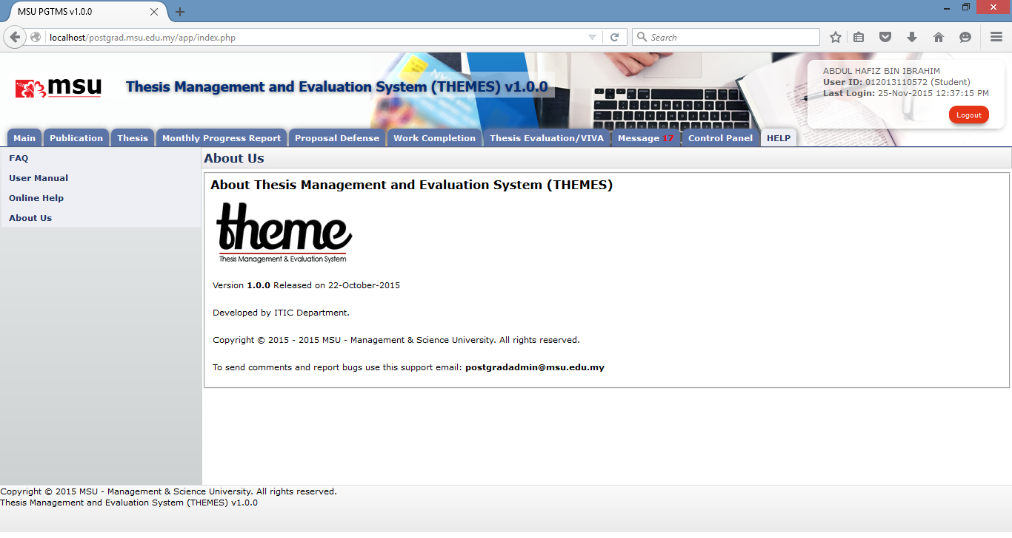

**3**

**2**

**1**

**Prerequisite**

None

**Steps**

1. Click on the **Help** tab on the **Top** panel
2. Click on the **About Us** menu on the **Left** panel
3. System will display the About Us information on the **Working Area** section.

**Next Action**

None

**Warning**

None

**Note**

None.

This page is intentionally left blank.